The Evolution and Spread of Moorish Revival Synagogues as Influenced by German Jews and Reform Judaism

Susan Beth Teichman

Submitted in partial fulfillment of the
requirements for the degree
Master of Arts in the History of Design and Curatorial Studies

MA Program in History of Design and Curatorial Studies

Cooper Hewitt, Smithsonian Design Museum
and Parsons The New School for Design

2016

TABLE OF CONTENTS

Page
List of Maps and Illustrations 3
Introduction 6
The European Connection
Chapter 1 – Moorish Revival Architecture in Europe 8
Definition of Moorish Revival Architecture 10
Chapter 2 - European Orientalism 12
German Orientalism 15
German-Jewish Orientalism 20
European Jewish History
Chapter 3 - Emancipation and Synagogue Styles 26
Chapter 4 - European Moorish Revival Synagogues 34
The Early Moorish Synagogues 34
Moorish Revival Synagogues of Central Europe 39
Reform Judaism
Chapter 5 - History of Reform Judaism in Germany 47
History of Reform Judaism in America 53
German Jews in America
Chapter 6 - Jewish American or American Jew? 60
Chapter 7 - The American Synagogue 68
Chapter 8 - Jewish New York 73
Chapter 9 - Moorish Revival Synagogues in New York City 83

Chapter 10 - Satellite Cities – Patterson and Newark, New Jersey, 94
Philadelphia, Pennsylvania
Chapter 11 - Jews of the Ohio River Valley 99
Chapter 12 - Moorish Synagogues of the Ohio River Valley 103
Cincinnati, Ohio
Wheeling, West Virginia
Owensboro, Kentucky
Paducah, Kentucky
Chapter 13 - Jews in the South 112
Chapter 14 - Moorish Synagogue of the South 116
Port Gibson, Mississippi
Corsicana, Texas
Wilmington, North Carolina
Chapter 15 – Jews of the Great Plains, Southwest and Pacific Coast 125
Chapter 16 – Moorish Synagogues of the West 135
Boise, Idaho
Helena, Montana
San Francisco, California
Chapter 17 – Conclusion 141
Notes 145
Bibliography 160
Appendix A 167
Appendix B
Appendix C 168
Appendix D 170
Illustrations 189

List of Maps and Illustrations

Map of Jewish Communities in America in 1800
Map of Jewish Communities in America in 1860
Map of Jewish Communities in America in 1918
Pictures of Synagogues
Dresden, Germany, Exterior and Interior
Ingelheim, Germany Exterior and Interior
Leipzig, Germany Exterior, Interior and Detail
Glockengasse, Germany Exterior and Interior
Leopoldstadt, Vienna Exterior and Interior
Dohany, Budapest Exterior and Interior
Neue, Germany Exterior and Interior
Temple Emanu-El, New York, Façade and Interior
Central Synagogue, New York Façade, Interior, North Wing, Tower Detail
Shaaray Tefila, New York
Anshe Chesed Beth, New York, Exterior and Interior
Eldridge Street, New York, Façade, Interiors, Detail of Roof and Doors
Park East, New York, Original Façade, Current Façade, Tower Detail, Interior
Beth El, New York, Exterior and Interior
Shaaray Tefila, New York
Beth Jacob Anshe Sholom, Brooklyn
Ohabai Shalom, Newark
B’nai Jeshurun, Newark
B’nai Jeshurun, Paterson, Exterior and Interior
Rodeph Shalom, Philadelphia
Isaac M. Wise, Cincinnati, Façade, View of Ark, Details
Eoff Street, Wheeling, Interior and Exterior
Adas Israel, Owensboro, Façade and Window Detail
Temple Israel, Paducah
Gemiluth Chessed, Port Gibson
Beth El, Corsicana
Temple of Israel, Wilmington
Beth Israel, Boise, Exterior and Interior
Emanu-El, Helena
Emanu-El, San Francisco
Ohabai Shalome, San Francisco

INTRODUCTION
The belief and manners of all people are
embedded in the edifices they raise.”
[A.W.N. Pugin, An Apology for the Revival of Christian
Architecture in England (London: J. Weale, 1843)¹]

In examining the architecture styles of synagogues, one finds an interesting, if not fully understood, phenomenon. Between 1850 and 1925 Moorish Revival/Oriental synagogues were erected around the world, numbering nearly a hundred by the close of their popularity. These highly stylized synagogues were built in the most elegant cities in Europe, finding homes in Berlin, Prague, Budapest, Sophia and Moscow to name a few. In America these synagogues were found from Cincinnati, Ohio in the north to Corsicana, Texas in the south and from New York City in the east to San Francisco in the west, and everywhere in between. Their construction in America was closely tied to the nascent modernism of the Gilded Age and Progressive Era. The remaining few stand as testament to a time marked by rapid expansion and progressive thinking.
In order to understand why so many synagogues resembling mosques were built in the United States during this time period, and to appreciate the significance of the architecture, it is necessary to explore the history of both the Jews and the Moorish synagogues of Europe and the history of the Jews in America including immigration, migration across the nation, the development of organized Jewish communities, and the building of synagogues. The cultural milieu that allowed for the development of these synagogues was deeply influenced by Jewish Emancipation across Europe, the growth of Reform Judaism worldwide, and the wide appeal of Orientalism during the nineteenth-century.
Nineteenth-century synagogue architecture is a reflection of the general architecture of the time. Historicism ran rampant through most of the century and was closely tied to artistic and literary Romanticism. Travel, literature, art and archeological findings all contributed to the fascination with ages past. Revivalism brought reinterpretations of Classical, Romanesque, Gothic and Renaissance styles. Blending with this was an over-arching interest in all things eastern. Whether this interest was inspired by an appreciation of the cultures or was related to imperial colonization of Asia and Africa, cannot be determined because of the complexity of the relationships between the Occident and the Orient. Arguments can be made for two sides, one that believes that all art and design from the East was misappropriated by the West, and the other believing that this art and design was brought back to Europe, not to deride it, but to emulate and treasure it. What remains clear is that the art and architecture of the nineteenth century was indeed inspired by Eastern cultures.

THE EUROPEAN CONNECTION
Chapter 1
Moorish Revival Architecture in Europe
After the construction of the synagogue at Dresden
(1840), where the interior supports, horseshoe arches,
and ornamentation were inspired by the Alhambra palace
in Spain, this style was adopted in many cities, including
Budapest, Cologne and NewYork.²

The appearance of Moorish Revival or neo-Islamic style, which so many architects adopted into designs for synagogues, harks back to a period in architecture associated with European lands controlled by Turkish rulers. A time when Islamic elements graced the architecture of Spain, Venice, Sicily and northern Africa. For Europeans, the attraction of Oriental style was one of luxury and splendor, conjuring up romantic images of Arabian nights and lush gardens³. For Jews, Orientalism was a reminder of the golden age of European Jewry in Andalusia, medieval Islamic Spain, between the twelfth and fifteenth centuries. Interestingly, it was not the Sephardic Jews, the direct descendants of the Jews exiled from Spain, who sought to recreate this architectural form, but the central and eastern European Jews known as Ashkenazim. These Jews had always lived within the bounds of one type of oppression or another, and saw Moorish Spain as an idyll. Oriental architecture was never really a proper movement as much as an exploration of styles, design elements and foreign cultures.⁴
Moorish Revival architecture in America during the nineteenth century has not been as well studied. Like in Europe, it is seen as a Victorian revival style, often falling into the category of eclectic because buildings often included elements of Gothic, Romanesque or Byzantine together with Islamic or Indian. Americans too, were caught up in the romance of the era and were especially captivated by Washington Irving’s Tales of the Alhambra which introduced the Alhambra to western audiences. Irving had travelled from Madrid to Grenada at the end of the 1820s, returning to America and publishing the book in 1832. America’s fascination with Islamic, Oriental and Moorish architecture grew from more diverse sources than the European variant, based more in popular culture than fine arts. These included literary works and the Bible, major displays at world’s fairs, and exposure to various constructs like Shriners’ temples, exotic homes, as well as commercial and religious buildings. Additionally, the public gain knowledge of the East through personal travel to the Holy Land, Spain, North Africa and the Orient.⁵ Before going further into Moorish Revival and synagogue design it is necessary to establish what the elements of this particular architectural style are.
Although the vast majority of nineteenth-century Moorish style architecture was used for the construction of synagogues, it was not created for them. Prior to the application of this design style to synagogues, European architects had built mock mosques in aristocratic pleasure gardens like the Royal Pavilion in Bristol and Orientalist displays at international exhibitions like the Alhambra Hall at the Crystal Palace in London. Modern nineteenth-century thought romanticized this style, and understood the term Oriental to mean anything that pertained to the Near and Middle East, rather than the Far East, thus design elements from Spain, the Middle East, Byzantium and India all merged under the construct of Oriental.⁶

Definition of Moorish Revival Architecture
Moorish Revival architecture is a pastiche of decorative and structural elements derived from a multitude of “Oriental” architectural styles, including, but not limited to: Moorish, Indo-Islamic, Asian, Indian, Assyrian, and Persian. During the nineteenth century this collage of decorative styles was referred to as Islamic, Arabic, Saracenic, and Oriental architecture. This nomenclature was based on Western Europeans’ (primarily the English and French) limited understanding of the culture of the Middle and Far East. The nineteenth century was a period of successive historicized styles, from neo-Classical at the beginning of the century to Renaissance Revival at the end, with neo-Gothic being the predominant trope of the era. Amidst this, Oriental architecture found itself somewhere in the middle between Classic and Gothic. Assigning a truly descriptive term to the architecture can be difficult because many of these Victorian buildings feature either an eclectic combination of elements from varied Eastern origins or the imposition of Eastern elements on Gothic or Romanesque structures blending the East and the West. Although different architectural styles representing China, India and the Far East existed in the first half of the nineteenth century, and before, neo-Islamic styles were the most influential at the turn of the twentieth century.⁷
The features that most easily identify a building as Moorish Revival include: one or more domes, minarets or towers, decorative scrollwork or arabesques, horseshoe arches often with multiple lobes, stone parapet with crenellations, dichromatic banding formed through the use of different colored bricks and/or stones and the use of colorful terra cotta tiles. (Horseshoe arches are curved arches whose maximum width is greater than the distance between its two side supports. Frequently these arches were set within an alfez, or enclosed rectangular frame). Moorish or Islamic architecture also incorporated stars as decorative elements, utilizing five, six or the eight-pointed stars, the latter known as a khatam. Dichromatic banding not only ran across the face of the building it also was used as an embellishments around windows or horseshoe arches on monochromatic walls. This was achieved by alternating red and white stone wedges, known as voussoirs, around the sweep of the arch. Ogee, or double-curved pointed arches composed of mirror imaged cyma curves, have long been associated with Gothic architecture, yet also have their origins in Islamic architecture.⁸ Unlike Catholic Cathedrals with wide columns supporting great rib vaulted ceilings, columns in these buildings were slender with floral capitals inspired by the Alhambra. Moorish Revival synagogues would feature an Ark of the Covenant that was decorated with the same Orientalist crenellations as those found on the exterior of the building. The interior of the synagogues were decorated with polychrome designs taken from pattern books like Owen Jones’ Grammar of Ornament or stenciled by master artisans.

Chapter 2
European Orientalism
All the forms of ornament which these people have
created are worthy of the most careful and exhaustive
consideration, as they present art qualities of the highest
kind. I know of no ornament more intricately beautiful
and mingled than the Persian – no geometric strapwork,
or systems of interlacing lines, so rich as those of the
Moors (the Alhambraic) . . . .
(Christopher Dresser, Principles, p. 61)⁹

By the end of the eighteenth century architecture theorists were attempting to understand Gothic architecture as well. Even though the Moors left architectural remains in Spain, Portugal and Sicily, and the Ottoman Empire stretched across the Mediterranean, the only information available came from the notes and sketches of travelers to the Near East. Oriental tastes, fostered by Romantics were fed by ideas of what the East might be like rather than what it was. More information and study began as a result of Napoleon’s incursions into Egypt which resulted in the creation of the Description de l’Egypt archive (1809-28) in which architecture was one of many topics.^{10, 11} In the early nineteenth century there was still little recorded knowledge of Islamic architecture in the West, unlike the volumes devoted to Classical Greek and Roman architecture which resulted from archeological excavations during the eighteenth century.
Western European nations had a different dynamic with Islamic countries than with China and the Far East. Islam adjoined Christian Europe in the case of Moorish Spain (8th – 15th centuries), Sicily (10th-12th centuries), and with the Turkish occupation of Greece and the Balkans (15th – 19th centuries). Early on, the stronger the Turks became, the stronger the Christian opposition. By the end of the seventeenth century, the Ottoman military threat to Europe lessened and Christian Europeans developed a growing fascination with Constantinople as the place where Roman, Byzantine-Christian, and Moslem architecture stood side by side.¹²
Ottoman power faltered during the nineteenth century resulting in the West’s economic domination over the Empire. Growth in knowledge about Islamic culture came with this inroad into the East. Egypt and Asia Minor, specifically Cairo and Istanbul became areas of crucial interest to Western European countries during the latter part of the century. Eventually France would control Istanbul and Great Britain would control Cairo. Germany, in a non-colonial role, became a trade and political partner of Ottoman republic, providing economic and governmental support to the Sultan.
By the second quarter of the nineteenth century a new style of architecture which incorporated Oriental elements with familiar Western forms emerged.¹³ In addition to knowledge gained in Egypt, the decorative arts and architecture of India would prove to be a source of inspiration for many English architects. For Victorians, Orientalism was often an interchangeable group of ideas about the art, religion, society, history and geography of countries in the Middle and Far East, and North Africa.
Orientalism is a very complex concept. It presents as a multi-faceted world view that encompasses romance and sexual fantasy (often expressed in literature and Romantic art), anti-modern authoritarianism, the desire to dominate the “Other”, and colonial aspirations.¹⁴ As the nineteenth century progressed, Orientalism grasped the imaginations of people around the world. By the middle of the century many of the world’s major architects and architectural theorists were interested in the arts of the Middle East. Very few of them actually travelled to these areas, so their designs and theories were based on assumptions rather than first-hand knowledge.
The term Orient has become contested over time. Within the context of the nineteenth century, the Near East or Middle East represented lands of the Ottoman Republic, including Turkey, Egypt, and what is now Israel (primarily the countries of the Mediterranean girdle).¹⁵ In addition Turkish control stretched beyond the capital city of Istanbul to include the sub-Arabian peninsula, North Africa and the Balkans.
National image became very important during the nineteenth century as a result of military incursions and fluctuating borders. The distinction between East and West, Occident and Orient, became much clearer. The word Orient is from the Latin word orient, meaning east and as far back as the 1400s was incorporated into the English language, not as a reflection of the East/West dichotomy, but as part of the common vernacular. We orient ourselves, or face eastward, to find direction when lost or confused.
The difference between the Orient and the Occident has been fundamental to the creation of European identity. By the end of the seventeenth century the West emerged as cultured and refined while the Orient was represented as the mysterious “Other.”¹⁶ Europeans used the East not only as a well for artistic inspiration, but as a source of decorative goods and raw materials as well. Additionally, the East served as a measuring stick for the West, assessing everything from industrial modernization to masculinity. The independent, industrialized West was gendered masculine while the dependent, less developed East was gendered female; another way for the Occidental world to express its power. Ivan Kalmar writing about Orientalism and Moorish architecture refers to a positive Western perception of the East when he states, “There were also other voices that were intended to be complimentary to the East: the romantic voice critical of rationality, the anti-modern voice critical of ‘progress’.”¹⁷
Some modern-day Orientalists believe that nineteenth-century orientalism was the result of the misappropriation of non-European cultures in an attempt to justify Western Imperialism; e.g. Great Britain’s colonization of India and other parts of Asia as well as Egypt and other Africa territories; France’s colonization of Algeria and Morocco; Belgium’s colonization of the Congo, and Germany’s colonization of Africa and Samoa (last decade of the nineteenth and early twentieth centuries). However, Western appreciation of the decorative arts of the Orient predates European Imperialism by centuries. Trade routes from East to West have existed for millennia, with silks and spices moving by land routes across the continents. The Dutch started trade with China during the sixteenth century and brought back ceramics and art that was enjoyed across Europe and in the New World. As trade expanded, trade routes, as well as new lands, were discovered to the maintain commerce between the East and the West. From an industrial point of view rather than an artistic or societal, the question raised by today’s Orientalists has some validity. Sir M. Digby Wyatt wrote very clearly, in 1870, about the nature mercenary aspect of the East/West trade, saying:
As traveler after traveler, and ship after ship, brought
to Portugal, to Holland, and to England beautiful specimens
of the textile fabrics of India, and the ceramic products of
China and Japan, gradually and slowly an inclination arose
to imitate those classes of products. The desire to rival the
shawls of Cashmere has helped to create and develop much
of the trade of Norwich, of Glasgow, and of Paisley.¹⁸

German Orientalism

The hopes and fears invested in the Orient were focused
in particular on the issue of religion; the acutely felt
desire for the rebirth of religious sentiment in the nine-
tenth century led many to demand either a return to
the purity and primordiality of Eastern faiths or the
purging of ‘Oriental’ features from Western spirituality.¹⁹

Not all the Orientalists of the nineteenth century were based in colonial countries. Germany, for most of the nineteenth century, was not an imperial nation, and did not have foreign colonies until after 1884 when Bismarck was in power. Bismarck was first appointed as Minister President in 1862 by King Wilhelm I, became Chancellor in 1871 holding position until 1890. German orientalism was manifestly different than the more commonly studied expressions of nineteenth century orientalism as exemplified by the fine and decorative arts and architecture of England and France. German orientalism was not based in the arts, it was purely academic evolving from studies in philology, the study of historic origins and relationships of languages. German orientalism had two diverse groups representing it, the German orientalists and the German Jewish orientalists, and although both groups were looking to the East for inspiration and answers, they were diametrically opposed in their ideals. Examining the differences in belief is essential to understanding why Moorish Revival synagogues became a symbol of the late nineteenth century Jew.
Germany, not having a physical presence in the Orient, developed an intellectual authority. Anglo-French response to interaction with the East functioned on many levels, through art, literature, music, furnishing, as well as trade and industry. The Germans had nothing to equal this. As such, German Orientalism was almost entirely an academic construct, and consisted of lyrics, literature and fantasies.²⁰ Not possessing an empire, Germany seized upon the Orient as the site upon which national and imperial visions could be brought to fruition.
The Western notion of the Orient is complicated. On one hand the growth and expansion of power and wealth symbolized the summation of history and the attainment of maturity while the East was viewed as backwards and in its infancy. Yet, at the same time Oriental civilizations were held up as shining examples of ancient wisdom and spiritual sublimity. Many of Germany’s greatest philosophers and critics of the late nineteenth and early twentieth century turned to their attention to the Orient when developing platforms on religion, race and national identity. They attempted to define the essence of “German-ness” by excluding what was foreign or un-German. China, India and Arabia provided fodder for their cultural fantasies; but when they looked inward for “Otherness” what they found were the Jews, an ancient people with their roots in the East.²¹
Gregory Moore in his article, “From Buddhism to Bolshevism: Some Orientalist Themes in German Thought” examines the philosophies of Germany’s pre-eminent Orientalists: Schopenhauer and Hartmann among others, and sheds light on the difficulties of German Orientalism. It is important to understand that during the mid to late nineteenth century, Christianity was under attack, accused of being debased and weak while the notion of atheism and the dream of a new religion drew new audiences. This examination was being led by some of the greatest thinkers of the time including Hegel, Kant and Nietzsche as well as the previously mentioned Schopenhauer and Hartmann.
Schopenhauer, in tune with his Romantic contemporaries, turned to India as the source of true wisdom, and popularized Buddhism, which he believed was the progenitor of Christianity. Schopenhauer noted an innate pessimism in Christianity which mirrored the tone of Buddhism, so he ascribed lineage to these two religions. He strongly believed that the Christian bible was being debased by its attachment to the Judaic Old Testament, which he believed was entirely unrelated. Judaism, according to Schopenhauer, by nature and design was an optimistic religion and could and should not be aligned with Christianity. In the above mentioned article, Gregory Moore reveals much about Schopenhauer’s ideology when he states, “For Schopenhauer a turn or return to the Orient meant the overthrow of (Jewish) philosophical and religious verities; including the notion that Pessimism is the correct point of view for religious thought and that Judaism, with its focus on kindness and hope, was incompatible with the Christian/Oriental world view.²²
Hartmann’s views of the Orient caused him to voice his opinion that the time had come to establish a new, post-Christian faith. He rejects Schopenhauer’s claims for an Indian religion as well as Hegel’s reforms of Christianity. Instead, his new faith was a synthesis of the divergent “Aryan” and “Semitic” traditions, essentially creating a pantheistic religion that would culminate in Buddhism. Hartmann does not view Christianity as an Eastern religion as Schopenhauer does, instead he finds that it is faithful to its Semitic roots. Hartmann believed that the task that faced German philosophy was to blend the religious ideas of the Orient with those elements of Christianity worth preserving, and infiltrating mass consciousness with this new found religion.²³
In their belief that Jewish ideas were profoundly oppositional to the healthy pessimism and idealism of the Orient, Schopenhauer and Hartmann attempted to exclude Judaism from the wisdom of the East. Nietzsche challenged his contemporaries with his views of Asian pessimism and anti-Semitism.
Much of Nietzsche’s writings were in essence “anti-anti-Semitic” rather than being clearly philo-Semitic. Nietzsche’s works offered contradictions, indicating his constant struggle with the image of the “good” Jew versus the “bad” Jew in-grained from youth.²⁴ His relationship with Ricard Wagner further complicated his thoughts and the message of his work. Wagner, Germany’s pre-eminent anti-Semite, was the mentor from whom Nietzsche could or would not separate. In the end, unlike Emile Zola, who took a public stand to renounce anti-Semitism in France, Nietzsche never publically denounced Germany’s growing intolerance, yet until his death he continued to criticize anti-Semitism and German nationalism. (As his health failed, his sister, Elizabeth Forster-Nietzsche became the editor of her brother’s manuscripts. An avid member of the growing Nazi party, she reworked Nietzsche’s unpublished writings to fit her own German nationalistic ideals, often contradicting or confusing his stated opinions, many of which were explicitly opposed to antisemitism and nationalism. Through her publications, Nietzsche’s name became associated with fascism and Nazism.)²⁵ While Nietzsche also believed that the West’s redemption from decadence would come from the East, his world views, lacking the vitriol, differed greatly from Schopenhauer and Hartmann.
Anti-Semitism, a termed coined by Wilhelm Marr in the 1870s, was the noxious outcome of German orientalism. This new type of anti-Jewish sentiment refocused attention on the Near Eastern racial origins of the assimilated German Jew. The most strident of the anti-Semitic writers recognized that they could not stop at wide-spread anti-Jewish sentiment, they rejected Judaism on the basis of its Oriental provenance which required them to question its legacy (Christianity) and re-evaluate the basic tenets of Western Civilization. The belief was that Oriental despotism, under the guise of Judeo-Christianity, had kept Europe in physical and spiritual bondage. What was needed was the release and cultural rebirth achieved by forcibly removing all manifestations of Asia in the West. This would foster the freedom and heroism of the ancient Germans, thereby establishing the Aryan race.²⁶
Suzanne Marchand’s research on German orientalism presents a different viewpoint. Marchand believes that Germany’s Orientalists were the most important in Europe between 1830 and 1930. By closely examining the world of these professional Orientalists and popular orientalism, she concluded that although focused on ancient languages at the beginning, German orientalism helped to destroy Western self-satisfaction, and provoked a momentous change in the culture of the West, such as renouncing Christianity and classical antiquity as universal norms, although raising interest in and knowledge about the Orient alone did not precipitate this change.²⁷
At the beginning of the nineteenth century German intellectuals wrote and produced travelogues and histories, as well as biblical criticism and “Orientalized” parodies. While the great scholars of Great Britain, France and Holland made studying the Orient a career by going there, German orientalists made the Orient a career by becoming academics focused on philology and philosophy. This training in classical philology as well as the lack of colonial presence and personal travel, came to define one peculiarity of nineteenth century German orientalism.²⁸
As discussed by Gregory Moore, the defining characteristic is the intense focus on the separating Christianity from its Jewish roots by associating it with Buddhism. German Orientalists embraced secularism and went on to invalidate the history of the Bible, a demonstration of the radicalism espoused by these philosophers. Their views were read by an ever expanding group of followers, who wanted to explore a new, non-biblical or even anti-biblical Orient. Opening up the Orient to European viewers in the period between 1880 and 1914, these scholars consumed vast quantities of textual and archeological records, and promoted the more remote Eastern religions like Zoroastrianism, the esoterica of ancient India and the primeval innovations of Assyria and Sumer. The result of the appeal, and apparent purity of these esoteric beliefs, was that to the well-known “Orientals” – especially the Israelites and the Egyptians – seemed uninspired, shady and trite.²⁹ The anti-Jewish sentiment flared at the same time the Jewish community was fully assimilating into German society. Although well integrated, some aspects of life remained within the community.

German Jewish Orientalism
Diaspora Jewish history in Europe can be conceptualized as
a series of Orientalizations. Through this history, Jews came to view Jewish tradition as oriental, developed intense commitments to westernization as a form of self-improvement, and became threatened by elements of Jewish culture that represented the oriental past.³⁰

German Jews had their own version of orientalism. Orientalism appealed to the newly emancipated Jews of Germany because at the same time the nation was trying to unite and create a national image, the German Jews, as independent citizens, were also struggling with issues of self-identity. German Jewish Orientalism straddled the line between an art and architectural movement, and is a device that defines the Kahilla or community. Thus, through both self-imposed and external beliefs, Jews came to view themselves as “oriental”, and sought to become more like German Gentile society. A common thought among Jews of the time was, “Be a man in the world, but a Jew at home”.³¹
Jewish studies, as a science, began in Germany in the 1820s, directing study not only of themselves, but of others as well. Jewish historians concentrated on Islamic history, the connection between Judaism and Islam, and Jewish life in the Muslim world. Medieval Spain especially attracted attention and admiration of these newly minted Jewish Orientalists. As the Jews became full citizens of what would become a united German Republic, they were often seen at the head of political, artistic and intellectual developments, yet they were also the epitome of the European “Other”. As such they were marginalized by the Gentiles, thus the Jews were Europe’s own Orientals. This strange dance, German orientalism vs. German Jewish Orientalism, or Free Citizen of Germany vs. German “Other” lasted well into the twentieth century.³²
There were four factors that motivated the Jewish orientalists. They were: (1) the desire for civil equality through emancipation; (2) their rejection of Orthodox Judaism; (3) their antipathy towards Christianity; and (4) their Islamophilia which saw them creating a mythical past, while promoting the idea as a national heritage.³³ This last factor strangely mirrors the rise of the German national myth of the ancient Aryan tribe.
While seeking a less doctrinal Judaism and making themselves less Jewish, they associated themselves with a time and place from which they did not descend, and they reveled in the illusion. German Jews are referred to as Ashkenazim, a title that refers to the Jews of Central and Eastern Europe. Moorish architecture historically belonged to the Jews of Spain or Sephardim who, upon banishment, emigrated to Italy, the Middle East and Africa, and most importantly, to Amsterdam. From there they resettled in England and sailed with the Dutch trading companies into the New World and India. The Sephardim have never sought to build in a neo-Moorish style. The Jews of Africa and Middle East, known as Mizrachi, built synagogues in the style of the Islamic countries in which they lived. Their Oriental synagogues, built much earlier in time, are true to time and space and are not a historic revival style.
As enlightenment and liberation came to Germany, German Jews found themselves in need of a positive image. Tired of being the Jewish “Other”, these rising, educated, bourgeois Jews sought ways to express themselves as modern citizens of the German Republic. By this point many of Germany’s Jews had already given up significant portions of their identity to prove they were worthy of full citizenship and the civil and economic rights that citizenship infers. In an attempt to appease Christians, Jews shed their “backward” traditions, dismantled communal infrastructures, and moved forward into “modernity”.³⁴ They changed their manner of dress and changed the language they spoke vernacularly, from Yiddish to German. Their attempt at westernization is what caused Germany’s Jews to both accept their own negative image and to apply this same duplicitous east/west classification system to fellow Jews, thereby Orientalizing the Eastern Jews that flooded into Germany during the last quarter of the century.
As explained by historian John Efron, the program of remaking German Jewish aesthetics depended upon establishing a hard cultural line between the Jews of Germany and the Jews of Poland (Eastern Europe). To do this they invoked the usable and easy to laud aspects of medieval Sephardic culture which the German Jews found exemplary.³⁵ This created a dichotomy between East and West within the Jewish community, a scenario where East was still “Other”. German Jews missed the irony of their actions. On one hand they were seen as the “Eastern” by the Gentile society of Germany and on the other hand they unabashedly demeaned the Jews arriving from communities in the East (a behavior that was maintained even among immigrants in America).
The Gentile literary trope of the Jews as an exotic and foreign Sephardi was perpetuated through literature. The noble Jew and the noble Oriental were both Enlightenment characters who embodied similar qualities. The image of the good Jew was one who was a rising middle class merchant, which was designed to flatter this emerging sector of society. In reality, throughout the nineteenth century the vast majority of Jews lived lower middle class lives, with less than 10 percent rising above that. These families though, were still better off than their Christian neighbors, as they were better educated, and more likely to have had training in a profession or trade. The flattering Oriental representations were appealing to Jewish bourgeoisie who previously felt the smothering hatred of pre-Enlightened times. In essence, by portraying the Oriental wise man at the courts of Spanish kings, the Jews were image building.³⁶ The Jews perpetuated this myth and it lived side by side with the image of the native born Teutonic warrior.
At the time the Moorish synagogues were being built, the Jews were considered by others and by themselves as the “Orientals” of the West. They had hoped to be the embodiment of idealized Orientalism, thereby convincing the public of the nobility of their Oriental blood. They were able to put forth this argument as it was generally acknowledged that the Jewish people originated in the Middle East. Throughout much of the nineteenth century, the Moorish synagogue was an expression of their quest.³⁷ By the middle of the nineteenth century enough progress had been made in terms of social standing, to allow for large imposing synagogues to be erected on the best streets of Vienna, Berlin and Budapest. Paris, London, Rome, Florence, Prague and St. Petersburg would all follow suit within the next two decades.
It is no accident that many synagogues built during the nineteenth century were of Moorish design. Despite A.W.N. Pugin and the grand push toward neo-Gothic revivalism that influenced both secular and religious architecture of the time, Jews had no desire to celebrate an architectural form with roots buried deep in Medieval Christianity. They turned instead to the beauty of Islamic culture. Looking back from the nineteenth century, German Jews believed that Islamic rulers had been good to the Jews. In fact, Heinrich Graetz, the leading Jewish historian of the century, saw Jews and Arabs as kin and praised the reciprocal relationship between the two peoples.³⁸
Although the newly westernized Jews of Germany were turning their eyes toward Andalusia and the east for architectural form, the German architects first looked at Egypt for design inspiration because of the biblical tie between the Israelites and Egypt. Christian architects experimented with Egyptian elements by including obelisks and stylized pylons in an early attempt at Oriental decoration on the synagogue of Karlsruhe. This trend would not last as Egyptomania fell from favor after the defeat of Napoleon in 1815. The romanticism of the mid-century ended the fascination with rationalism and the stark linearity associated with it. Moorish Revivalist architecture was the German Jewish Orientalist equivalent of the neo-Gothic and Romanesque Revival styles being used across Europe. The neo-Gothic and Romanesque were deeply tied to church architecture and were not considered appropriate for synagogues, whereas the Moorish Revival style, complete with its curves, arabesques and heavy ornamentation became the architectural device that demonstrated that synagogues were no longer invisible.³⁹
The spate of synagogue building that began mid-century followed an impressive increase in church building which occurred at the beginning of the nineteenth century. Initiating in England, and spreading across Europe the new middle class sought to impart morality and respectable behavior to the working class. The Jews of Central and Western Europe, looked on these building projects favorably and followed suit. More important than the need to address an immoral working class (which was not as much of an issue within Jewish communities), was the opportunity presented by emancipation.
Emancipation allowed the Jewish communities to build synagogues that demonstrated to the public the pride that the Jewish people had in their religious distinctiveness. For the first time German Jews were permitted to discard the inconspicuous, nondescript, and often unofficial, houses of worship. The magnificent synagogues constructed in the mid to late nineteenth century gave resounding public testimony to the place that Jews occupied in the modern world and was visual confirmation of their confidence in the durability of emancipation.⁴⁰ The beauty of the buildings, with their references to the past and allure of the exoticness, allowed the Jews to turn the past’s negative notions of “Jews being alien” to a positive expression of “otherness”. By the 1850s and 60s incredible Moorish synagogues graced the communities of Leipzig, Cologne, Frankfort, Mainz, Budapest, Vienna and Berlin. By the end of the century majestic synagogues graced cities all over Europe.

Chapter 3
European Jewish History
Emancipation and Synagogue Styles
Article I. All men are born and remain, free and equal in rights:
social distinctions cannot be found but on common utility. . .
No person shall be molested for his opinions, even such as are
religious, provided that the manifestations of these opinions
does not disturb the public order established by the law.⁴¹
(Declaration of the Rights of Man and of the Citizen –
French Assembly, French Constitution –August 26, 1789)

The Fundamental Rights of the German People. The following
rights shall be granted to the German people. They shall serve
as a norm for the Constitution of the individual German states
and no constitution or legislation of an individual German state
may abolish or restrict them……
Article 5….Paragraph 14. Every German has full freedom of faith
and conscience. Nobody shall be forced to disclose his religious
creed. . .⁴²
(The Frankfurt Parliament, Religious Equality – December 27, 1848)

The history of the Jewish people in Europe has been long and torturous, yet Jewish communities were established all over Europe before and during Roman occupation. These communities thrived and built synagogues until the early fourth century (C.E.) when the Roman Empire officially accepted Christianity. Jews then suffered under the influence of the overt anti-Semitism of the New Testament. Building new synagogues was forbidden and repairing existing structures was difficult. However, under Byzantine rule, the imposed restrictions were not absolute and synagogue building continued. These new structures had modest exteriors making them unnoticeable from the street, thus preventing the attention that led to defacement. For these synagogues the beauty lay within. As time passed, synagogues were erected with magnificent interiors following the decorative styles of the time, be it Gothic, Humanist, Baroque, or Rococo, with adaptations made for Jewish sensibilities. This propensity for building innocuous synagogue buildings continued for centuries, until Napoleon and Emancipation opened up the Ghettos of Europe. Finally, the Jews were allowed to establish themselves in towns and cities as equal citizens.⁴³
Centuries before there were Moorish Revival synagogues, there were the synagogues erected in Moorish Spain. A thousand years before the Spanish Inquisition, the Visigothic kings ignored the pleas for tolerance of St. Isidore of Seville, until 694 when the Jews were declared traitors and enslaved. This kingdom was swept away by 711 with the arrival of Muslim armies that stormed across the Straits of Africa. In seven years they conquered nearly all of Iberia. The outcome was, that under Muslim rule Jews were taxed but left in peace. The interpretation of the Koran at that time declared was that “no-one who belongs to either Christianity or Judaism is to be dissuaded from it”.⁴⁴ For thirteen centuries, Jews thrived in Al-Andalus; an era often referred to as the Golden Age and a period that would serve as an inspiration for later generations.
Fifteen thousand Jews (Sephardim) lived in Toledo, the ancient capital of Spain. Although hundreds of synagogues must have existed during the period of Muslim rule, none of them have survived intact. Throughout the centuries, battle for control of Spain waged between Christian monarchs and their Muslim counterparts. Prior to the rise of Ferdinand of Aragon and Isabella of Castile in the second half of the fifteenth century, Christian kings often found themselves ruling Muslim communities. Not only were relations amicable, history shows that these monarchs appreciated the Moorish architectural style and emulated it in a style known as mudejar, or Islamic style built under a non-Islamic regime.⁴⁵ Mudejar is also the descriptor for the Islamic style synagogues built during this period. There are only two left in Toledo from this period. The earlier one dates back to 1200 and is now (and has been since confiscated during the Inquisition) known as Santa Maria Blanca. With four long rows of columns supporting horseshoe arcades, it is difficult to envision how this space functioned as a synagogue as there is no evidence of space planned for a bimah (reader’s stand), ark or women’s gallery. What has survived through the centuries are the detailed arabesques carved onto the walls and the decorative ornamentation of the capitals. The other surviving synagogue was built in 1357 as a family sanctuary for Meir Ha-Levi Abulafia, the leader of a distinguished family in the Spanish Jewish community. This synagogue was also confiscated by the Church and converted into the Chapel of the Dormition of the Virgin (Ermita del Transito de Nuestra Senora). It is now referred to as the Transito Synagogue.
Unlike Santa Maria Blanca, the design program here is more clearly articulated. There are no arcades here, just a large open space that would have allowed for the placement of a bimah. This space features decoratively carved walls, one contains a niche that served as an ark, above which two small windows rest in the place where stone tablets representing the law originally stood. Additionally, the southern wall features a women’s gallery. Moorish arches and embellished columns decorate the walls. As historian H.A. Meeks describes it, “There are also stucco friezes of strap work bearing the repeated Arabic words for happiness and prosperity. The lower frieze features mudejar decorations, Arabic slogans and framed quotations from the Hebrew bible.”⁴⁶
Outside Toledo, in Andalusia, a small synagogue still stands in Cordoba. Built in 1314, no ark or bimah survive, and it too has suffered the violation of being converted into a Church, yet it persists as an example of the enduring beauty of mudejar architecture. March 31, 1492 marked the official end of mudejar synagogues on the European continent. From that time forward the only synagogues constructed using ‘Oriental’ architectural elements would be in the ‘Orient’, i.e. Asia, Africa, and India. Moorish architecture became a fleeting style that was quickly eclipsed by the innovations of the Renaissance.
The nineteenth century was marked by a renewed interest in historical styles. This deep seated need to recreate the past was most evident in Britain and France where a series of revival styles flowed through the decades. Some of these styles would come to epitomize a nation, like Gothic Revival and Great Britain; and some like Neo-Classicism were tied to the rise of the Romantic Movement in art and literature. Revivalism would eventually visit much of history to see ‘modern’ interpretations of Renaissance, Byzantine, Egyptian, Celtic and Moorish architecture and design.
During the first half of the 19th century dialogues over style and meaning developed. John Ruskin, upon his return from touring much of the Mediterranean and Venice espoused that Gothic architecture was the most suitable for England, declaring it, “not only the best but the only rational architecture as being that which can fit itself most easily to all services, vulgar and noble.”⁴⁷ Ruskin was supported by A.W.N. Pugin who equated Gothic with Christianity and the moral welfare of the nation. Pugin, unlike Ruskin, also saw Gothic architecture as a way to revitalize Catholicism in Great Britain. Pugin set out to transfer his ideas into architectural design, while Ruskin sought reform and aligned with the socialist Pre-Raphaelite artists.
Looking at Oriental architecture in the context of general nineteenth century European historicism, the style was considered one of luxury and splendor, evoking images of Arabian nights. It bordered on the profane, which is why it was used for fun palaces and garden pavilions rather than churches or governmental buildings. However, the same Neo-Oriental style was perfect for the emerging Jewish community because it was neither a national or church style, and unlike Romanesque and Gothic, had no historic standing in Europe.⁴⁸
Anti-Semitic criticism ranged from the coarse nationalistically promoted “foreign suspicions”, to the more sophisticated anti-Semites who claimed that Islamic architecture reflected “Jewish character”; meaning unlike Gothic, Moorish architecture was not rational, and was therefore merely decorative, showing limited intellectual range.⁴⁹ Further, Christians viewed the Eastern inspired style as seductive rather than holy, salacious rather than uplifting, better suited for amusement and gardens than houses of worship.
At the same time, design styles were being discussed in Vienna by Heinrich Hubsch, a prominent architect and prolific writer. He posed the question, “What style should we build?” in a book published under that title. The Renaissance had put an end to Gothic architecture and Hubsch advocated a return to the round-arched style or Rundbogenstil prominent in Roman and Byzantine architecture. The basis of the appeal of this style to Hubsch was in economics and structural rationality rather than historicism and nationalism.⁵⁰
The nineteenth century also marked a change for Jewish communities in Europe. The French Revolution in 1789 led to citizenship for all Frenchmen, including Jews (although some provinces took longer to emancipate their Jews than others). This was the first time in modern history that Jews stood on equal ground with their fellow Europeans.
As the armies of the French Republic marched through Europe they brought the concept of equality for all men with them. French ideals of democracy were often met with resistance and intolerance. Nevertheless, Napoleon set up consistories, or governing bodies over the Jews in an attempt to dissipate Judaism through intermarriage, but this failed. Still, the great gift of the New Republic was that doors opened that had been closed for centuries. In Holland, full citizenship was granted in 1796 under pressure of the French envoy. The next year saw Jews elected to the Dutch legislature. The French moved from Holland to Italy bringing sweeping changes with them, as one city after another demolished their Ghettos, affording Jews the same privileges as their Christian neighbors. Finally, on July 10, 1797 the gates of the first European Ghetto, in Venice, were burned followed by those of the Roman Ghetto in February 1798.⁵¹
In Germany, at the end of the eighteenth century, Jews were not yet on ‘civil parity’ with Christians, but they were encouraged to mix with the general population and in 1786 an edict was issued requiring every Jew to adopt an official surname rather than a patronymic. True German Jewish emancipation followed the arrival of the French. Within the first decade of the nineteenth century Westphalia (1807) and Frankfort (1811) granted civil rights to Jews. In the provinces that were annexed by France, Jews attained freedom. The provinces that remained German states issued limited emancipation. Austria prevailed in maintaining their oppressive restrictions.
Long standing anti-Semitism, however, was not eradicated by a civil code of ethics. By 1810 many free cities in Germany reinstated segregation, while others went as far as expelling their Jewish citizens. No uniform code existed. Systems ranged from almost complete emancipation to eviction.⁵²
Italian Jews in the Church states did not fare any better than their German brethren. Within a few years of the new century, those states belonging to the Church more or less reverted to the unenlightened system of the eighteenth century. The Church even went as far as trying to reinstate the wearing of badges.
In the 1830s the struggle for Jewish rights entered a new phase. Jewish emancipation became a political issue for German liberals. In 1833, Cassel granted full equality to its resident Jews, followed by Brunswick in 1834. Even Prussia granted modified rights in 1847. 1848 was the turning point after which successive states removed impediments and issued new civil codes. At the same time the governing bodies of both Austria and Hungary voted in favor of emancipating their Jews. Similar progress was occurring elsewhere in Europe. Country after country lifted ancient restrictions: both Holland and Belgium in 1830. Denmark stands out for the enlightened thinking of it governing body in that Danish Jews were given extensive civil rights in 1814, elected Jews to public office in 1837 and saw full emancipation in 1849. One by one European legislatures passed liberal policies concerning Jewish citizens, with the last laws signed in 1866.⁵³
Italy’s situation was different from central and northern Europe because during the mid-nineteenth century the city states were struggling to unify into a single nation and the Republics of Rome and Venice as well as those represented by Garibaldi were all financially indebted to their Jews. By 1870 Rome was seized and made the capital of a unified Italy and the oldest Jewish community in the western world was liberated.⁵⁴
It is interesting to note that during this time of struggle in the first half of the nineteenth century, England, France and America refused to sign any agreements with countries that would not allow Jewish subjects to settle or trade.
Jewish history in England is long and twisted. Jews arrived in England with William the Conqueror in 1066, but were expelled in 1290 by Edward I. They were not allowed back until there was a Republican government led by Oliver Cromwell in 1650. At that point Dutch Jews petitioned Cromwell for the right to return, which he granted. By the nineteenth century English anti-Semitism was less overt, with fewer disadvantages and was therefore slower to change. Social emancipation had been granted upon the Jews’ return in the seventeenth century, but it took until 1829 for full emancipation. This resulted when protests demanding parity for Jews were raised after Parliament granted emancipation to Catholics. In 1833, after a second introduction in the House of Commons, the bill was passed. It did not pass the House of Lords and therefore Jewish citizens that had been granted knighthoods could not take their seats in the Upper House. This issue was finally resolved in 1847, allowing the second Lord Rothschild to take his seat.⁵⁵

Chapter 4
European Moorish Revival Synagogues
The Early Moorish Synagogues
The Moorish style seems to me the most characteristic.
Jewry hangs on with indestructible piety to its heritage,
customs, and usages. The organization of its religious
practice and, in short its entire existence lives in remin-
iscences on its motherland, the Orient.
(Otto Simonson on his decision to build a Moorish-style
Exterior and interior on the Leipzig synagogue)⁵⁶

Prior to the nineteenth century, there was no unified architectural style for synagogues. Two factors were significant contributors to this: first, unlike Christian worship that historically was place dependent, Jews did not need a particular place to pray, just a community with whom to pray, and second, prohibitions against owning land made it imprudent to invest money in buildings that could be taken way or destroyed at any time. Additionally, there were no Jewish architects, so synagogue design was left to Christian imaginations and pre-conceptions, mostly following church architecture.
Semper, an internationally renowned architect and writer, was responsible for designing the earliest acknowledged Moorish synagogue, located in Dresden in 1840. This was a new type of synagogue that influenced the public’s perception of synagogue design for decades to come.⁵⁷
During the mid-nineteenth century it was commonly held, by both architects and Jewish congregations, that certain architectural styles were more acceptable for synagogue construction than others; this being largely based on religious bias and historical reference. The Gothic style was considered too emblematic of Catholicism and was to be avoided in synagogue design. That style, according to Semper was based on the basilica plan and therefore not conducive to a sermon based worship service. Byzantine and Romanesque styles were emblematic of Protestantism and therefore, Semper believed, more aligned with Judaism. This belief was derived from the fact that modern Jewish communities in Germany were undergoing reformation and assimilation and were, indeed, becoming closely aligned with their Protestant neighbors.
Albert Rosengarten, an assistant to a Christian architect, and one of the rare Jewish architects in Germany during the 1830s, added his belief that Egyptian Revival was also inappropriate for synagogue design, pointing out the unhappy historical association between the Jews and the Egyptians. He also believed that Jews now lived in a modern world and needed to have a new approach to synagogue design.⁵⁸
Semper’s Dresden synagogue, with its Alhambra-influenced ornamentation, rounded arches, decorative interior supports and tented roof, was illustrative for many architects who studied its design for inspiration rather than reproducing copies. This synagogue had a more identifiably Romanesque exterior, while its interior was ornamented with Moorish designs. Rosenau sums up Semper’s contribution to synagogue architecture by looking at the historical development of this type of building, noting that in antiquity synagogues were mostly derivatives of the basilica, and during the Middle Ages they were based on the double-aisled hall. During later periods they were significantly influenced by the Protestant church and therefore followed Neo-Classical models. Semper’s greatest contribution was the creation of something novel.⁵⁹
Another early Moorish synagogue was built in Ingelheim. It was located at the back of the property Stiegelgasse 25, and was dedicated on August 27, 1841. The synagogue had a Moorish façade and combined typical elements of contemporary European architecture. This façade, on the West side of the building, was characterized by a three-part stepped gable wall with a decorative border and a large, round window at its center, placed in the spot corresponding to a cathedral’s rose window. Below the window were the horseshoe-shaped twin-doors that served as the entrance for the men. On both sides were the entrances for the women, which led upstairs to the gallery. On the Eastern wall, the wall closest to Jerusalem, there was a richly decorated, semi-circular elevated niche for the ark containing the Torah. By design, this niche is similar to a mihrab. A mihrab is the semicircular niche in the wall of a mosque that indicates the direction of the Kaaba in Mecca and indicating the direction that Muslims should face when praying, thus serving the same function as the ark’s placement on the Eastern wall. Interior ornament was predominated by an oriental style, with patterns based on oriental carpets painted on the lower half of the wall and a star-filled heaven on the upper half. In the center of this niche, two double columns formed a horseshoe-shaped arch for the ark which held the Torahs. These columns supported a second horseshoe-shaped blind arch rising above the shrine, which served as the decorative frame for the two tablets of the Ten Commandments. To the left and right of the Tablets, on cornices, were two oriental-style candelabras. Two large candelabras also stood on either side of the ark. The children of the community sat on curved benches to the right and left of the ark. The bimah, or readers platform from which the Torah was read, was placed in front of the ark, as was the custom of Reform synagogues. Also in keeping with Reform tradition, the Ingelheim synagogue had an organ.⁶⁰
In 1855 a synagogue was dedicated in Leipzig, then part of Saxony. Otto Simonson, who was a Jewish architect trained by Gottfried Semper, had been hired by the community and he created a synagogue that became a model for those that followed. It was here that Simonson introduced the Arabic horseshoe arches. Additionally, his ark was placed in a rounded niche that strongly resembled a mihrab, and his pulpit looked like the elevated lectern in mosques known as the minbar. Due to the location of Leipzig this synagogue was very important because Jewish travelers from all over Europe and America attended annual fairs there. In his writings about this synagogue, Simonson claimed that he believed that the Moorish style is the most characteristic of a Temple. Judaism, he felt, was faithful to its history and traditions which originated in the east, and therefore the east was a symbolic motherland.⁶¹
The overall structure of these synagogues followed the basics of church architecture. The minarets that became one of the identifying features on the exteriors of these buildings were typically located on top of towers that would under other circumstances house steeples. Some architects included four towers in their plans, one on each corner of the building. None, however, featured just one minaret, which would have emulated the majority of mosques. Interior floor plans were identical to churches although full transepts were avoided because of its reference to the cross.⁶² This period of mid-nineteenth century synagogue building was referred to as the age of “cathedral synagogues” because magnificent buildings were erected throughout Europe that were on par with the most elaborate of Christian churches.⁶³
Because these synagogues were often a flight of fancy combining elements from several architectural styles some buildings are more Moorish and others less depending on the number and placement of their Moorish features. Exteriors were often less ornate than the interiors, and were classified as Moorish if they showed one or both of the following features: stone parapets with ornamental crenellations and horseshoe arches over windows and/or doors. Additionally, the following exterior features can also be read as Moorish: one or more domes emulating those found on mosques or the Taj Mahal; towers either evoking or topped with minarets; horizontal bands in two alternating colors, usually brick alternating with stone creating a red and yellow effect; and a glazed octagonal medallion in the façade where a rose window would be on a church.⁶⁴ Exteriors were designed for public consumption and as such not only had to please the congregation but had to meld with the buildings surrounding it to be accepted in the city without prejudice. The interiors however, were lavishly decorated and were intended for the eyes of the congregants only.
Rich, polychrome designs ornamented the walls and ceilings, often following contemporary design books, like Owen Jones’ Grammar of Ornament from 1856, which were inspired by the Alhambra. Other synagogues had gifted artisans cut stencils and then paint the walls and ceilings with remarkably detailed patterns. The Ark, usually located on the eastern wall, was richly decorated with a cornice that featured Orientalist crenellations like those on the external parapet. Both exterior and interior spaces, including the Ark were often decorated with arches that featured multiple, horseshoe-shaped lobes. Many also included slender pillars with floral capitals that were derived from those of the Alhambra. Design features characterize different periods of Moorish synagogue building, as they styles of decoration and ornamentation evolved to suit the needs of the time and place in which the building was erected.⁶⁵
Moorish style expanded around the world after the construction of the Dresden synagogue and became the dominant style in Europe and America. Among the most notable in Europe were the Leopoldstadt Temple by Ludwig Forster in Vienna (1858), the Dohany Street synagogue in Budapest also by Ludwig Forster (1859), the New Synagogue or Oranienburger Strasse Temple in Berlin (1866) by Eduard Knoblauch and Friedrich August Stüler, the Glockengasse Synagogue in Cologne (1861) by Ernst Zwirner, the Tempio Israelitico in Florence (1882) by Vincenzo Micheli, Marco Treves and Mariano Falcini, and the Tempio Israelitico in Turin (1884) by Giuseppe Logogue. While in America some of the most notable were in New York: Temple Emanu-El (1868) by Leopold Eidlitz and Henry Fernbach, Ahawath Chesed (Central Synagogue) (1872) by Henry Fernbach, the Eldridge Street Synagogue (1887) by the Herter Brothers, and Temple Beth El (1891) by Arnold Brunner. Spanish and North African medieval architecture was as delicate and decorative as Gothic, so in a sense it can be viewed as “Jewish Gothic”.⁶⁶

Moorish Revival Synagogues of Central Europe:
Jewish Moorish Architecture in Practice

With the renown of the synagogue of Leipzig, built in 1853-55,
the Islamic style became accepted as a style suitable for syna-
gogue buildings. Beginning the in 1850s many synagogues were
built in Germany and Austria-Hungary which influenced synagogue
architecture world-wide. Although all were erected in a Neo-Islamic
style, they were not in any manner uniform in relation to either
the architectural plan of the building or the ornamental design.⁶⁷

The Synagogues (in chronological order)
Leopoldstädter Tempel, By Ludwig Forster, Vienna, Austria, 1858
Status: Destroyed On Kristallnacht, November 9, 1938
As of 1846 the Jewish community of Vienna was sizeable enough to need more synagogue seating, especially for the High Holidays. Initially they remodeled existing synagogues, but that did not solve the problem. In 1853, after four years of negotiations about new synagogues, permission was granted for a new building in Leopoldstädt, in the II District of Vienna, where most of the Jews lived. Fundraising began with the selling of memberships.
Ludwig Forster, a highly reputed city architect, was hired to design the synagogue. Plans were drawn up by April 1854 and approved by the Emperor the same year. The cornerstone, acquired from the Holy Land, was laid in 1856 and the building was dedicated on June 15, 1858.⁶⁸
The building was situated in the center of an oblong lot, which allowed it access to a maximal amount of light and air from all sides. In addition, from this location, the synagogue was not only adjacent to Jewish owned properties on all sides, it was no longer hidden in a courtyard as its façade was seen from the street. Forster focused attention on the image the synagogue should present and took his inspiration from Solomon’s Temple. The structure he created featured a tripartite façade with a higher center portion based on his visualization of the Biblical description of The Temple coupled with newly found archeological discoveries from Germany.
Because there was no detailed description of The Temple, it was not uncommon for scholars of the nineteenth century to attribute characteristics of Israel’s neighbors to the structure, thus Orientalizing Jewish places. It was known that Hiram assisted in the building of The Temple, so Assyrian and Phoenician motifs were considered logical inclusions. Forster’s reply to questions about the minaret-like towers flanking the central section of the façade being “church-like” was that he was inspired by the great columns Joachim and Boaz. Forster believed that Jews and Arabs shared geographic affinities so he imitated Islamic ornament in his synagogue design.⁶⁹
Quatrefoil windows were placed in each section of the façade over large rundbogen openings, providing light to the galleries. The central archway was the entrance. Inside, wall surfaces were decorated like tapestries and geometric patterns adorned the ceiling. Slim turrets ornamented the corners framing the naves. The use of cast iron not only incorporated the most technologically advanced material, but also enabled the architect to imitate the slender Moorish columns of the Alhambra and at the same time allowed women an almost unobstructed view. The ark niche was framed by clusters of slim columns which supported an arch under a cornice. A rose window was set above the ark. The bimah was located in the middle of the men’s section and was raised on a balustrade of Moorish arches. The eastern wall was defined by a towering arch that soared the height of the building. The congregation opted not to include an organ even though Forster’s plan called for one. This was to balance the needs of members on both sides of the Modern/Traditional divide.⁷⁰
The Dohany Utca Tempel, by Ludwig Forster, Budapest, 1859
Status: Bombed on February 3, 1939, Restored between 1991 and 1998

The Dohany utca Tempel was the largest synagogue in the world at the time of its construction. Built in a residential area between 1854 and 1859, the monumental synagogue has a capacity of nearly 3,000 seats (1,492 for men and 1,472 in the women’s galleries) making it still the largest in Europe and one of the largest working synagogues in the world. The city of Budapest was comprised of three independent municipalities, Obuda, Pest, and Buda. Jews migrated from one district to another, mostly settling in Pest by the middle of the 19th century. With no accurate census numbers of the time, an estimate on the Jewish population for Pest in 1857 was 27,101. Building a synagogue of this magnitude required a clear vision of the style, architectural features and relationship with its surroundings, and the board could not come to a unanimous decision. The construction project was initially offered to two architects, Joseph Hild, a neo-classicist and Frigyes Feszl, a less established architect who worked in the Romantic style. Both entries were eventually rejected and the project was awarded to Ludwig Forster, who had just begun the Leopoldstädter Tempel in Vienna.⁷¹
Like in Vienna, Forster was committed to using the most advanced technology, including cast iron columns and trusses. Forster was dedicated to a functional approach to design, successfully merging the use of new materials and construction methods with the aesthetics necessary for the project. Like other reformers of his time, he argued that the quest for beauty must not be at the expense of function, and that it architecture needed to reflect the construction methods used. The message the Dohany utca solidified under the direction of Forster was one of oriental pomp, modernity, and cosmopolitanism, capturing the imagination of Pest’s wealthy Jews.⁷² The building, accommodating 3,000 worshippers, is 242 feet long and 88 feet wide. The floor plan is similar to a basilica, featuring three spacious aisles, two galleries and an organ.⁷³
The Dohany’s most identifying feature is the twin minarets, surmounted with onion domes, which are accented with intricate, gilded arabesques. These octagonal towers are 141 feet high and flank the entrance. Smaller minarets surround the building. A rose stained glass window is installed over the main entrance. The window features a 12-pointed star in the center and is a flourish of 6-pointed stars. The window is surrounded with a mosaic band featuring 8- pointed stars. There is also a rose window on the façade of the rear wall. The exterior remains true to Islamic design and is covered in alternating bands of red and white burnt bricks, and includes a crenellated parapet at the roof line, featuring floral tiles that blend the Oriental and Byzantine styles. Centered over the entrance, at the roof line, are stone tablets of the law. Within the alternating bands of color there are decorative, mosaic bands the patterns of which were copied from recently discovered Near Eastern monuments. All around the building are windows that invoke the shape of the stone tablets. These windows feature stone tracery in the shape of 8-pointed stars. Multi-lobed arches are also an important design element and they are used throughout the building, including at the entrance where a multi-lobed stone arch frames a traditional, heavy wooden door. There is also an arcade featuring foliate capitals on the columns. Above the door is the Hebrew inscription from Exodus that translates to: And let them make Me a sanctuary that I may dwell among them.^{74, 75}
The Torah ark and the internal frescos made of colored and golden geometric shapes are the work of Frigyes Feszl, the Romantic architect originally contacted for the project. There are clustered column supports on either side of the ark supporting a pediment and cornice. Large oriental candelabra stand on either side of the Ark. Decorative niches flank the clustered columns. Historically, there has been special emphasis on the ark which is essentially a small temple itself. Writing at the time of the construction, Denes Komarek wrote, “the ark was a richly decorated, central edifice with a fine structure, topped by a dome. . . it has a monumental effect due to its proportions and size in relation to the Temple itself.”⁷⁶ The wide hall leads to a large interior space enclosed by galleries on three sides. The sanctuary is covered by a dome on the Eastern end. The seats on the ground floor are for men, and there are upper galleries on the second and third levels, supported by cast iron columns, which provide seating for women.⁷⁷
For decades the Dohany utca Tempel would symbolize Pest Jews’ endeavor to become part of the Hungarian nation. The Dohany Tempel and the Leopoldstädter Tempel were the first monumental examples of the new European synagogue style, Moorish/Islamic Revivalism, that would endure for decades and strongly influence synagogue design around the globe. Of particular note here, New York City’s Central Synagogue (51st and Lexington) is an exact copy of the Dohany Street Synagogue, if not by scale than by design.⁷⁸
Neue Synagogue on Oranienburger Straße, by Eduard Knoblauch and Friedrich August Stüler, Berlin, 1866
Status: Desecrated on Kristallnacht, November 9, 1938, further damaged by Allied bombing. Restored in sections – The only structurally intact part of the building was the main façade, this was kept as a memorial. The front of the building was rebuilt in 1988-91 and the Dome reconstructed in 1991. The building now houses the Centrum Judaicum foundation.

The Neue Synagogue located at no. 30 Oranienburger Straße, in Berlin, was opened in 1866 with a ceremony marking the Jewish New Year. The building’s seating capacity of 3,200 made it one of the most imposing synagogues ever constructed. Following on the heels of the Dohany, the plan for this synagogue utilized every available engineering and design technique known at the time. It was erected, based on the design of prominent Berlin architect Eduard Knoblauch, between 1859 and 1866. Neither Knoblauch nor his colleague August Stüler, lived to see the project completed. The inspiration for the building, came from the Moorish style of the Alhambra in Granada. The elevation of the façade of the Neue Synagogue gives no hint to either the depth of the building or the intricacies of the plan, which included a twelve-sided vestibule.⁷⁹
The great prayer hall measured 187 feet long and 75 feet high. Like Forster’s synagogues, iron galleries supported upon slender iron columns overlooked a vast display of Moorish cusped or lobed arches. Semicircular arches spanned the nave arcades, which created high vaults over the galleries, while compound arches crossed diagonally over the naves themselves. Similar to a basilica plan, there is an apse at the far end, the same width as the nave, and a colonnade at the gallery level enveloped the domed Ark, as well as the organ and choir loft. Modern advances like gaslights, skylights and ventilating ducts were incorporated into the building.⁸⁰
The main dome was placed over the dodecagonal (twelve sided) vestibule near the entrance. If it had been set back further, over the sanctuary instead, it would not have been visible from the street. From the outside the view is magnificent, a grand dome perched on a decorative drum, framed by a pair of towers, all three covered with a web of gold-plated lattice-work. The dome stands more than 164 feet high, making it visible from long distances.⁸¹ In addition to the dome and towers, the exterior is noted for its traditional Moorish ornamentation using shaped bricks and terracotta, accented by colored glazed bricks. The interior had richly painted walls, stained glass windows and a carved Ark.
Glockengasse Synagogue, by Ernst Zwirner, Cologne, 1861
Status: Destroyed on Kristallnacht, November 9, 1938
A rare color lithograph by J. Hoegg after an aquarelle by Carl Emanuel Conrad, part of the exhibit The Life of the Synagogue, from the William A. Rosenthall Judaica Collection, at the Marlene and Nathan Addlestone Library of the College of Charleston, shows the interior of the Glockengasse Synagogue in Cologne as it existed in 1861. It reveals just how vivid the colors were and how intricate the interior ornamental detail was in this, and by inference many other nineteenth century Moorish synagogues. Designed by Ernst Zwirner, architect of the famed Cologne Cathedral, the Glockengasse synagogue was financed by the prominent Jewish banker Abraham Oppenheim as a gift to the Cologne Jewish community. The cornerstone of the synagogue was laid on June 23, 1857; the building was dedicated on August 29, 1861.⁸²
Glockengasse synagogue, although following the trend of Jewish Orientalism is notable, because it is the first example of a central plan domed synagogue building, with the Bimah placed directly beneath the cupola. This provides important insight into this congregation, which must have held to traditional beliefs, otherwise the basilica plan with a nave and apse would have sufficed. The central plan diverges from the basilica plan that had been commonly used for synagogue design at that time as it refers back to the Greek-cross or Byzantine configuration of space. In this floor plan the four arms of the cross had the same length, and when overlaid on a square, four rooms emerge at the corners. The rooms here become the access way for the staircases to the ladies gallery.
The dome, ceiling, and Moorish-style horseshoe arches were covered with golden stars painted on a blue background. Three interior walls boasted two women’s galleries each, supported by cast iron columns. There were window placed above the galleries to allow light to stream in, providing for better illumination. At the front of the sanctuary, beneath a beautiful rose window was installed, and pillars made of Carrara marble flank the carved wooden ark. The synagogue accommodated 226 men and 140 women.⁸³
Exterior design called for a two wings flanking a tall protruding entry known as a risalit and was terminated on top with a solid, pointed crenellation called a merlon rim. Like Forster and Knoblauch, Zwirner placed rose windows on the façade. The dome sat above the transept upon a drum base encircled with windows. The dome was ornamented with a lantern and a small onion dome. Over the crossing there was a dome with windows all around. At the top there was a lantern and an onion cupola. The cupola measured 131 feet in height and 32 meters in diameter.

Chapter 5
Reform Judaism
History of Reform Judaism in Germany
At the onset of modern Jewish Renaissance some emancipated
Jews did not consider Christianity as Jewish apostasy any more,
but rather the universal religion, or better still, a cultural common
denominator of the ‘civilized world’ as they put it, i.e. Western
societies.⁸⁴

There are two factors that connect the Moorish Revival synagogues of Europe with the Moorish Revival synagogues of the America, Reform Judaism and German Jewish immigrants. Prior to the construction of these buildings across America, this style of architecture was considered exotic, and was used for kiosks at world’s fairs, theaters and for the elaborate mansions of a select few, including P.T. Barnum’s Iranistan in Bridgeport, Connecticut, Haller Nutt’s Longwood in Natchez, Mississippi and the Flagler estate In Tampa, Florida. It was the arrival of the German Jewish immigrants during the 1840s and 50s that set in motion the creation of a unified American Jewish religion and the creation of houses of worship that would stand as bastions for this new expression of an ancient religion.
Reform Judaism was born in Germany as an outgrowth of emancipation. Centuries of imprisonment in ghettos led to isolation from the outside world and the intellectual growth that was taking place. By force of situation, Jews adopted a common language, fostered their own intellectual studies and developed their own social networks. By the mid-eighteenth century, the systematic exclusion from Christian society had done its work and Jews lived a world of their own creation. Although connected with each other across the globe, they were disconnected from the workings of the modern world. When intellectual and religious emancipation occurred, and the ghetto gates came down, Jews began to examine the practices developed throughout the years of confinement and sought reforms that would reflect their current civic position and accompanying freedom of thought and expression.⁸⁵
According to Reform historian Michael A. Meyer, “the reform movement was a particular response to a new set of historical circumstances that gradually emerged in the late eighteenth century.”⁸⁶ Its origins were not in the rediscovery of forgotten elements in traditional Judaism, but in the creation of a new interpretation that altered Jewish practice and thought so that it was more in line with Christian philosophy in a newly emancipated Jewish world. Reform Judaism began at the same time modernism was influencing life in Germany. A period noted for the rejection of the rationalism associated with Enlightenment, as well as the rejection of religious belief which triggered much of the unrest fueled by the German philosophers previously discussed. Concurrently, technological advancements brought rapid economic growth to Germany, changing it from an agrarian society in the 1830s, to a rising world power in the 1860s. Jews now held positions in business, education, and government never before available to them.
Many people, both laymen and rabbis, believed that Jewish observance and practice needed to be reassessed and re-envisioned to meet the needs of Jews in the mid-nineteenth century. Inevitably, there was to be controversy and conflict between traditional, Orthodox theology and the new doctrines being espoused by reformers. The basis of contention centered on the basic tenets of the religion. Historically, Judaism is based on the precept that all laws, both the written law conveyed through the Torah, and the oral law as conveyed through the Talmud, were given to Moses and Israel at Mount Sinai, thus of Divine origin and equally holy, and that these laws were immutable, so that nothing could be added or changed.
Debate centered on the argument that through the millennia customs and ceremonies changed to meet the needs of successive generations; that the cannon of law was responsive to the needs of man. Reformers, in an attempt to balance the religion with contemporary life, made a radical departure from rabbinic tradition by claiming that only the Torah, or written law, was given at Sinai, and that the oral laws were written by Divinely inspired men. With that break, Reformers could justify the repudiation of tradition and break with Jewish law.
The second major point of contention concerned the rabbinic belief in Jewish nationhood and the return to Palestine (Israel) at the end of the Diaspora, as represented through traditional prayer. Reform Jews protested against this doctrine, contending that the national existence of the Jewish nation ended with the Roman occupation of Judea and the burning of the Second Temple in Jerusalem. For these men, newly granted citizenship was a gift, and their allegiance was with the German fatherland. After centuries of their loyalty to their native country being questioned, assimilated Jewish men of the mid-nineteenth century rejected the notion of a future Jewish homeland in favor of the membership in German society.
Reformers in Germany placed great importance on the principles behind the traditions, as did the Orthodox, but they discriminated between separate traditions. With an eye toward modern times, they evaluated laws, observances and customs in their myriad forms, and accepted or rejected precepts based upon their nineteenth century world view.⁸⁷ Many of the rabbis associated with the new movement were all highly educated men, trained within the Orthodox traditions at seminaries and yeshivas. Some, like Samuel Holdheim (1806-1860), Abraham Geiger (1810-1874) and David Einhorn (1809-1879), were also educated in German universities and so had a foot in each world – the traditional and the modern.
As far as innovations of the Reform movement, there is a distinction between the efforts of the laity and those of the rabbinical leadership. The laity were business and professional men, and as such were the first to encounter the secular world and the first to have livelihoods that depended on interactions with Christians. They were interested in changes that would allow Judaism to fit into their changed lifestyles; superficial changes that would only effect the outer manifestations of Jewish life.⁸⁸ Real changes to religious observance came in the 1840s and 50s, when rabbis approached the idea of modernizing Jewish observance.
Abraham Geiger was not only a scholar and researcher commenting on important subjects and characters in Jewish history, he was also the rabbi responsible for much of the German reform doctrine of the mid-19th century. Geiger’s approach was moderate, and he sought to found a new branch of Judaism based on the scientific study of history, rather than continuing the belief in the Divine transmission of the law. Rabbi Geiger’s ideas were so important to the development of new doctrines, he is considered the founder of Reform Judaism.
The more radical rabbis of the movement, Samuel Holdheim, and David Einhorn, recognized the ideas espoused by the laity but were concerned with deeper matters. Unlike the businessmen, these men grappled with theological issues and the ramifications of changing ancient religious doctrine. They were not merely modernizing Judaism, they were re-thinking and forming an entirely new canon that would serve as the foundation for the entire enterprise. Rabbi Holdheim formulated the principle upon which Reform is based, that Judaism is not a religion of ancient creed but one of living deeds. This change of ideology allowed the emphasis of Jewish doctrine to switch from the Torah and service to G-d through observance of His laws, to the concept of holiness through Tikkun Olam (repairing the world).
David Einhorn was a supporter of Geiger’s, who became much more radical in his beliefs. In 1844, he was at the Frankfurt Assembly lobbying for change. Einhorn advocated for the prayers in the vernacular German, the exclusion of references to restoration of a national homeland or of the Temple in Jerusalem, as well as removal of references to the sacrificial services of the Temple. Further, he called for the removal of references to Jews as G-d’s Chosen People. David Einhorn emigrated from Germany to the United States in 1855, taking the position of Rabbi of Har Sinai in Baltimore. From that position, David Einhorn became one of two founders of American Reform Judaism.
At the beginning of the 1840s, the German city most primed for change was Frankfort, with a Jewish community that numbered 4,000 members. Although once a strongly Orthodox community, upward mobility resulted in two thirds of this population leaving Orthodox practice behind. In 1842, a group of laymen called the Society of the Friends of Reform in Frankfort, set down five principles for the new movement, and sent it out to surrounding to Friends in other communities, purposely excluding rabbis. These principles would serve as a platform for discussion for religious reformers in Germany and in America. The proposed doctrines were: 1) to consider Mosaic tradition capable of continuous development, 2) do not consider various rituals, including dietary and laws concerned with bodily practices that emanated from ancient policy, binding, 3) do not consider circumcision binding as a religious act or symbol, 4) do not recognize the Talmud as authoritative, and 5) do not expect or long for a Messiah who will lead the Jews back to Palestine, but regard the country to which they belong either by birth or citizenship as their fatherland.⁸⁹
In 1844 a similar group is formed in Berlin under the leadership of Rabbi Holdheim. That same year, the first Reform Synod met to discuss changes to both creed and ritual. Other synods would meet throughout the 1840s.
With all its popularity in Germany, the Reform movement made no headway in the Russian Empire, and it was vehemently opposed in Hungary. To the Hungarian Orthodox Rabbinate, Reform was a conscious rejection of the biblical prohibition against imitating the Gentile world. However, in Germany it became common in large cities to find modern Jews living lives barely discernable from their Christian neighbors. (Sabbath worship included music from organs held in basilica-style synagogues, Jews ate in the same restaurants as non-Jews, and conducted business on Saturdays.) In “Reform Judaism in America”, Solomon B. Freehof defends the changes in Jewish ritual practices when he states: “Jews were modernized in their habits and tastes and they wanted their Judaism to fit them as modern people, not to please Christains”.⁹⁰
Changes in religious observance affected worship, and these modifications impacted on synagogue design. Worship turned away from the use of Hebrew as the notion of using the German vernacular took root. In addition, service structure changed with greater importance placed on a weekly sermon, also given in German, which replaced much of the ritual of a Torah service. As a result, the synagogues’ interior design changed to accommodate new ideals. The ancient floor plan of the basilica readily adapted itself for synagogue use. The basilica was originally a Roman public building that featured a rectangular space ending in a semicircular apse. Early Christian churches converted the form into a building that contains a central nave and parallel side aisles separated by rows of columns, ending in a semicircular apse, often with clerestory windows and a large high transept. Architects found this interior floor plan amenable for synagogue use when music became acceptable on the Sabbath, and organs needed to be installed, as well as when synagogue services incorporated sermons and space for a speaker needed to be created. The wide aisles accommodated seating for men on the ground floor, and provided space for Torah processionals held during services. The configuration of the space would align the building so that the wall containing the apse would be on the east. As such, this site housed the ark containing the Torahs. The clerestory readily transformed itself into an upper gallery for women, while the transept was usually eliminated because of its reference to the cross.
The creation of the Reform Movement was crucial to the development of Moorish Revival synagogues. Given their strong animosity towards Zionism and Jewish nationalism, many of those involved with the Reform movement were also involved in the Sephardic Renaissance. These German Jewish reformers chose to express their nationalism by looking to medieval Spain rather than to Palestine, and Moorish synagogues spread with Reform Judaism across Europe and to the United States.

History of Reform Judaism in America

In full accordance with the spirit of Mosaic legislation
which strives to regulate the relationship between rich
and poor, we deem it our duty to participate in the great
task of modern times, to solve on the basis of justice and
righteousness the problems presented by the contrasts
and evils of the present organization of society.
(Eighth plank of the Pittsburgh Platform – 1885)⁹¹

Reform rabbis from Germany brought these changes to America. Up until the mid-nineteenth century all the rabbis in the United States were hired directly from Europe by congregational representatives. Attempts to reform Judaism existed in America as early as 1824, when members of Charleston’s Kahal Kodesh Beth Elohim congregation petitioned for changes in the service including English translation of the prayers, and a sermon in English. When denied, the disappointed members resigned from the congregation and organized “The Reformed Society of Israelites”. Reform Judaism in America, started in earnest, however, in the 1840s and involved the implementation of ideas from rabbinical leadership. Among those rabbis arriving on American shores, two played a dominant role in the development of American Reform Judaism: Rabbi David Einhorn and Rabbi Isaac Mayer Wise. Driven by different concerns and visions, they redefined American Judaism.
The history of the Reform movement in America comes down to a struggle of ideas between Einhorn and Wise. Both men recognized that American Jewry was lacking leadership and direction, and close to being lost through total assimilation. However, their visions differed greatly, and there was only bitterness between the two men. By the second half of the nineteenth century, Wise’s name was synonymous with the American Reform movement, and remains so to this day. However, it was Einhorn’s ideas that dominated at the end of the nineteenth century, and have carried on to the present as Classic American Reform Judaism. In this discussion American Reform movement refers to the formation of an organized group of synagogues, as well as the implemented changes to ritual and practice, developed under the leadership of I. M. Wise. Classic American Reform Judaism refers to the practice of Judaism by the denomination that has come to be known as Reform, including the tenets of the group and liturgical materials.
David Einhorn accepted the rabbinic position at Har Sinai in Baltimore, a congregation formed by German Jews that was intent on reformations at the congregation’s inception in 1842. These congregants, like those in Charleston, were influenced by the Hamburg Reform Temple, and protested traditionalism. Originally, the congregation followed customary rituals such as separate seating and the requirement for men’s head covering, however, the congregation installed an organ for use on holidays and the Sabbath, which broke with the Orthodox practice of playing music on the Sabbath and holy days. By 1855, when Rabbi Einhorn arrived, Har Sinai was totally dedicated to Reform Theology.
Rabbi Einhorn, a radical Reform rabbi in Germany, believed that German culture was of the utmost importance. He firmly believed that German Jews needed to retain the German language and culture in America. As such, he preached in German, fearing that Reform would disappear with fading German culture. Although he held onto his European essence, Einhorn was one of the great influences on American Jewish Reform.⁹² Einhorn would not only have an impact on the German Jewish community of Baltimore, but his ideology would affect the direction of Reform Judaism for decades to come.
Einhorn turned the concept of exile into one of redemption in his new philosophy. He believed that the Jewish people were not punished with exile, as asserted in historic texts, but that they were given the opportunity to perform service for the world. His contention was that the Mosaic laws trained the Jewish people to be priest-people for the world, to teach mankind through their actions. He believed that ancient laws were no longer relevant as laws, but they were living doctrines that could be molded to modern life.⁹³
Isaac Meyer Wise emigrated from Germany in 1846, and took his first American pulpit in Albany. He began agitating for reform soon after his arrival, implementing family seating rather than traditional separate men’s and women’s sections, and went as far as counting women in a minyan, the traditional quorum of men needed for a prayer service. By 1850 he had created an irreparable rift in the Albany community, so he and his supporters withdrew and started another congregation, with whom he stayed until 1854.
His teachings were similar to Einhorn’s, sharing the ideology of Jews enlightening the world. What separated him from Einhorn is how he viewed America and the opportunities open to Jewish people. Unlike Einhorn, he embraced Americanization. In 1854 he was elected the rabbi of Bene Yeshurun in Cincinnati, Ohio and held that position for the rest of his life (d. 1900). By the time Wise arrived in Cincinnati his goals were clear. He firmly believed that American Jews lacked unity and leadership and everything he did from that point onward was geared toward establishing a unified American Jewry.
Upon arriving in America, Wise discovered that German-American Jews had little interest in religion and minimal knowledge of Hebrew or the practice of the religion. Reformers, like Wise and Einhorn, believed that changes from Orthodoxy would bring marginalized Jews back rather than pushing them further away. These pioneer rabbinic leaders saw themselves as rescuers of the faith rather than as apostates.⁹⁴
Rabbi Wise had such a tremendous impact on American Judaism because he was the first to recognize that there was no organized Judaism in America, and strove to unite it. His efforts were methodical and patient. He firmly believed in the use of the English language as well as believing that Judaism’s greatest home was in America. In Wise’s belief system, the future of religion in America was that some form of Reform Judaism would be accepted by everyone. This notion was based on his writings concerning the derivation of Christianity from Judaism.⁹⁵
This being said, Wise was extremely practical and patient in his goal to strengthen and unify American Judaism. In 1854, the year he arrived in Cincinnati, he founded a national Jewish newspaper, The Israelite, which was published in English. In 1876, this was reorganized as The American Israelite. The following year he started publishing a German newspaper, Deborah.⁹⁶ Other innovations introduced by Wise were, sermons in the English, a mixed choir, and confirmation rather than Bar Mitzvah (the traditional coming of age ceremony).
In addition, he created an umbrella group for Reform minded synagogues, the Union of American Hebrew Congregations, in 1873. He spent a great deal of time visiting communities, founding new congregations that would join the ranks of membership in the Union. In a biographical essay about Rabbi Wise, Cyrus Adler says: “During his lifetime Isaac M. Wise was regarded as the most prominent Jew of his time in the United States. His genius for organization was of a very high order; and he was masterful, rich in resources, and possessed of an inflexible will. More than of any of his contemporaries, it may be said of him that he left the impress of his personality upon the development of Judaism in the United States.”⁹⁷
Rabbi Wise also recognized that there was no school in America that trained and ordained rabbis and stridently wrote and preached about the need for a theological seminary for training rabbis for American pulpits. All the rabbis in the country at that time had been hired directly from Europe and he fully believed that to achieve American Judaism American rabbis were needed as leaders. Wise’s desire was not just to apply the reforms from Germany to American congregations. He believed that American Jews, many of whom were uneducated and disenfranchised, needed a synagogue life for cultural, spiritual and intellectual development. He founded Hebrew Union College, the first rabbinical seminary in America, which opened in 1875, and had ordained its first four students eight years later.
The period when these two men were most active, between 1860 and 1880, was a period in Jewish American History known as German Jewish Domination. At this time there were 225,000 Jews in America, all speaking German. They were a culturally homogeneous community, with a common culture, language, and sociological bent. In 1860 there were two main centers of Jewish settlement, New York City with 30,000 Jews and Cincinnati, also with 30,000 Jews.⁹⁸
By 1880, the second wave of Jewish Immigration had started, ultimately bringing in thousands of Eastern European Jews, who were Orthodox in their religious observance. This change in the dynamics of Jewish America was one of the factors that differentiated Einhorn and Wise. The other would be position on slavery before and during the Civil War.
Both Einhorn and Wise recognized the challenges presented by the flood of traditional Jews. Wise still believed in a unified American Jewish community, and he made strides to bring all sides to common agreement, whereas Einhorn looked upon the differences as irreconcilable, and worked toward the formation of denominations. Both Rabbis wrote prayer books that would further their goals. Rabbi Wise published Minhag America, revealing his ideology, saying he was following tradition (minhag means tradition or custom in Hebrew). He intended the book to be traditional in terms of what historically existed, but new, to meet the new customs of America. Minhag America was released in three editions: Hebrew/English, Hebrew/German, and all Hebrew. The book looked Orthodox, contained Hebrew and opened left to right, but the prayers included and their translations, all furthered Wise’s message that a person can pray in any language. To his credit, Wise understood the people. By 1870 virtually all the large congregations in America used Minhag America.⁹⁹
Rabbi Einhorn being much more rigid in his opinions, with little flexibility, saw breaking American Jews into denominations, as the path for the future. He published a prayer book entitled Olat Tamid for use in services, and it became one of the models for the Union Prayer Book published in 1894 by the Central Conference of American Rabbis. Olat Tamid, meaning eternal sacrifice, indicating Einhorn’s belief that the eternal offering was his book. Unlike Wise’s Minhag America, it was written in German vernacular, with very little Hebrew. This reflected Einhorn’s belief that Reform Judaism could only be expressed in German, and that English could corrupt the spirit of Reform. Einhorn also removed references to the status of Jews as a chosen people and eliminated references to the restoration of sacrificial services in the Temple.¹⁰⁰
In 1885, at a conference of Reform rabbis in Pittsburgh, The Pittsburgh Platform was approved, concluding work begun in Philadelphia in1869. This was a defining moment for the American Reform movement. Eight theological doctrines were accepted as a unified code. These were to serve as guiding principles for many decades. The platform transformed Jewish observance by focusing on moral and philosophical issues, as well as social justice.
It was the 1895 Union Prayer Book, edited by Rabbi Kaufmann Kohler, the author of the Pittsburgh Platform of 1885, which established the tenets of “Classical Reform”. Following Einhorn, this prayer book also eliminated mention of traditional concepts such as: Jews as a chosen people, a personal Messiah, resurrection and of a return to Israel. The service in the Union Prayer Book was structured to have little participation from congregants, with most aspects of prayer delegated to the rabbi and choir. By July 1895, the Publication Committee of the Central Conference of American Rabbis reported that the first and second volumes of the Union Prayer Book had been published and were in use by 55 of congregations in 23 states, within the first two months of its release.
Despite creating infrastructure for the Reform Movement, Wise’s brand of moderate reform which called for a universal American Judaism was replaced by Einhorn’s much more radical reform which was institutionalized as the American Reform Movement. This format, creating denominations within Judaism, has persisted through the twenty-first century and while Union Prayer Book persisted until the 1960s, when the needs for a new prayer book was addressed. To Wise’s credit, Hebrew Union College still exists and has added two campuses, the Union of American Hebrew Congregations is now called the Union for Reform Judaism, and it serves as the congregational branch of Reform Judaism in North America. It is still served by the Central Conference of American Rabbis.¹⁰¹

CHAPTER 6
German Jews in America
Jewish American or American Jew,
Where Does The Moorish Fit In?
The peddlers began to fan out into the hinterlands adjacent
to cities. As they sought out new territories where they faced
little competition, they established new Jewish beachheads
in the interior. The burgeoning towns and growing farm
population, which created a high demand for goods, deter-
mined Jewish settlement patterns in America.¹⁰²
(Hasia Diner in The Jews of the United States)

Jewish immigration to the United States occurred in two waves, German Jews, along with other Central European Jews, between the 1820s and the 1880s, and the arrival of Eastern European Jews from Russia, Poland and Hungary, between 1880 and 1924. Although the synagogues being looked at in this paper were built up until the 1920s, the group of immigrants most pertinent to their story are the German Jews who arrived earlier in the nineteenth century. The growth of their communities is a reflection not just on the temerity of these early settlers, it is indicative of how the country, itself, grew.
Prior to the arrival of German Jews, Jewish congregations were predominantly Sephardic, descendants of the Dutch and Portuguese Jews who arrived on the shores of New Amsterdam. By the mid nineteenth century, these Jews were completely assimilated into American society, and Judaism in the United States was at risk of disappearing. Jewish communities were challenged by loose affiliation, lack of religious education, intermarriage and missionaries. Comprising less than one percent of the population, Jews were not a threat to Christian society.
Although the constitution guaranteed religious freedom, individual states determined the extent of that freedom. States like Maryland had regulations that prevented Jews from serving in the military, taking public office or practicing law, until 1826. Similar laws lasted until 1868 in North Carolina and 1877 in New Hampshire.¹⁰³ Despite these hindrances, Jews voted, joined the military and were elected to political positions.
Ashkenazic (German) Jews began arriving in the 1820s bringing with them ideals birthed by the French Revolution and emancipation in Europe. Although Reform was starting to brew in Germany, the immigrants who arrived at this point in time wanted to re-create the traditional worship they had left behind. With little choice in synagogues available, those arriving early in the nineteenth century were forced to join Sephardic congregations. Tensions built up between the two groups, forcing the newly arrived German Jews to form their own congregations.
The widely held belief that Reform Judaism in the United States began in the middle of the middle of the nineteenth century is untrue. In fact, Beth Elohim in Charleston, South Carolina began changing their rituals as early as 1824. A contingent of that congregation petitioned for shorter services, held in English. Denied, they withdrew membership and form the Reformed Society of Israelites in 1825. Very concerned with the issue of decorum, they modelled themselves after Protestant churches. This however, was an aberration and did not symbolize the formal establishment of Reform Judaism in America.¹⁰⁴
All the German Jews, independent of when they arrived, came for personal opportunity, economic freedom and political equality. After suffering the repression, discrimination and hostility of German society, the Jews did not need special incentive to emigrate. The factor that determined whether they left in 1830 or 1860 was when they were able to pay for passage. With limited trade options and no property to sell, it was often difficult to acquire the funds necessary to leave Germany. They persevered and between 1842 and 1860, 50,000 German Jewish immigrants arrived in America. This influx greatly impacted the total population of Jews in America, growing from 3,000 in 1820 to 15,000 in 1840 and to 200,000 in 1860.^{105, 106}
This period marked a great increase in overall immigration from Germany, of which the Jews were a small percentage. Unlike their Christian counterparts who left Germany as family units because they were able to liquidate property and other assets, the German Jews leaving Germany were predominantly single men. Jews did not have assets to liquidate, and therefore it was much more difficult to save the funds needed for transit fares. This created the situation where one family member left, established himself in America, and then sent for other family members to join him.
Employment prospects were dim for these newly arrived young men. The vast majority were poor and uneducated with limited English. Early in the immigration wave, these Jewish men lived in tightly defined neighborhoods with people like themselves, often turning to peddling and garment making to earn a living. Peddling was not only a means to an income, it was a path to Americanization. For example, a man named Abraham Kohn arrived in America in 1842, when he was 23 years old. Starting out as a peddler, he moved from the East coast to Chicago, where in two years he owned his own shop. During his peddling years he kept a diary describing how difficult it was on the road. He said:
Thousands of peddlers wander America. Young, strong people
waste their strength through heavy carrying and walking in heat of
summer. . . and wholly forget in the course of it, their creator. They do not lay tefillin, they never pray on a weekday, nor on
a holiday, truly they have ceased having religion with a bundle
on their back.¹⁰⁷

During the 19th century, these young men followed a path that took them from foot peddlers to peddling from a horse and wagon, to storekeepers. Unusually, a disproportionate number of German Jews succeeded in becoming successful merchants; some would even found or operate the country’s largest department stores. Rabbi Isaac M. Wise spoke of these young men, with heavy packs travelling on foot until they could not manage the load any further. If they were lucky enough, they had a horse and wagon, in which case they drove until weariness forced them to stop.¹⁰⁸
Thus Jewish settlement, previously clinging to port cities on the East coast, moved westward and southward, travelling migration trails across the country. Relying on the necessity of trade, Jewish men followed settlers heading to California for the gold rush, to Texas as oil was discovered, and up and down the Ohio and Mississippi Rivers to trade along the shipping lanes. Leaving behind all that was familiar in Europe, adventurous young men formed outposts in the most remote sections of America, hoping to find economic success. Most succeeded at some level. Jewish peddlers settled into small towns and opened mercantile shops. They blended with their Protestant neighbors, even served on town councils and as mayors.
Occasionally, towns were even named after prominent Jews, like Kaplan, Louisiana and Marks, Mississippi. Part of their business success was due to the fact that they were open to all possibilities in business and traded with everyone, including the Native American tribes. Aside from retail, Jews were involve in fur trading, scrap metal, furniture and garment trades.¹⁰⁹
The list of department stores started by Jewish men who were able to make the transition to store owners is impressive. These men settled in cities across America and developed the business of retail sales in department stores. These stores, still familiar to us today, include: Macy’s in New York and cities throughout the country (bought by Isadore and Nathan Straus), Filene’s in Boston, Kaufman’s in Pittsburgh, Neiman-Marcus in Dallas, I. Magnin in San Francisco, Rich’s in Atlanta, May’s in St. Louis and Bloomingdale’s in New York.¹¹⁰
The immigration wave between 1840 and 1860, also brought German Jews who were more educated and more financially secure than those that arrived earlier. These Jews brought with them ideas from a freer German society, including traditions of culture, charity and Reform Jewish practice. They quickly found ways to incorporate these traditions into their new American lives while maintaining Jewish connections within their communities.
From the pool of immigrants of the 1840s came some of the leading business and industrial icons of the nineteenth century. Within the span of 30 to 40 years, German Jews not only changed the financial world, they created modern philanthropy, which supported both Jewish and secular charities. Guggenheim, Rosenwald, Straus, Schiff and Kohn were the leading philanthropists of the era. Meyer Guggenheim started out as a peddler In Pennsylvania. He identified the need for a better stove polish, created one, and found instant success. By the 1870s his sons were opening silver mines in Colorado. Julius Rosenwald was the genius behind Sears and Roebuck, and Jacob Schiff was a leading financier.
Schiff was one of several men trained in finance in Europe. Jewish bankers became successful despite the prejudices of the Gentile banking world in New York. Not accepted by the predominantly Protestant banking houses, highly trained and intelligent men like Schiff and August Belmont were forced to start their own banks and brokerage firms. Jewish banks in France, Germany and England sent investment capital to fellow Jews in New York. (This was akin to the ancient trade routes of Europe where Jews helped their fellows in business.) European Jews helped those who emigrate. With these investments, these men went on to finance some of the most important projects in America, including the building of the trans-continental railroads. Post-emancipation success in Europe financed German Jewish success in America. ¹¹¹
During this same 20-year period, 1840 to 1850, many Jews actually left established communities and spread out across America. New congregations emerged one after the other in cities like Cleveland, Boston, Rochester, Chicago, Buffalo, Pittsburgh and Memphis. Once away from the East Coast settlements, German Jews began to adopt the mores of surrounding Christian society. In smaller cities, Jews were more flexible in religious observance and were willing to make personal accommodations for the sake of the community at large. Henry Feingold, in German Jews and the American Jewish Synthesis, points out that “German Jews in both America and Germany were the first to confront the survival dilemma posed by Emancipation.”¹¹² That is, how to fit into a secular world, making the necessary adaptations and still ensure Jewish continuity.
In America, German Jewry lost its survival instinct, a sense of self-protection that developed throughout the centuries of anti-Semitic persecution. Liberal changes created by the Reform Movement lead to a Judaism that was free of binding laws. Lack of structure and accountability, due to a dearth of rabbis and educated lay leaders, made assimilation and converting to Christianity much easier. German nationalism was replaced with American patriotism. German Jews felt themselves to be Americans first and then Jews, as such they did their best to integrate into America’s civil society. The Reform Pittsburgh Platform stated as much when it proclaimed, “we are no longer a nation, we are a religious community.” In their desire to be accepted, they rushed headlong into Christian society, without pausing to notice that this blind acceptance meant that their children were now considered acceptable mates for Gentiles.¹¹³
The most important leader of American Judaism prior to the 1850s was Isaac Leeser. Leeser was the Rabbi at Mikveh Israel in Philadelphia, a position which he had held since 1829. Before of Isaac Mayer Wise’s arrival in America and his rise in prominence, Rabbi Leeser “determined to educate and organize American Jewry and to assert his own role as a teacher and leader.”¹¹⁴ He was Orthodox and wanted to maintain this form of religious practice. Still, he understood that education and adaptation were necessary for Judaism to flourish in America. His largest concern was with over-identification with Christian neighbors, which prodded him to issue rules to establish decorum in American synagogue services.
Even adaptation and assimilation could not prevent anti-Semitism from rearing its ugly head in America, especially during social stress of the Civil War. Like the culture and traditions that the German Jews brought with them from Europe, Christian immigrants, German and otherwise, brought their tradition of anti-Semitism to the New World. Preceding the war, Jews lived in both the North and the South, and they aligned themselves accordingly. Jews, making a living as merchants and peddlers, were accused of black marketeering.
The rumors resulted in General Grant issuing Federal Order #11 on December 17, 1862 which provided for the removal of citizens within the war zone. This action exiled the 116,000 Jews who lived in Kentucky, Tennessee, and Mississippi. This was the only collective punishment of Jews in American history. Jews fought back by sending telegrams of protest to President Lincoln, who rescinded the edict in three days.¹¹⁵
Despite the war, German Jews continued to immigrate to America. Those that were here were avid to defend their country, whether that meant the Union or the Confederacy. So many men enlisted that the first Jewish chaplain to the Union army, Rabbi Arnold Fischel of Shearith Israel in New York City was appointed in 1862. Northern Rabbis were split on the issue of slavery. Rabbi Einhorn, in Baltimore, was avidly abolitionist, while Rabbi Wise, in Cincinnati expressed his beliefs that the slaves were savages who sold their fellow man into bondage, and therefore, it would not benefit the country to free them.
Synagogues too, continued to be built, especially after the war. Often while congregations were still small and growing, they would buy church buildings and augment them to meet the programmatic needs of a synagogue. Just prior to the Moorish Revival Movement, Greek Temples became an important source of inspiration. Surviving synagogues in Greek revival style include Kahal Kadosh Beth Elohim in Charleston, South Carolina and Baltimore’s Lloyd Street Synagogue.
Many German Jewish congregations across America used Moorish Revival style during the mid-nineteenth and early twentieth centuries. “As late as 1925, critic Louis Mumford referred to Moorish style synagogues: ‘If it were possible for the dome to be used consistently in synagogue architecture in America, a very definite step would be taken toward a coherent architectural style, which would give the stamp of Judaism to a synagogue.”¹¹⁶

Chapter 7
The American Synagogue
No American Judaism must step forth, the equal of any church
in broadness of view and largeness of scope, as a living truth, as
an inspiring message to the new humanity that is now in the making,
not as a mere memory of the past and a piece of Orientalism in
the midst of vigorous, forward-pressing Occidental civilization.
(Kaufman Kohler – drafter of the Pittsburgh Platform
The Concordance of Judaism and Americanism – 1911)¹¹⁷

According to synagogue historian Rachel Wischnitzer, the first two hundred years of Jewish worship in America does not tell a complete story of synagogue architecture in the United States.¹¹⁸ During this time there was a growing process that included several phases an expressions, in which synagogues evolved from modified church buildings to neo-classic temples, to the historicizing styles, including the Moorish Revival of the Gilded Age, to the Byzantine of the 1920s, onward through the original designs of the twentieth century and beyond. Additionally, American synagogue design reflects how the demographics of the Jewish community in changed over time.
Synagogues have always been the heart of the Jewish community, serving not just as a house of worship, but as the center of all life cycle events, from birth to death. Synagogues are the setting of weddings, circumcisions, bar mitzvahs, confirmations, and funerals. Unlike in Europe, religious observance and congregational participation in America was voluntary as a result of the democratic environment of the country. Jews in America were responsible for determining their own level of religious observance. They were free to choose their level of observance, free to marry as they pleased, or settle where they wanted. From the earliest times of the Dutch Jews in New Amsterdam, synagogues and community were synonymous.
The original Jewish settlers were Dutch, descendants of Spanish and Portuguese Jews, who lived in Recife, Brazil. When the Dutch were overrun by the Portuguese, and lost control of the city, it became necessary for the Jews to flee or become trapped in the “nets” of the Inquisition. Twenty-three Jewish men, women and children settled in New Amsterdam, a colony still under Dutch governance, which granted the religious freedoms denied in lands and territories controlled by the Inquisition. These Jews formed the basis of the first congregation in New Amsterdam, congregation Shearith Israel. Shearith Israel survived the transition to British rule and the establishment of New York. The congregation built synagogue buildings that would be the nexus of their religious life.
By the end of the American Revolution, there were six congregations, with six small synagogues, in the new United States; in New York, Philadelphia, Richmond, Charleston, Savannah and Newport. All of these congregations were Sephardic. Constitutionally, congregations were primarily English and Dutch Sephardim until the end of the eighteenth century. By 1795 enough German Jews had settled in Philadelphia, that these Jews broke away from the original synagogue, Mikveh Israel, and created the first Ashkenzic synagogue in America, Rodeph Shalom.
The development of an architectural style for American synagogues is a process that continues to evolve, as there is no archetypical format. Synagogues built before the Common Era, were often built in the style of Roman basilicas, a style of public building meant to hold a large number of people, while those built in the centuries before the period of European Enlightenment, were unadorned, and architecturally unremarkable, to keep them safe from anti-Semitic desecration. In America, the exterior of early synagogues often looked like churches in keeping with local ordinances.
Being constructed by Sephardic Jews from either England or Holland, the interior architecture of these original synagogues were reminiscent of the Great Synagogue of Amsterdam (1671-75) and the nearly identical, Bevis Marks Synagogue in London (1698). The construction of Amsterdam’s Great Synagogue was a turning point in synagogue architecture, as it was the first to be on prominent display as a synagogue.
The building was designed with classical symmetry on the exterior. The interior design matches the grandeur of the exterior architecture. It features majestic stone columns, dark wooden furniture, white walls and brass chandeliers. Four Ionic columns support the vaults while the women’s gallery rests on twelve separate stone columns. A framed lattice parapet wraps around the gallery which allowed the women to see what was happening below. The bimah, or reader’s stand, and the Ark are the focal points of the interior space, The Ark as dictated by tradition, is located on the eastern wall and the bimah on the west, with a seat for the chief rabbi in front of it. The significance of this building’s design cannot be understated. Not only was this building a magnificent sacred space that served the community of Amsterdam, but because of its importance to the community and the transitory nature of the Jewish populace as a whole, this synagogue became the contemporary prototype for many of the important synagogues that were to follow, including those built in the New World prior to the nineteenth century.
Although the architecture of Protestant Churches impacted on the exterior architectural style of early American synagogues, there was no significant Catholic population, therefore there were no churches to exert stylistic influence. Of greater significance to the development of synagogue architecture was the push and pull between Orthodox and Reform, as well as between Sephardic and Ashkenazi. Interior plans were evolving as well. Decisions were made concerning placement of the bimah, ark and windows, the introduction of a reader’s stand facing the congregation rather than the ark, elimination of a women’s gallery, family seating and the installation of organs to name a few. By the mid-nineteenth century, decorative elements specifically identifying the nature of the building, i.e. Stars of David and the Tablets of the Law, were added to the overall design of synagogues, particularly those of the German congregations.
Many of the early synagogues were reconstructions of old churches that were purchased and then adapted for synagogue use. As congregations grew in size and economic standing, new buildings were constructed, moving and expanding in step with the growth of the cities in which they were located. Leading up to the mid-nineteenth century, synagogues were built in a myriad of architectural styles, including: German Gothic, neo-Classical, Gothic Revival and Romanesque Revival.¹¹⁹
Building Moorish synagogues in America is a peculiarity, as it is a country without the history of religious intolerance or the need for Jewish national mythology. This synagogue style, transplanted from Germany to America, is more of an expression of German Romanticism or nostalgia. It can be asserted to be “the” style of the American German Jewish community. Although inspired by the great synagogues being built in Germany, the American Moorish Revival synagogues had a different structural plan from those in Germany. In American synagogues the basic scheme remained Gothic, as evidenced by the facades with two towers flanking the entrance (which were given an Oriental treatment by topping with domes and star finials or minarets). Many of the large-scale American buildings were basilica plan, while in Germany, Moorish synagogues were usually a Greek Cross plan, with a dome centered over a square building.¹²⁰ Fostered by Isaac Mayer Wise, American Germans embraced this style after he claimed that his Plum Street Synagogue was the new Alhambra and that America was to be the site of next Golden Age for the Jews.
The architecture of these synagogues are, if anything, representative of the Victorian age. As so much of design and décor of that period, they are more of a pastiche of design elements than a true historical recreation. Buildings favoring the Romanesque or Gothic are modified with minarets, onion domes, crenellations, poly-chrome voussoirs and horseshoe arches. Oriental motifs and design elements are borrowed not only from Moorish Spain, but from the Saracens (Middle Eastern Muslims) and India as well.
Moorish synagogues remained fashionable until the second half of the 1920s when the Oriental expression shifted to Byzantine-style edifices. The new synagogues still perpetuated the Eastern essence, but they eliminated the towers and individual domes in favor of a single large dome or over barrel vault. As the 1920s progressed, American style adapting to an Art Deco aesthetic, and the Byzantine style lent itself well to the updated adornments like geometric tiles or mosaics. Two examples of these blended styles are: the current Wilshire Boulevard Synagogue, Los Angeles, California building and Temple Emanu-El, Patterson, New Jersey, both from 1929. The Wilshire Boulevard Synagogue is the congregation’s third building, and is Byzantine with a huge domed ceiling decorated with octagonal coffering, and Art Deco murals depicting Bible stories. Temple Emanu-El, presently vacant, was designed with Art Deco detailing on the exterior walls and an embossed, copper roof. The synagogue was highlighted with Art Deco stained glass windows that were removed and moved to the congregation’s new building.

Chapter 8
Jewish New York
Beyond simply hosting the most Moorish synagogues in the world,
new York City’s tolerant and cosmopolitan atmosphere lent entirely
novel meanings to the Moorish style and encourages the development
of new expressions of religiosity for the American Jews who congre-
gated within them or even just walked by them. The very tolerance,
freedom, and cosmopolitanism that made multiple New York Moorish
styles distinct from Dresden, Budapest, or Berlin allowed for a broad
range of American Jewish expressions.¹²¹

The Moorish Revival architectural style of synagogues began in Europe as Jewish communities gained freedoms as a result of post-Napoleonic emancipation. It was transplanted to the United States where these Moorish style synagogues were a physical expression of the religious freedom, open citizenship and social acceptance that the newly immigrated Jews found upon the American shores. These highly stylized synagogues were built in the both elegant cities and small towns across America. More than a passing fad, this form of architecture struck a chord with both the Jewish communities that commissioned them and the Gentile architects who designed them. According to Ben Greenfield, the years between 1830 and 1930 saw the construction of approximately one hundred Moorish Revival synagogues built around the world, some of which remain among Judaism’s most significant.¹²²
In America these synagogues could be found from Cincinnati in the north to Corsicana, Texas in the south, and from Philadelphia in the east to San Francisco in the west. Even Charleston, West Virginia’s Jewish community had a Moorish Revival synagogue.¹²³ Everywhere that Jews, especially German Jews, migrated to across the country saw the rise of Moorish synagogues. The greatest concentration of this style of synagogue, was found in New York City, where between 1860 and 1910 at least 15 such buildings were erected all over Manhattan, from the Lower East Side to Harlem. Turning away from New York, the Mid-West, West and South will also be discussed.
American society vastly differed from European society in that not only were its citizens granted the freedom to worship as they pleased, but this was the first country to separate church from state thereby prohibiting an imposed State religion, which resulted in an absence of State sanctioned anti-Semitism. From the earliest Colonial times, New York’s Jews lived with freedoms which allowed for their assimilation into the greater community. Jewish people lived in New York City from the earliest Dutch days and the community expanded throughout the centuries as immigrants continued to arrive from Europe.
The city’s first Jewish community was comprised of Sephardic Jews, whose families originated in Spain and Portugal, who came to New Amsterdam from Holland seeking opportunities and from Brazil escaping the long arm of the Inquisition. During the period of time beginning after the American Revolution and going through the 1830s, the Jewish population remained at less than 1% of the city’s population. The late 1830’s and1840’s saw the first large increase in New York City’s Jewish population when a massive wave of German Jewish immigrants arrived from Germany raising the city’s Jewish population to approximately 4% by the eve of the Civil War, in the early 1860s.¹²⁴
The face of the New York Jewish community changed with the addition of these immigrants. Not comfortable with the existing Sephardic synagogues, this new group developed congregations of their own, renting spaces and then building structures as their numbers grew. This is significant as many of these early congregations would move as the city grew. As the congregants became well established citizens, they built Moorish synagogues reminiscent of those back in Germany. Among these are Congregation Anshe Chesed founded in 1828, Congregation Shaarey Zedek founded in1839, Shaarey Hashamayim in 1839, Rodeph Shalom in 1842, and Temple Emanu-El in 1845. By 1860 there were five major synagogue structures in New York, all of which were abandoned as newer buildings were constructed by the 1890s. In the 1850s Anshe Chesed was the largest congregation in America and by the Civil War, Temple Emanu-El was one of the wealthiest and most influential of the congregations.¹²⁵ Although these congregations were founded in the first half of the nineteenth century, it is important to note that prior to the Civil War most Jewish congregations lacked the resources to build their own structures. It was not uncommon at this time for synagogues to buy church buildings from Protestant congregations as they were vacated, and vice versa. According to Annie Polland and Daniel Soyer in the second volume of City of Promises entitled Emerging Metropolis: New York Jews in the Age of Immigration – 1840-1920, the rapid economic growth which occurred as a result Civil War gave leading Jewish congregants the ability to funnel their monetary success into the design and construction of magnificent houses of worship. Between 1860 and 1870 synagogue construction in New York City doubled its seating capacity to over 21,000 seats and increased synagogue property values to $1,831,950.¹²⁶
Beginning in 1870 a second wave of Jewish immigration occurred which lasted for fifty years. These immigrants arrived from Eastern Europe, primarily Russia and Hungary, and they changed all aspects of New York Jewry: demography, social structure, cultural life and communal order. Most took up residence on the Lower East Side and became subsumed into the burgeoning tenement community. According to Arthur Aryeh Goren’s writings for virtualjewishlibrary.com, by the 1870s the earlier arrivals had become, for the most part, middle class in outlook, mercantile in its economic base, and Reform in group identity. They had successfully integrated into the economic life of the city and became well advanced in its acculturation to the larger society; with the most prominent members ensconced as bankers, merchant princes, brokers and manufacturers. It was these men who formed the leadership of the mid-century arrivals’ community.¹²⁷
Once established, the German Jews viewed the Eastern European Jews with the same disdain that was perpetrated in Germany. Having a thirty year lead, the German Jews of the first immigration wave were fully ensconced in New York society when the poorer, less educated Jews arrived from Russia and Poland. Although it is praiseworthy that the German Jews established to aid the needs of the Eastern Europeans flooding New York, they were not welcoming and separated themselves form the primarily Orthodox new immigrants.
The Eastern Europeans, for the most part, came from small, agricultural communities (shtetls) and smaller cities, often beyond the Russian Pale of Settlement. Napoleon’s defeat in Russia resulted in crushing anti-Semitism that not only left the Jews impoverished but severely curtailed their educational opportunities, often limiting them to their religious studies.¹²⁸ This vast difference in background initially created a social divide within the Jewish community. Goren describes the situation as one where the prosperous and Americanized “uptown Jews” confronted and interacted with the alien and plebian “downtown Jews”. In the end, their interactions shaped the course of the community’s development including the synagogues that would be built.¹²⁹
As noted earlier, as a result of the first wave of Jewish immigration, Jews represented 4% of the total population of New York City by the early 1860s, and this remained constant until 1880. By 1890 the number had increased to 9% of the total population and by 1900 this increased to 11%. The first two decades of the twentieth century saw that number grow to 29% of the city by 1920, representing 1,643,000 Jews in New York, 45% of the Jewish population of the entire United States.¹³⁰
The growth of the Jewish community throughout the nineteenth century was marked by areas of rising congestion and rapid dispersion. In 1870 the less affluent, as well those whose jobs required it, lived on the Lower East Side, along the axis of East Broadway among the Germans and Irish that constituted the majority of the area’s population. By 1890, the German Jews moved to the 14th Street area leaving the southern wards of the Lower East Side to be replaced by the growing numbers of Russian Jews. Ten years later these same German Jews left 14th street for regions further uptown, leaving the entire region below 14th Street to the growing Jewish immigrant population. The German Jews who left the Lower East Side moved halfway up the east side of Manhattan in the years following the Civil War, joining areas that were already settled by the most affluent of the German Jewish community. Most settled between 50th and 90th streets, including the heavily German area of Yorkville, while smaller groups settled farther north in the upper-class neighborhood of Harlem. The settlement of Harlem grew more slowly than those areas further downtown because it was less accessible to the center of the city, and therefore beyond the reach of most middle class families. In 1874 the first synagogue was built in Harlem and remained the only one for fourteen years. By 1900 there were thirteen, four of them established by East European Jews that had moved up from the Lower East Side.¹³¹
All this movement of people meant relocation of their synagogues. Temple Emanu-El moved to Fifth Avenue and 43rd Street and dedicated a new building in 1868. In 1872 Ahawath Chesed moved to Lexington Avenue and 55th Street (its fourth site in 26 years) and became known as the Central Synagogue. 1873 brought Anshe Chesed’s relocated to Lexington Avenue and 63rd Street, and shortly afterward it merged with Adas Jeshurun to become Temple Beth El; which in turn moved in 1891 to Fifth Avenue and 76th Street. Shaarey Tefillah moved to the Upper West Side in 1893. The 1890s became the time of the building of the great Moorish Revival synagogues, some of which still stand today.¹³²
The freedoms America provided offered greater opportunities for assimilation. Jews became well established citizens who were truly integrated into the mainstream of the city’s culture. With this opportunity to be co-mingled, American Jews, like their European brethren, were faced with the challenge of having to define themselves as both American and Modern. Style and expression of synagogues varied according to how much the congregations wanted to conform to mainstream America or to distinguish themselves within their local environment. Congregations chose design elements that they believed emulated Christian values or were perceived as distinctly American, with specific forms influenced by the prevailing fashions of the time.¹³³ Nineteenth century architecture and design was a period steeped in revivalism, and American architects, like their European counterparts, looked to the past for inspiration for their designs. During this age of revivalism, Jews developed a distinctly Jewish iconography that was integrated into synagogues across the United States. An example of this would be the incorporation of round, multi-colored windows that incorporated the Star of David. This type of design element incorporated into the structure demonstrated the importance of Jewish symbolism in an American building whose style was otherwise typical of the period.¹³⁴
Although relatively well accepted in American society, Jews always remained a minority. The exotic, Eastern-looking architecture, so prevalent in Europe, distinguished their otherness in a way that was acceptable to American Jews and non-Jews alike. In America though, there was no need to perpetuate the nationalistic myth created in Germany as New York in particular, and America in general, was comprised of immigrants from many countries who all chose to be Americans. Keeping with the dictates of Reform Judaism, German Jews were American first, and Jews second. As defined by the Pittsburgh Platform, they were a religion, not a nation, and as such their allegiance was to America.
Interest in Near Eastern architecture and design around the mid-century mark was spurred on by the goods that became available as a result of European colonial activities in Asia and North Africa, and was popularized in America by travel books and romantic novels such as Washington Irving’s Alhambra and Benjamin Disraeli’s The Wonderous Tale of Alroy. Although no one is sure why Moorish architecture became the accepted design for American synagogue architecture, the fact remains that by 1870 the style had found its way across the Atlantic and had influenced the construction of synagogues in New York, Cincinnati and Philadelphia.¹³⁵ These synagogues, and those that followed, are tightly linked to that group of German Jews who arrived in the first immigrant wave of the 1840s and 1850s. Anecdotal evidence suggests the vast majority of the Moorish Revival synagogues were built by congregations of well-established German-American Jews. Much of the desire for Moorish synagogues was probably less concerned with the contemporary taste for the exotic and more concerned with perpetuating memories of the European prototypes and religious ideals. “As incongruous as the connection may be, there is no question that the Moorish synagogue style in America often was derived from some congregation member’s recollection of his former house of worship.¹³⁶
Although this style of synagogue was most often built for German Jewish congregations, as time went by, the Eastern European congregations also became engaged in building in this format. The building style was eventually used by both Reform and the Orthodox congregations as well, as evidenced by the building of the Eldridge Street Synagogue on the Lower East Side. The style however, was not adopted by the few remaining Sephardic congregations like Shearith Israel, whose first building dated back to 1730.
In 1730, Shearith Israel consecrated its first synagogue building on Mill Street, now known as South William Street. The building constructed was a modest, scaled down version of the synagogues in Amsterdam and London. These buildings were designed with classical symmetry on the exterior, and with interiors that featured majestic stone columns, dark wooden furniture, white walls, and brass chandeliers. The most important feature of these synagogues is that the bimah (reader’s stand set upon a raised platform surrounded by a balustrade) and the ark are the focal points of the interior space. By Sephardic tradition, they are located opposite each other; the ark as dictated by the Talmud, is on the eastern wall and the bimah is in the center, with a seat for the chief rabbi in front of it. The interior of the Mill Street synagogue building, is recorded to have contained a reader’s desk, a seat for the president, the wooden Tablets of the Law, and a glass lamp for the eternal light. The building was also known to have a high parapet that contained the women’s section. Shearith Israel was the only Jewish Congregation in New York City between 1654 until 1825. During that entire span of time, all of the Jewish population of New York belonged to this Congregation, which provided for all the needs of the Jewish Community, from birth to death.
As the city’s Jewish population began to swell with German/Ashkenazi Jews, other synagogues were built. Shearith Israel, the New York City Spanish Portuguese Synagogue moved into five buildings over the centuries, all of which were built according to the old Sephardic traditions. At a time when all the Ashkenazi synagogues in New York were building massive Moorish Revival palaces, Shearith Israel chose to honor their real heritage rather than joining with the trend and building a fantasy of Sephardi design. The current building, erected at the end in 1897, has a Classical exterior, a neutral design motif that reveals nothing of the real purpose of the building, but ties it to the cityscape that surrounds it.
There is an important factor in the development of these synagogues in New York City that makes them different than those in Europe and that is that New York allowed for the participation of Jewish architects. Three Jewish architects played a significant role in designing and building some of the most beautiful synagogues New Yorker’s ever saw. They were: Leopold Eidlitz, Henry Fernbach and Arnold Brunner.
Eidlitz was the first Jewish architect in the United States. He was born in Prague, educated in Vienna and came to New York in 1843. After several years of church and public building projects, his first synagogue was erected in New York in 1847 on Wooster Street on the Lower East Side. His masterpiece, built with Henry Fernbach, was the building for Temple Emanu-El in 1868 on Fifth Avenue and 43rd, richly inspired by the Alhambra.
Henry Fernbach was born in Breslau, Germany and educated in Berlin. He immigrated to the United States in 1855. After working with Eidlitz on Temple Emanu-El, Fernbach then completed a second major Manhattan Moorish synagogue, the Ahawath Chesed/Central Synagogue on 55th Street and Lexington Avenue. Inspiration for this building was the Dohany Synagogue in Budapest, as they have almost identical facades. He completed a third synagogue, which eliminated the flanking towers and focused on the central dome, for Shaaray Tefilah on West 44th Street.
Arnold Brunner was the first American-born Jewish architect and was trained at the Massachusetts Institute of Technology. He designed Temple Beth El on 5th Avenue and 76th Street that placed a high hipped dome over an axial planned basilica. This building was based less on historic precedent than the others and served as an exercise in creative eclecticism.¹³⁷
By the 1880s, the diversity of Moorish architecture was expressed in synagogues all over the city, helping to shape the New York City urban landscape. Ahawath Chesed’s Moorish Central Synagogue on Lexington differed from Temple Emanu-El’s Moorish synagogue on Fifth Avenue or Shaarey Tefilah’s on 45th Street. In time Kahal Adath Jeshurun’s Moorish building on Eldridge Street would meld with but differ from the early synagogues. All the buildings expressed the multitudinous ways to be Jewish in New York, even if the Jews were just a few blocks from one another. Freedom from state sponsored religion allowed each congregation to develop independently, creating a competitive environment in which each congregation defined itself not be its level of reform or adherence to tradition, but also in comparison with its neighbors.¹³⁸

Chapter 9
Moorish Revival Synagogues in New York
Every Structure, like every picture, if the artist knows his art,
Should tell its own story. There should be a “sermon in stone.”
This synagogue, it seems to us, does tell its own story. It carries
its meaning with it. As the work rises before our eyes, we cannot
Fail to admire the beauty of its designs, its precise consistency
With its object. The simple yet majestic worship of a people,
Proud of their Faith, but humble in their aspirations.
[“The Central Synagogue,” Jewish Chronicle 31 (October 29, 1869)]¹³⁹

The Synagogues (in chronological order)
Temple Emanu-El, Leopold Eidlitz and Henry Fernbach, 43rd St. and 5th Ave., 1866 – 1868
Status – Demolished in 1927

Eidlitz’s plan reconciled a Gothic plan with Moorish decoration, even incorporating a church-like transept that was criticized by some at the time. He made particular use of color on the exterior where he used a yellow and brownstone façade that contrasted with alternating courses of red and black tile on the roof. Two side towers were topped with large, domed minarets and roof corners featured smaller, thinner minarets. There were hand-carved decorations and horseshoe arches reminiscent of the Alhambra on the interior, which were painted in tones of red, blue and yellow with gold accents. The front and transept façades each featured a large rose window that had been fitted with a Star of David within the tracery. Temple Emanu-El seated 1800 on the floor and 500 in the galleries and was fitted with 500 gas jets.¹⁴⁰
Shaaray Tefila, Henry Fernbach, 127 West 44th Street, 1868 – 1869
Status – Demolished
Shaaray Tefila was a moderate size building commissioned by a congregation that was moving uptown from Wooster Street. The drawing by Fernbach is the only remaining visual evidence of this building. Fernbach dropped the two side towers and put strong emphasis on a large, axial dome. He incorporated stairs into low unobtrusive wings that receded slightly from the street. The front façade contained three large round-arch windows set over three round-arch portals which were the focal points of a central pavilion that was suggestive of the Lombard Gothic style. Fernbach featured a ribbed, gilded, oriental dome and minaret-like pinnacles, creating a style that was referred to as “Byzantine-Moresque”. Fernbach carefully placed Jewish emblems throughout his design which featured twin Tablets of the Law that were fitted onto the parapet that edged the dome and a Star of David was perched on the finial of the dome.¹⁴¹ The interior was richly decorated and illuminated by a rose window that Fernbach placed over the Ark. This was a challenging move for the designer since Shaaray Tefila was a south-facing edifice. This synagogue included a women’s gallery keeping with Orthodox tradition, however the congregation itself was Reform and followed the precepts of that denomination including the installation of an organ as part of the interior design.¹⁴²
Achawath Chesed [Central Synagogue], Henry Fernbach, 123 East 55th Street at Lexington, 1870 – 1872
Status – Active synagogue

This congregation was started by the Jews of Bohemia and this building by Henry Fernbach was one of the most important Moorish buildings erected between the late 1860s and early 1870s. Fernbach, born in Prussia and educated in Berlin was aware of the great architectural synagogues being built in Europe, and even those that were constructed after his departure were written about and illustrated in articles and journals. The interior view of the Dohany Street Synagogue for example was featured in the Allegemeine illustrierte Judenzeitung in 1860.¹⁴³ Fernbach’s design was clearly inspired by the Dohany Street Synagogue in Budapest, Hungary and features a tripartite façade with the same distribution of windows and nearly identical minarets with gilded, ribbed domes. The main difference between the two buildings is that Fernbach created a three door entrance for the Central Synagogue (Achawath Chesed) and Forster, the architect of the Dohany Street Synagogue utilized a single door entrance.¹⁴⁴
The building’s front and 55th street side are constructed of brown Belleville stone and Ohio limestone while brick was used for the rest of the edifice. The southern elevation incorporates round-arched windows with voissors in alternating colors of brown and beige. These windows are separated by pilasters. Both side elevations, north and south, feature clerestory windows that follow the design of the façade. A large rose window with a 10-pointed star formed from white pine tracery was placed over the entrance. The apex of the building was ornamented with a stylized cornice that has been surmounted with crenellation. The square towers on either side of the central building give verticality to the design and the addition of minarets at the top reinforce the Eastern nature of the architecture.¹⁴⁵
Henry Fernbach designed all aspects of the interior from the floor to the ceiling and it is a visual tour de force. The interior surface decoration is a polychromatic application of geometric and vegetal patterns with an extensive use of gold. There are cast iron columns with highly stylized capitals. The ceiling is divided into rectangular quadrants and painted lapis blue with gold stars. Multicolored stained glass windows surround the sanctuary and add to the glory of the polychrome surface. The theme of the rounded horseshoe arches from the outside façade is carried into the interior design as arches of alternating color that are painted rather than stone, define the side galleries. Lastly, an elaborate ark rests on the eastern wall under a cupola.¹⁴⁶
Anshe Chesed/Beth El then Rodeph Sholom, David and John E. Jardine, Lexington Avenue at 63rd Street, 1873
Status – Demolished

This building, which combined Romanesque elements with Moorish design details was originally built by Anshe Chesed when they decided to move uptown. Anshe Chesed then merged with Adas Jeshurun and the new congregation in this building was called Beth El. Beth El eventually outgrew the area and moved further uptown in 1890, selling this building to Rodeph Sholom. When the building was erected it followed the Central Synagogue’s lead, moved into this neighborhood, and the Jewish presence on the East Side continued to grow. Rodeph Sholom remained in this building until 1930 when they moved to West 83rd Street.
The synagogue had several features that made it different from the other Moorish synagogues of the time. Like the Central Synagogue, there was a center building with a tripartite entry, however, the front of Anshe Chesed had three gabled porticos that formed an arcade. Typical to the style the voissors of these rounded arches were alternating colors. This treatment was also around the arched windows and surrounded the focal point of the façade, an immense rose window. Straying from the alternating colored bands on the exterior, the Jardines designed a checkered pattern that was applied to emphasize a separation between levels.
Another unusual aspect of this synagogue was the side towers of differing heights as well as the differing roof treatments. The taller tower, well over three stories was finished with a cross gabled roof whereas the shorter tower, at two stories, was topped with a cupola or minaret. The large round window and the curved treatment of the center roofline was indicative of the high barrel vaulted ceiling over the full length of the nave. The sanctuary was illuminated by two story windows that graced the length of the building. The upper story windows were round and fit beneath rounded arches and the lower windows were rectangular. The sanctuary is traversed with crenelated arches capped with elaborate capitals and decorated with richly painted, polychromatic ornamental designs. The Ark is a blend of Gothic and Moorish elements placed under a massive rounded arch against an ornately painted wall.

Khal Adas Jeshurun [Eldridge Street Synagogue], Peter and Francis William Herter, 12 Eldridge Street between Forsyth and Canal Streets, 1886 – 1887
Status – Renovated, active Orthodox synagogue and museum
The Eldridge Street Synagogue, although now in the middle of Chinatown, was once in the heart of the Jewish Lower East Side. Its significance to the history of the Jewish Lower East Side and the architectural history of late nineteenth century synagogues cannot be underestimated. This is because up until the point that Khal Adas Jeshurun dedicated its new synagogue in 1887, Eastern European Jews had worshipped in a series of make-shift places including storefronts, partitioned tenement halls and even churches converted into synagogues. Additionally, this synagogue was the first synagogue to be built by Eastern European Jews of primarily modest means. All of the other important synagogues built in this era were erected by German Jewish congregations that for the most part were well established New York citizens who lived at some level of affluence. Nothing in the neighborhood’s architecture denoted the Jewish presence like the Eldridge Street Synagogue did.¹⁴⁷ This synagogue is rare among the Moorish-style buildings because it marks a transition, one where the Eastern European Jews were settled enough to follow the precedent set by the wealthier, more established Germans. When the Eldridge Street Synagogue was completed it was critiqued by the local press and the writers marveled at the commanding Moorish-style building, with its 70-foot-high vaulted ceiling, magnificent stained glass rose windows, elaborate brass fixtures and hand-stenciled walls.¹⁴⁸
The congregation had hired brothers Peter and Francis William Herter who were German born architects with experience building tenements in the area, but not synagogues. They should not be confused with either the Herter Brothers (Gustav and Christian) who made fine furniture or Henry Herter of the architectural partnership Schneider and Herter, as there is no relationship between Peter and Francis William and the other gentlemen.
The exterior is faced with cream-colored bricks with decorative details, like Stars of David, made of terra cotta. The design of the façade combines Gothic and Romanesque with the Moorish style. The design uses a numbering pattern that may be drawn from Kabbalah; for example, the twelve roundels of the rose window representing the twelve tribes of Israel and five keyhole windows for the Five Books of Moses.¹⁴⁹ Like many of the other synagogues of the time there are towers flanking either side of a central building which contain stairs that go up to the women’s galleries. These towers however, do not rise above the height of the main building. Instead there is a high gabled roof that peaks above the central rose window and accommodates the vaulted ceiling of the sanctuary. On the corners of the towers the Herter Brothers mounted cupolas that are topped with Jewish star finials. A cupola or minaret is also placed at the peak of the gable and surmounted with a Jewish star finial.
The Herters also made liberal use of the horseshoe arch both on the façade and in the interior. The arches on the façade have dentate ornamentation and are the dominant design element on the façade. Arcades define the gallery spaces within the sanctuary. Trompe l’oeil murals and faux marble painting are incorporated into the design details of the interior space. Stained glass designs based on the Star of David fill the windows of the synagogue and another layer of color and ornament to the décor. Skylights in the roof allowed natural light to flood into the sanctuary illuminating the sanctuary space. The synagogue was original lit by gas fixtures, four brass and glass torchiers which stand at the corners of the Eldridge Street bimah as well as brass fixtures (three on every column) and an enormous chandelier hanging from the chain in the center of the space. There was also a menorah and eternal light at the front of the sanctuary. In the 1920s these fixtures were electrified so that the synagogue had incandescent lighting.
After decades of neglect, a 20 year restoration project that ended in 2007 turned back the hands of time and reversed the decay that threatened to destroy this architectural treasure. Architectural historian Gerard Wolfe writes about the synagogue saying: “Once the building was the largest and most elegant Eastern European Jewish synagogue in New York. In a city that was dominated by expansive Reform synagogues like Emanu-El and Central Synagogue, The Eldridge Street Synagogue, in all its grandeur, remained almost defiantly Orthodox and decidedly Eastern European.”¹⁵⁰ What exists today is a non-sectarian cultural organization called the Museum at Eldridge Street dedicated to the culture, history and traditions of the Jewish immigrants to the Lower East Side. At the same time religious services continue to meet in a smaller chapel or study room called a bais medrash, thus continuing the historic function of this grand synagogue of the Lower East Side.¹⁵¹ Eldridge Street Synagogue demonstrates how pervasive Moorish Revival synagogues were in both Europe and America. By the time the building was erected, Moorish-style synagogues had expanded beyond the German borders into much of Europe including the westernized parts of Russia.
Zichron Ephraim – Park East Synagogue, Ernest Schneider and Henry Herter, 163 East 67th Street, 1889 – 1890
Status – Active synagogue, original congregation

Park East Synagogue, built by Congregation Zichron Ephraim in 1889, is one of the few synagogues still used by the congregation that erected the building. Most of the synagogues from the end of the nineteenth century have either been demolished or sold when the congregation no longer needed the building they occupied. Of the Moorish Revival synagogues, the only other one in continuous use is the Central Synagogue (Ahawath Chesed).
Park East Synagogue was based on the unique design of the architects Ernest Schneider and Henry Herter, famous German-born architects. Like Rodeph Sholom, which was only four blocks away, the synagogue featured asymmetrical towers with by dome-like cupolas set at the various levels, each surmounted by a slender shaft supporting a Star of David. Additionally, there is a baldachin mounted over the gable. The cupolas and the baldachin have since been removed. The facade of the building rises from an elaborately designed arched portico featuring horseshoe arches. Stained-glass windows are featured prominently throughout the Synagogue and are best observed from within the sanctuary. There are two extraordinary circular stained-glass windows, one above the Ark in pink, blue, and silver, called the Moon and the other, the Sun, in the rear wall, facing the street.¹⁵²
The interior of the sanctuary is white with sky blue painted on the rib vaulted ceiling. The arches traversing the space are crenellated adding dimension to a monochromatic scheme of white arches rising from white columns joined by white, fretted ribs. It is not clear whether or not this is the original color scheme, as there are no early photographs or descriptions.

Beth El, Arnold Brunner and Thomas Tryon, 945 Fifth Avenue at 76th Street, 1891
Status – Demolished in 1947
Congregation Beth El, the merger of Anshe Chesed and Adas Jeshurun, hired Arnold Brunner when they outgrew Anshe Chesed’s building on East 63rd Street (see Rodeph Sholom). Brunner built them a building that came to epitomize synagogue architecture in the 1890s. Brunner followed the single domed mode created by Henry Fernbach’s Shaaray Tefila and devised a structure with a large, hipped, axial dome that was over just the front of the building. The dome was covered with a ribbed and patterned, gilded decoration which is an idea that came from modern French-type domes. Brunner lowered the side towers to roof level and simplified corner pinnacles so as not to interfere with the dome. The front façade featured a wide archivolt, or wide decorative band that defined the arch, which enclosed the entrance arcade. The treatment of the windows were suggestive of the Hagia Sophia while the rows of colonettes on the parapets were influenced by the Palazzo Vendramini in Venice. Brunner also moved away from tradition when he devised a square sanctuary rather than repeating the prosaic rectangular format. There were galleries on three sides and seats on the main floor were set on a curve which brought more seats closer to the pulpit. The barrel vaulted ceiling was set with a vast expanse of stained glass and the Ark was carved from Mexican onyx. ¹⁵³
Kol Israel Anshe Poland, Schneider and Herter, 27 Forsyth Street, 1892
Status –sold to St. Barbara’s Greek Orthodox Church in 1926; vacant until 1934; currently occupied by St. Barbara’s)

Although there is not much information available on this synagogue, it is important to note because the building still stands and is in use. Kol Israel Anshe Poland was a small congregation organized in the early nineteenth century. Little is known of them until 1892 when they hired Schneider and Herter to build their own monumental synagogue on the Lower East Side. The building was designed in the eclectic style of the later nineteenth century synagogues that meld the Romanesque and Gothic with the Moorish style. The building’s façade featured a huge arch fitted with an elaborate rose window over a tripartite portico. There was also entries on either side that led directly to stairs that ascended to the galleries. Like the other late century synagogue the side towers were brought down to roof level so as not to obstruct the view of the octagonal dome rising in the front of the building. Smaller rose windows were installed in the flanking buildings on the second story. There is no photographic evidence of the interior design or décor of this synagogue. St. Barbara’s has removed all evidence of Jewish life from the building including the stained glass windows and the original octagonal dome.¹⁵⁴
Shaaray Tefila, West End Synagogue, Arnold Brunner, 160 W. 82nd Street, 1894
Status – Sold to Ukrainian Autocephalic Orthodox Church of St. Volodymyr in1959; currently occupied by that church

Although Shaaray Tefila had built a synagogue building in 1868, by the late 1880s, the area around west 44th Street became increasingly less residential and slowly became the city’s theater district. The congregation sold the 44th Street building in February 1893 and by May construction began on a new building on west 82nd Street. This time the congregation hired Arnold Brunner to design the building. At this point in time Brunner was personally losing interest in the Moorish Revival style, yet working with the congregation he designed the Byzantine-Moorish synagogue that would come to be known as the West End Synagogue. “The exterior was built of Indiana limestone, brick and terra cotta. The main entrance was quadripartite arcade which was surmounted by four arched windows separated by slender columns with decorative capitals. A double flight of stairs opened into a stone vestibule that had a marble mosaic on the floor. The sanctuary had galleries on three sides. The ark, which was moved from the old synagogue, was crafted of walnut and oak which was inlaid and gilded in a Moorish style. Above the ark were arcaded windows that were lit from behind.”¹⁵⁵ The greatest compliment paid to the architecture of this building is that Congregation Beth Jacob Anshe Shalom in Williamsburg, Brooklyn hired architect George F. Pelham to make an exact copy of Brunner’s creation.
Shaare Zedek, Michael Bernstein, 25 W. 118th Street, 1900
Status – Became the Canaan Baptist church and is now the Bethel Way of the Cross Church of Christ

Shaare Zedek stands out not just because of its architectural style but because of the congregational migration from Henry Street to Harlem in 1899 causing a split in one of the oldest congregations in New York. It was a bold move for the congregation because once the break was made, members were asked to resign their membership from the downtown congregation. The Harlem community was fashionable and this uptown membership set about constructing their Shaare Zedek in a newly built section of central Harlem.¹⁵⁶ The congregation hired Michael Bernstein who created a more modern Moorish building for the new century.¹⁵⁷ Keeping with tradition, the front façade featured the tripartite entrance but the round window over the entry was only large enough to rest above the center door, bound together with decorative molding. The buildings are roof level like the later synagogues, but these are domed. Two keyhole windows separated by pilasters sit above side entrances. The building is much simpler, having less decorative ornamentation which is reflective of the early twentieth century’s ideas about decoration and modernism. The two congregations kept in contact with each other, and by 1914, the Henry Street building was sold and all factions were reunited under one roof uptown. However, with all the strife, this building only served Shaare Zedek for a little more than 20 years, when they uprooted again and moved back down to west 93rd Street.¹⁵⁸ In 1922 the congregation forfeited the Moorish building in an unsure neighborhood in favor of a Classical Revival building on the prominent west side.

Chapter 10
Satellite Cities: Newark and Paterson, New Jersey
These “Germans,” who began coming in the Napoleonic period were
of course not America’s Jewish pioneers, for they found already here
a native tidewater “Sephardic” community which looked upon the
newcomers as strangers if not interlopers to be held at arm’s length
socially; these immigrants were alien in tongue, manner and title.
Overwhelmed in numbers the natives affected to ignore the newcomers,
but as soon as the Ashkenazim were strong enough they opened their
own bethels.¹⁵⁹
(Rabbi Jacob Rader Marcus in, “United States Jewry: 1776-1985)

By the 1840s German Jewish settlers in New York City had prospered enough to cross the Hudson, and establish themselves in New Jersey. There were towns in North Jersey that had Jewish citizens since the mid-eighteenth century, however, the wave of immigration in the middle of the nineteenth century, brought Germans Christians as well as German Jews, and many of these new German-Jewish immigrants sought to settle near their Christian compatriots because of shared customs and language. However comfortable these German Jews were with their German compatriots, they still clustered together, and by the 1840s were meeting and conducting services together. By the 1870s small Jewish communities in New Brunswick, Trenton, Orange, Hoboken and Jersey City were developing and starting congregations.¹⁶⁰ The two towns that attracted the largest number of immigrants during the mid to late-nineteenth century were Newark and Paterson. By the middle of the twentieth century Newark had 50 synagogues and Paterson peaked at a population of 40,000 Jews.
Newark was a booming city in the mid-nineteenth century and the Jewish population continued to expand. Like elsewhere in the country discussions on religious reforms were common, with the familiar issues of mixed seating, music at services and prayers in English, even the wearing of skullcaps during services, up for debate. In 1848, B’nai Jeshurun incorporates becoming the first synagogue in Newark, and second in the state, along with B’nai Jeshurun in Paterson, which incorporated in 1847. By 1858 the congregation is affluent enough to build for future growth. In 1860 the congregation splits over the issues of religious reform. The majority of B’nai Jeshurun were for the rituals of Reform Judaism, which their Rabbi opposed. The decision to abandon both Orthodoxy and the Rabbi caused a rift in the congregation. Those who left, hired the Rabbi (Isaac S. Cohen) and formed Oheb Shalom. Even though part of the congregation left, a larger building was needed and they erected a large, Moorish Revival synagogue at 324 Washington Street and dedicated it on August 29, 1868.
The new Moorish synagogue had two flanking towers topped by copper onion domes and a copper clad dome. The members of B’nai Jeshurun had achieved much during the Civil War years, for in less than twenty years, these men and women went from being new Americans to building a synagogue that matched any going up in New York. Their success continued, and the congregation grew. By 1915 they had built a third, even larger synagogue using neo-Byzantine as their architectural style.¹⁶¹
The members who founded Oheb Shalom also prospered. In 1860, when they were founded, they were the third congregation in Newark to offer services in German, and they continued to have German services well into the 1880s when English became the standard. At the same time the services changed to English, the congregation outgrew their original space. In 1884 they erected a Moorish Revival synagogue at 32 Prince Street, across the street from their original building. The red brick building featured keyhole windows surrounded by horseshoe arches, an entrance arch with red and white voussoirs, and twin towers topped by diminutive domes. The façade was graced with a rose window over the entry. In an expression of acceptance of “American Judaism”, family seating is installed, as well as an organ. By 1911, this building was sold to congregation Adas Israel and they build a neo-Classical synagogue on high street. In 1939, the building ceases to function as a synagogue when Adas Israel sells it to Metropolitan Baptist Church. The building was saved from demolition, and restored by the Greater Newark Conservancy.¹⁶²
The Paterson Jewish community, as mentioned above, incorporated the first synagogue in New Jersey, calling their congregation B’nai Jeshurun. In the mid-nineteenth century Paterson was the national center of locomotive manufacturing, and by the later part of the century, the town becomes a world leader in silk production. As a result many Jews who worked in textiles and needle trades emigrated from Europe to work in the silk trade in Paterson. Many of these Jews were Eastern European and they arrived to join the German and Bohemian Jews that were already residing there. These early arriving German Jews were merchants and tailors. Jews were also heavily involved in professions and commerce.¹⁶³
Paterson’s leading citizen was Nathan Barnert, who arrived form Posen in 1849 as an impoverished eleven year old and grew up to make a fortune. Barnert would eventually hold two terms as mayor of Patterson. Barnert and B’nai Jeshurun are intrinsically tied together, because he donated the land that the synagogue was built on, and in time it was known as the Barnert Synagogue.¹⁶⁴
B’nai Jeshurun was a traditional Ashkenazi, Orthodox congregation founded in 1847 by German Jewish merchants and professional men. They were joined by the Eastern Europeans as they arrived in Paterson. The synagogue has no papers indicating that it formally adopted Reform Judaism but the congregation gradually drifted toward the Liberal Reform Judaism popular in the 1870s. At this point Eastern Europeans were forming their own congregation. Those who were not happy with the changes at B’nai Jeshurun joined with the Eastern Europeans and organized B’nai Israel.¹⁶⁵
In 1894 Paterson’s Reform Temple was built by Congregation B’nai Jeshurun and was located on the corner of Broadway and Straight Street. This was a Moorish building with seating for over 650. The interior was described as beautifully decorated with windows of stained-glass. There is nothing written indicating the architect of the building, but it resembles Park East synagogue in Manhattan, having two towers of differing heights and large central rose window, a baldachin over the center archway and courses of different colored bricks dividing the façade.
This synagogue building was used for a much longer period of time than most of its contemporaries. Flight from its neighborhood caused membership to decline and the congregation moved from this site in 1964. The decaying building was finally shut down in 1980.¹⁶⁶
Philadelphia, Pennsylvania
Although not a satellite of New York, it is important to note that Philadelphia in particular, and Pennsylvania in general, was well settled by German Jews early in the America’s history. The original Jewish settlers in Philadelphia were Sephardic, but by the mid-1790’s there was a large contingent of German Jews dissatisfied with services at the established congregation, Mikve Israel. They left and founded congregation Rodeph Shalom, which as noted earlier was America’s first Ashkenazic synagogue. As the congregation grew, they moved to various sites around the city. By 1868 the congregation purchased property on the corner of Broad and Mt. Vernon Streets with intention to build. Plans were drawn by Frank Furness of the firm of Frazer, Furness and Hewitt. These plans called for the installation of an organ, but still separated women’s and men’s seats on opposite sides of the main aisle. In keeping with a Reform tradition, the reader’s stand faced the congregation rather than the Ark. The formal break with Orthodoxy did not come until 1901.^{167, 168}
The plan for Rodeph Shalom blended elements of Romanesque architecture with stylistic elements of Moorish Revival architecture. To add interest to the building, the architect’s plan created an asymmetrical façade, with only one tower on the right side. This treatment was popular with churches at the time, this asymmetrical treatment reappears on New York’s Park East synagogue in 1890. Like many other Moorish synagogues of the time, the tower was topped with an onion dome, although in this case the dome was quite squat.
Additional Moorish details included horseshoe arches, scalloped arches, corbelled cornices, painted geometric wall décor, and dichromatic voissors around the window arches.¹⁶⁹

Chapter 11
The Ohio River Valley
Between 1750 and 1850 the political, social, and economic development
identified as modernization began to dramatically change the traditional
life of European Jewry soon, too westward movement rearranged the
demography of European Jewry, just as, beginning with the Northwest
Territory, westward movement of the North American continent reshaped
the United States. Together, these phenomena helped create new Jewish
communities in the Ohio River Valley, for ultimately the roots of the
valley’s small-town Jewish communities can be found in the small towns
of southern Germany and eastern France.¹⁷⁰

At the beginning of the nineteenth century, the Ohio River served as the boundary between the United States and the Northwest Territory, which was all the land west of Pennsylvania and northwest of the Ohio River; a piece of land that now includes Indiana, Illinois, Michigan, Wisconsin and Minnesota, as well as Ohio. The river flows in an east to west direction, originating in Pittsburgh, Pennsylvania and terminating in Cairo, Kentucky, where it flows into the Mississippi River. The Ohio River Valley, which became progressively settled throughout the nineteenth century, entails the states of Pennsylvania, West Virginia, Ohio, Kentucky, Indiana and Illinois. Ohio was a growing state by the early nineteenth century, and Cincinnati, the largest city west of the Ohio River, was a place that balanced the cultural influences of the Upper and Deep South with those from the Northeast. By the mid to late-nineteenth century, the Midwest, meaning much of the Ohio River Valley, was a middle-class frontier. The only things that kept Cincinnati from booming into another New York City were the tempering effects of the South and access to parts of the country not on the Rivers.¹⁷¹
The geographic location of the Ohio River Valley, full of rivers, tributaries and trails and eventually roads and train tracks, called to the new German Jewish immigrants, especially the young men who arrived, looking for an opportunity to make if not their mark, than a suitable living on this new frontier. Most left the city in which they disembarked within a short period of time, although the major over-crowding of areas like New York City’s Lower East Side seemed to decry this. Yet, German Jews, peddling, and the Ohio River Valley are not only inextricably tied, they are woven together into the fabric of America.
As has been previously noted, 200,000 German Jews entered the United States between 1830 and 1914, the majority of which arrived in the middle of the nineteenth century. German Jews, because of employment restrictions, were commonly peddlers in their home towns and villages. As difficult as it was to travel from place to place for a meager living, this occupation made emigration much easier for the Jewish Germans, than the non-Jewish Germans who emigrated at the same time. One reason for this is that peddling in Europe gave these young men a wider world view; having seen more of the world, they were less afraid of the unknown that America presented. Their experience travelling gave them the skills they needed to traverse the new territories of the American frontier. They were also used to leaving family behind during their travels, so this too, was not an overwhelming problem.
Many came from small towns in Germany and Alsace with significant Jewish populations. This was important because many of these towns had Jewish schools that provided some level of secular education. It was not uncommon, at this point in time, for Jews to have a better education than a non-Jew coming from the same or similar sized town. Lastly, Jewish peddlers had networks established in both Europe and America – networks of relatives, business contacts and religious contacts. All of these factors, along with the drive to succeed, pushed these small, independent vendors into the outer edges of the settled American country-side.
There was a pattern to Jewish settlement. A young man or several men together in partnership, would establish a store after a period of time spent peddling. As they prospered, they sent for brothers to assist with the store or to open subsidiaries in other towns. In time, they would marry (either single Jewish women who emigrated because of limited marriage prospects at home, Jewish women they met in their travels, or in some instances, non-Jewish women) and these families would become the nucleus of a new Jewish community. Lee Weissbach, in Jewish Life in Small-Town America, writes:
Those Jews who chose to marry outside the faith were
usually men, but whether they were of German origin or
Eastern Europeans, their intermarriage usually did not result
in their conversion to Christianity. Indeed, small-town Jews
married to Christians often maintained some sort of Jewish
identity, and if they were members of a Reform congregation
which would have been relatively tolerant of assimilation,
they may even have continued to attend services at the
local temple. Sometimes they were accompanied by their
non-Jewish wives.¹⁷²

The places these men chose to settle were well thought out, not random, and the Ohio River Valley was frequently selected because of its proximity to Cincinnati, which was the northern hub of river shipping that stretched from Pittsburgh to New Orleans. Cincinnati prospered in the antebellum years not only because it was an agricultural center, but because it became a center for law, banking, science and medicine, publishing, literature, art and music. The German Jews, however, were not part of these trades. They introduced a new trade to the city, the garment trade. By 1850, Cincinnati produced more ready-made menswear than all the other western cities combined. A large proportion of the community also made livings in mercantile businesses usually associated with Jews; i.e. dry goods, liquor, and cigar-making¹⁷³
The Jews who came in the first migration wave pioneered the mercantile frontier by visiting the Ohio River Valley’s small towns. German speaking immigrants, both Jewish and Christian, flooded the countryside in the first half of the nineteenth century. Jewish peddlers were unlike their non-Jewish counterparts as they walked their routes, and then bought horse carts when they could afford them. Non-Jewish peddlers owned boats upon which they travelled the river. Their trade was limited to the river banks, while the Jewish peddlers’ businesses took them to the people and allowed them to develop relationships with the communities. This in turn gave them information on where to settle.
During the first half of the nineteenth century the Ohio River Valley experienced rapid population growth, with Cincinnati at its core. On the southern bank, towns sprang up from Marietta, Ohio down-river to Evansville, Indiana. Cities also prospered on the northern banks of the river, with the development and rapid growth of in Pennsylvania and what was Virginia, presently West Virginia. Wheeling grew to be the second largest city in the state, only Richmond was larger. Even after the development of Louisville in Kentucky, Cincinnati remained the dominant city on the Ohio, while Cleveland dominated the Great Lakes.
According to Jewish historian, Jacob Rader Marcus, the American frontier formed a new type of Jew. The ghetto was left behind, and he became a frontiersman. That is he became an individual with opportunity, achievement and the regard of others, with this came self-respect and dignity.¹⁷⁴ By 1830 the Ohio River Valley was no longer a frontier. Cincinnati had developed into a national metropolis able to compete with the other large cities of the time. By the 1840s there were Jewish communities throughout the Northwest Territory, including the Ohio River Valley states of Ohio, Illinois and Indiana. At the mid-century, at the height of the first wave of Jewish Migration, there were as many Jewish people in Cincinnati as there were in New York.

Chapter 12
Moorish Synagogues of the Ohio River Valley
Of course, the more Moorish architecture was embraced by
prestigious Jewish congregations in the major cities of Europe
and the United States, the more its adoption was encouraged
in smaller communities.¹⁷⁵
(Lee Shai Weissbach, The Synagogues of Kentucky)

Plum Street Synagogue (Isaac M. Wise Synagogue), 720 Plum Street, Cincinnati, Ohio, James Key Wilson, 1865-66
Status: Active Synagogue
In 1840, a group of German Jewish immigrants in Cincinnati dissatisfied congregants broke away from the existing synagogue, K.K. Bene Israel, and started congregation, K.K. B’nai Yeshurun. In 1853 the congregation hired Rabbi Isaac Mayer Wise as its spiritual leader, and the congregation rose to nation prominence. By the beginning of the 1860s, the congregation was twenty years old, and had a congregation of 200 families. After several moves, the congregation was in a position to erect a building whose magnificence would be equal to its standing. They purchased a lot on the corner of Plum and Eighth Streets, yet because of Civil War delays, the synagogue would not be completed until 1866.
The synagogue, now called the Plum Street Synagogue, was designed by James Key Wilson, and is the first example of a Moorish Revival Synagogue in America. The style, which originated in Germany, had been tied to memories of the Golden Age of Spanish Jewry. Rabbi Wise, himself a German Jew, sincerely believed that a second Golden Age of Jewry was going to be experienced in America and he wanted a building that reflected that optimism. The Plum Street Synagogue was designed to be the prototypical American synagogue, offering a style of architecture that was unique to synagogues.
The decorative language of the synagogue is laden with messages representing religious freedom in America. Many symbols associated with Rationalism are also included because Wise believed that American Judaism could be blended with Rationalism. Where others saw America as a land of opportunity, Wise saw America from a perspective of Enlightened Rationalism, and believed that America would be a land where Jewish Intellectualism would flourish and be treasured. During the ceremony for laying of cornerstone, the congregation placed a copy of the Emancipation Proclamation, a copy of the Constitution, and a flag-draped Bible into the cornerstone as to imbue the building with the nation’s devotion to personal freedom. Rabbi Wise addressed the gathering with words defining the principles on which American Judaism was based. He said, “It was the Judaism of American citizens, the religion of one G-d, one human family, giving freedom, equality, justice and salvation for all.”¹⁷⁶
In the 50th anniversary history book, published in 1892, the synagogue is described as an “Alhambra with slender pillars and thirteen domes.”¹⁷⁷ Although following Gothic style, utilizing a basilica plan, the architecture is modified with the incorporation of domes, thereby introducing the Moro-Byzantine motif. The tri-partite façade is true to the design’s Gothic origins, their treatment, however, is Oriental, with the portals highly ornamented with carved stonework and lacy, Eastern tracery cut by James McLaughlin. The doors are framed with Gothic arches, yet high above the center door rises two tall minaret towers with the long, pointed windows frequently seen on mosques. These are traversed by the horizontal line of a decorative parapet. The sides of the building are punctuated with the rounded arch windows known as rundbogenstil. The exterior construction materials are brick and masonry, creating dichromatic bands of red and white on the façade.¹⁷⁸
The eclectic style of the building, its floorplan, minarets, stonework, and ornamentation, would serve as an archetypical form for a Moorish Synagogue in America. It is important to note that as impressive as Plum Street Synagogue is, Wilson was not the first architect in America to use these design elements. Leopold Eidletz designed Iranistan, the P.T. Barnum mansion, in 1848 incorporating elements from Indo-Islamic design.¹⁷⁹ Eidletz goes on to design the Eldridge Street Synagogue, a Gothic-Moorish synagogue in New York City.
Interior ornamentation closely resembles Islamic decorative techniques and is a masterwork created by Francis and Charles Pedretti, two brothers highly trained in decorative painting and stenciling, in Milan. Although familiar with the designs of Owen Jones, the Pedretti brothers created their own stencils. In addition to the Pedretti brothers, Giovani Smeraldi, from Sicily, brought stencils with him from Europe. The elements of the stencils used in the synagogue are very similar to those used on the walls of the Great Synagogue in Florence.
The attention to detail is remarkable, as every surface is vibrant with color and pattern. The sanctuary has a wide range of stars (5, 6, and 8 pointed), lines, circles and florets painted on the walls, using 5,000 separate stencils, rendered in 69 shades of red, tan, gold, brown, blue and apricot.¹⁸⁰ These colors, reminiscent of those used on the Alhambra, are probably more typical of those used during the Victorian era. Wise had already instituted mixed seating in the sanctuary, but the synagogue was built with a balcony for overflow seating.
This building was precisely planned to further Wise’s ideology, in that it contains highly symbolic imagery. Not only was he seeking to create a new Judaism, he was creating the perfect vessel to display it in.
Jayne Merkel, in an article in the Cincinnati Enquirer in 1977, describe the temple as a complex and wonderful blend of Gothic forms, Victorian influences and Orientalizing decorative motifs. She refers to the eclecticism of nineteenth century architecture and expresses how Moorish Revivalism is an example of this heterogeneity.¹⁸¹
The final details of the sanctuary involve the choreographed placement of stained glass windows and Hebrew passages around the room. In addition, high up above the sanctuary floor rests the organ, which was designed to be a miniature replica of the façade. Up on the bimah rest two Gothic chairs that incorporate 5-pointed stars representing America. Lastly, various non-Jewish elements are scattered throughout the space. This includes the stained- glass windows, a Gothic tradition, re-invented with Moorish designs containing no human figures, copying the ogee arch designs on the doorways at Capernaum (site of Jesus’ ministry in Galilee), and crowning the Ark with a dingir, a Sumerian symbol for G-d. Then there is the oddity that all the domes all contain an inner ring of Greek or Maltese crosses.
Leshem Shomayim (later Temple Shalom), Wheeling, WV, 1892, E. W. Wells (died before completion) and O. S. Philpott
Status: Destroyed
Congregation Leshem Shomayim was founded in 1849 by German Jews in Wheeling, when the city was still in Northwestern Virginia. Wheeling, with the rest of Northwestern Virginia ceded and became West Virginia in 1863, making Leshem Shomayim the first Jewish congregation in the new state. By 1890 the German Jews were solidly middle and upper class, maintaining the traditional businesses, dry goods and garment trade, which granted them their success. By this time the community had become close knit through marriages and business transactions.¹⁸²
In 1892 the congregation dedicates a new synagogue, designed by architect E. W. Wells in the Moorish Revival style. The new building was 44’ by 100’, and seated 1000. The exterior was constructed of pressed brick with stone trimming. The building featured a central keyhole door, flanked on each side by two low towers with windows, and a crenelated parapet. There was a central dome surrounded by small minarets. The sanctuary featured artistic stained-glass and a series of horseshoe arches leading down toward the apse, which was surrounded by a decorated arch. The apse held an ornamented Ark.¹⁸³
The congregation, like the other’s being discussed originate at Orthodox, German-speaking, Ashkenazic synagogues and evolve into Reform congregations. In Wheeling, the congregation adopted Einhorn’s prayer book in 1865, and follow the more radical Classical Reform movement. However, with the dedication of the new synagogue, the congregation joins Wise’s Union of America Hebrew Congregations (UAHC), and follows Wise’s precepts.¹⁸⁴
Leshem Shomayim eventually merged with other synagogues in Wheeling and became Temple Shalom. As neighborhoods changed and congregants left, the building was abandoned and the congregation moved to other buildings, and the 1892 building was demolished.
Adath Israel, Owensboro, Kentucky, 1877, Architect Unknown
Status: Synagogue maintained and used occasionally for religious study

Owensboro, Kentucky in the nineteenth century was a sleepy, little town that over the decades developed into a thriving commercial center. Between 1830 and 1880 the population of the town grew from 229 residents to over 6,200 and would continue to grow into the first decades of the twentieth century.
German Jews first settled in Owensboro in the 1840s when a growing number of Jews were escaping unrest in Southern Germany. Mostly single men, they continued to arrive throughout the 1850s and 1860s. Like in other Ohio River Valley towns, Jews because the town offered the opportunity to open commercial business ventures. Over time Jewish men opened and prospered in the businesses commonly associated with Jewish merchants like, garment trade, dry goods, and other mercantile goods. In fact there were fifteen clothing stores in Owensboro in the late nineteenth century, and thirteen were owned by Jews. Other Jewish owned businesses included a whiskey distillery, a bottling business, and another common Jewish-owned business, scrap metal.¹⁸⁵
Organized Jewish life began in the late 1850s, with the creation of a burial society, which was a common way for Jewish communities to begin in unsettled areas. In 1865, a congregation is formally established under the name Adath Israel, and from its inception the congregation was Reform. In 1873 Adath Israel joined the UAHC. The same year land was purchased and plans drawn for a synagogue that would seat 200 people. In 1877 the synagogue was dedicated.
The synagogue is very simple in design. It is a rectangular building with gothic windows and one entrance portal, also situated within a gothic arch. There are four pilasters on the front façade, two at the corners and two flanking the door. These pilasters are spaced along the side walls, between the windows, as well. The decorative molding at the roofline above the door is what transforms this ordinary country church-like building into a Moorish synagogue. This highly ornamental tin molding rests upon a simple cornice and is sculpted into a series of minarets topped with onion domes. An article from the Owensboro Daily Inquirer, dated November 18, 1895, refers to the “new front” of the Jewish synagogue, which indicated that the Moorish detail was added 18 years after the construction of the building.¹⁸⁶
The exterior of the building is painted all white while the interior is a robin’s egg blue. The interior is unornamented except for stained-glass windows that were added around 1900. The windows are a curiosity because centered in the middle of the windows is a circle containing a five-pointed star, and all these years later, there is no real explanation. There are two possible explanations for the oddity. The first is that the windows were ordered from the manufacturer without stipulating without stipulating a six-pointed star, and the glass artist did not know the difference between a five-pointed star and a six-pointed star. The second explanation is that the five-pointed star was purposely ordered to express the American-ness of the congregation, much like the use of five-pointed stars in the Plum Street synagogue in Cincinnati.
At first glance it is hard to distinguish the sanctuary from one of a church. Its lack of ornamentation, organ and simple rows of pews combined with the Gothic peaked windows combine to create a church-like atmosphere. The space is divided by two side aisles leading to the apse rather than a single aisle, as the space does not allow for three aisles and two are need for the processional and recessional of a Torah service. In addition there is a beautiful Ark at the end of the apse, although it is of neo-Classical design, not Oriental.
Viewing this synagogue today, nearly 140 years since its dedication, raises many questions. With only two Jewish people left in Owensboro, and no archival material about the construction of the building, it is difficult to understand why the congregation made the design choices they did. In essence, why was this ornament added to a building whose vocabulary is overwhelmingly “American Protestant.” Was the modification done to emulate the larger, more affluent synagogues being built in the country, or was it a way to identify with Rabbi Wise and the UAHC? There is not clear answer at this point in time. However, downriver in Paducah, was Temple Israel, built in an unambiguously Moorish Revival style.
Temple Israel, Paducah, Kentucky, 1893
Status: Demolished

Paducah, Kentucky s located just above the confluence of the Ohio and Mississippi rivers, ideally located for trade. Originally the town was overshadowed by neighboring Smithland, however Paducah’s fortune changed with the arrival of the railroad. After the Civil War, Paducah became the mid-point on the train line between Louisville and Memphis.¹⁸⁷
Jews settled in this area as early as the 1840s. Like the rest of the Ohio River Valley, these Jews were from southern Germany and Alsace. Their settlement of Paducah was similar to Jewish settlement of Owensboro, in that these immigrants established businesses traditionally associated with Jewish ownership, i.e. six out of eight clothing establishments were owned by Jews, in addition to those in the cigar and distillery businesses.
Because of its strategic geographical position, the city was overtaken by General U. S. Grant early in the Civil War. Tension between the Jewish citizens and General Grant grew over accusations of trading with the South, and the Jews of Paducah, like the rest of the Jews in the territory were evicted under Order No. 11. As discussed earlier, influential members of the community contacted President Lincoln directly, and the edict was rescinded, but not before several families headed upstream to Cincinnati.¹⁸⁸
Although the Jews of Paducah had established a burial society in 1859, it was not until well after the war that the community felt the need for a congregation and synagogue. In 1871, the community formed Kehilah Kodesh Bene Yeshurun as a congregation. There was heated discussions about rites and observances. Most members favored the services and rituals of the Reform movement, but a traditional faction still favored separate seating and the requirement of head covering for men. A concession was reached when both sides agreed on mixed seating and men allowed to cover their heads if so desired.¹⁸⁹
The Jewish community continued to grow and prosper into the 1890s. In 1893 they incorporated as Temple Israel, replacing Kehilah Kodesh Bene Yeshurun. The congregation was faced with the need of building a larger synagogue and they commissioned Brinton B. Davis as architect for the project, and he planned and executed a grand three-story building with well integrated Moorish elements. Inspiration for the Moorish design is credited to their Rabbi, the Reverend Morris Ungerleider.¹⁹⁰
The building featured a central tower flanked on either side by minarets. All three are topped with onion domes. The central tower has an oriel window with stained-glass and an inset star. There were also, three tiers of horseshoe windows where were surrounded by white voussoirs that contrasted with the brick of the building. The front entrance was tripartite, divided by columns topped with horseshoe arches. Searching the written history of the Jewish community and the synagogue, published in 1912, there is no discussion of the decoration of the synagogue’s interior.¹⁹¹

Chapter 13
Jews of the South
The brunt of antebellum prejudice was borne by Negroes and
Catholics; for the time being the Jew was bypassed by the nativists.
Yet rejection of the Jews may have spurred the new arrivals to
hasten their acculturation. Desiring to be like their Gentile neighbors
the Jews speeded up the process; in a generation at most he became
a suave, well-dressed, typical American businessman.¹⁹²

Jewish settlement of the South, dates back to the development of America’s oldest cities. Charleston and Savannah had established Jewish communities at the time of the Revolution. In fact, Jews had been arriving with the earliest explorers of the continent, during the sixteenth and seventeenth centuries. Those Jews fleeing the Inquisition of the Iberian Peninsula sought religious tolerance, economic opportunity and freedom in the New World. In addition to Europe, Jews came to the American South from the Caribbean and South America, some even ventured down from Northern cities. By 1749 Charleston had enough Jews to form a small congregation. These early Jews were predominantly Sephardic.
Jewish population of the South slowly built through the turn of the nineteenth century, with congregations established in New Orleans and Richmond in addition the growth of those in Savannah and Charleston. By 1820, Charleston had the largest Jewish community in the nation, numbering 700 people. By 1860, the New Orleans Jewish community had grown to 2,000, the majority of which were Southern-born, and English speaking.¹⁹³
From the 1820s to the 1870s most Jews immigrating to the American South were Ashkenazi from Central and Western Europe, primarily from Bavaria, Posen and Alsace. As the Ashkenazic community grew, the German Jews separated themselves from the existing Sephardic synagogues and formed their own congregations. How strange it must have been for German Jewish immigrants to the South; to find themselves in a community where they and their businesses were welcome and Catholics were not. However, religious freedom was a double-edged sword for the Jewish communities of America because with no state religion there was no pressure to affiliate with a community or congregation as there was in Europe. Peddlers were able to take advantage not only of the freedoms afforded by the country, but of the commonality they shared with their fellow landsmen already settled in cities and towns.
Jewish merchants in large cities like Charleston and Savannah provided credit for young peddlers, who sold merchandise belonging to the merchants. These young men went town to town until they saved enough to open their own store. It was not uncommon for German Jewish boarders to be taken in by middle-class families and provided with familiar food, language and religion, in exchange for extra income for the host family.¹⁹⁴
The period between 1830 and 1860 saw the establishment of Memphis, Tennessee which became a major distribution center for the mid-Southern states of Tennessee, Alabama, Mississippi and Missouri.¹⁹⁵ This time period also saw the growth of Jewish communities in Birmingham and Mobile, Alabama, Vicksburg and Natchez, Mississippi, as well as Houston and Galveston, Texas. The South Eastern states saw grown in Richmond, Virginia, Atlanta and Augusta, Georgia and Wilmington, North Carolina. Throughout the antebellum period small towns throughout the South all welcomed Jewish settlers.
Jewish communities developed in a familiar pattern. In smaller villages and towns outside the larger cities, Jews gathered in temporary locations, like a merchant’s store, until the community was big enough to support a synagogue. Community building more often than not started with a burial society that provided for the dead, then philanthropic and social societies, and then after borrowing and renting spaces, a synagogue would be built is the community was large enough to sustain it. Depending on the religious demands of the community a shochet (ritual slaughter), a hazzan (religious leader) and a mohel (person who performs ritual circumcisions).¹⁹⁶
Once established, Jews became part of the Southern culture; some owned slaves, certainly the majority supported the system of which they were a part. Staunch in their support, when the Civil War broke out, Jewish citizens fought for the Confederacy. Even new immigrants to the South felt compelled to fight and their numbers swelled the ranks of the Confederate army. They even published a newspaper, Jewish South, late into the 1870s, well after the war, continuing to espouse “Southern values”.¹⁹⁷
Yet, after the Civil War, attitudes towards Jews change with the rise of the Ku Klux Klan and the populist movement which were consequences of a lost Confederacy. Before the war Jews established stores in almost every small town in the South. Everywhere one travelled in the Southern states there were dry goods, groceries, furniture and tobacco stores, as well as manufacturing and distilling businesses. After the war, the Jews in some places, became scapegoats and were blamed for the loss of the war; the implication being that they failed to fight or that they were profiteering. So many non-Jews were subsistence farmers before they war, that when they lost everything, it was easier to blame others than attend to the loss. Not being able to blame the upper class plantation owners, who were the officers of the Confederacy, for the calamitous outcome of the war, left no real outlet for the anger and despair that resulted from defeat.¹⁹⁸ The barely contained ire changed the community relations in many places. Southern Jews were always aware of their “good fortune”; Southerners scapegoated Jews less than African Americans, and behaved with less overt prejudice and violence than they had experienced in Europe, yet, the threat of losing everything hung over their heads constantly.¹⁹⁹
Patrick Q. Mason, in his article on anti-Jewish violence in the New South, quoted American historian, C. Vann Woodward’s description of the post-Civil War South, as “one of the most violent communities of comparable size in all of Christendom”.²⁰⁰ The result of this change in atmosphere was that Southern Jews learned to blend in and adapt to Southern customs, partly out of fear of the consequences of rejection and partly to be accepted.²⁰¹ As the nineteenth century progressed, some parts of the South saw the establishment and growth of Jewish communities while some reached their peak at the end of the century, and began to decline as the twentieth century changed the demographics of Jewish communities in small Southern towns.

Chapter 14
Moorish Synagogues of the South
In Georgia, between 1870 and 1920, dramatic changes occurred in
synagogue architecture as a result of increased Americanization and
the rise of Reform Judaism. The first synagogues built in Georgia
were constructed as monuments or civic improvements that would
move congregations toward greater social and economic integration
with the gentile community. A few were designed to blend with
existing religious buildings, but most featured Oriental architectural
motifs which proclaimed the building’s Jewish association.²⁰²

Gemiluth Chessed, Port Gibson, Mississippi, 1892, Bartlett and Budemeyer
Status: Saved from demolition in 1987, became property of private owners who were restoring it. It is now used as a meeting place for Messianic Jews. Not active an active synagogue.

The first Jews to settle in Port Gibson immigrated from Germany and Alsace-Lorraine between 1839 and 1840. They were peddlers who arrived carrying their wares on their backs. Port Gibson’s growth was in part due to the fact that it was a river town, and that facilitated trade. The people lived a small town life in general, and these were truly small town Jews, whose lives were not different from other Jews in other small Southern towns. The most important aspect of such a life for Jewish people is that German Jewish immigrants with limited interaction with the non-Jewish world, now found that they lived and depended on contact with their Protestant neighbors. This lead to the adoption of the mores of the townspeople.²⁰³
In fact, it took until 1859 to build a congregation of 22 Jews who gathered together to sign the charter for their congregation, which they named Gemiluth Chessed. Prior to incorporating, Jewish activities was confined to private homes. It is unclear whether the Jewish stores stayed open on Saturdays during this time period, but by the 1880’s and 1890’s, almost all of the Jewish owned stores stayed open on Shabbat.²⁰⁴
In 1871, the Congregation moved to provide Jewish education for their children and hired Henry Mayer of Cincinnati Talmid Yelodim Institute to run the school. The same year they also acquired land for a cemetery. In 1874, the congregation joined the UAHC, and formed chapters of both B’nai Brith and the Free Sons of Israel.²⁰⁵
Although they had a central communal organization, Gemiluth Chessed did not have a permanent building until 1892. The plot of land was purchased on Church Street in 1887, and on January 3, 1892, the cornerstone was laid. The building, which was reported to have cost $12,000 is known for its unique Moorish style architecture. Gemiluth Chessed is considered one of the finest, most complete examples of Moorish Revival architecture in the state of Mississippi. Gemiluth Chessed is the oldest existing synagogue in the state of Mississippi.²⁰⁶
The building is constructed on red brick with a shingled roof. The brickwork on the façade features dentil work at the roof line. There is a single portal that is designed to look like a horseshoe arch set into an alfez, or decorative square frame. Above the portal a square tower rises, faced with two keyhole windows (now shuttered). The tower is topped with a prominent squared onion dome. The portal is flanked with a wing on each side. Each wing, as well as the sides of the building have arched windows with a single string course of bricks bisecting the round element of the widow from the rectangular. These windows appear from the exterior to be simple arched windows; however, the stained glass windows, in the interior, are in the form of Moorish keyhole windows set into an arched, masonry window openings, a device that gives the effect of Moorish windows without the expense of creating horseshoe arches in the brickwork. Each window around the building is filled with stained-glass.
The interior, although simple in design is enriched by a highly ornamental niche in which an elaborately carved Ark rests. The walls of the sanctuary are painted pale blue, and the intricate, multi-lobed horseshoe arch surrounding the Ark, and the Ark itself are painted white with gold detailing. The Ark itself is architectural in form, thin square columns supporting a simple cornice which is topped with a decorative ornament that matches the lobing of the arch. The sanctuary has a single aisle that leads down to the bimah and the Ark. There is a balcony at the rear of the sanctuary, looking down on the main floor. The ceiling is high and peaked, accommodating the upper gallery. Seating on the main floor is shaped in a U formation, and rests on a hardwood floor. Two Victorian crystal chandeliers hang above the seating in the sanctuary. Sadly, there are no Jewish people left in Port Gibson, but the synagogue and the Jewish cemetery are cared for by the town and people of Port Gibson.
Temple Beth-El, Corsicana, Texas, 1898-1900
Status: The Temple was sold to the Save the Temple Committee of the Navarro County Historical Society in 1982. On March 29, 1987 the Historical Society the Temple Beth El gave the restored building to the citizens of Corsicana to be used for meetings of various organizations. Listed on National Register of Historic Places.

Corsicana, a small town located 58 miles southeast of Dallas, was established in 1848. The first Jews arrived in 1871 when the tracks of the Houston and Texas Central Railroad were extended. By 1890 there were approximately one hundred Jewish families in town. Prosperity came to Corsicana in 1894, when the first major oil well drilled west of the Mississippi, struck oil. As a result, a predominantly German-Jewish community boomed with the rest of the Corsicana. Jews prospered in business, banking, real estate, and law. There were so many Jewish businessmen in the city that the High Holidays shut down business. Jews even held positions as mayor, fire chief, and bank president.²⁰⁷
As was common practice with developing Jewish communities, the Jewish residents established a cemetery first; doing so in 1875. By 1890 there were approximately one hundred families attending worship services, held in various places in town. In 1898 there was a split in the group over religious observance and rituals, which resulted in the formation of an Orthodox group and a Reform group. It is the Reform group, of about 60 families, that went on to charter Temple Beth-El. The building they chartered was dedicated two years later in September 1900.²⁰⁸
The Orthodox community also grew, becoming Agudas Achim in 1915. By the 1940s, there were approximately 500 Jews attending services at one or the other synagogue. With a community this substantial Beth-El was able to employ full-time Rabbis, through the years, well into the 1960s.²⁰⁹ Then the oil dried up, and business and people began drifting to the major urban centers. This was compounded by a seconded problem, also common to these Southern towns and cities, of the exodus of the next generation. Children sent away to college, did not come back, leaving a void in the congregation.
Temple Beth-El is a wood frame building with clapboard siding. The building has a center-set double door entrance with keyhole windows on the doors. Towers with octagonal caps and onion domes, are placed on the front corners of the building. Each of the three levels of the towers has rectangular windows; one on the first floor, two on the second floor, and a window on each face of the octagon on the top level. Each window has an inset that molds light into the shape of a minaret in each window. Above the door rests a gable at the roof line overhanging the door. Above the gable, centered on the façade are Tiffany stained-glass windows, one in the shape of the Ten Commandments, and over those, a rose window containing a Star of David. Flanking the doors and the stained-glass windows are two sets of pilasters that have the silhouette of minarets painted on them.
It is not possible to evaluate what the interior looked like in 1900. The building was enlarged and modernized sometime in the mid-twentieth century. The building was also renovated, with no indication of what was removed. The Ark is most likely much newer than the building, and carpeting was installed. The lighting fixtures hanging from the ceiling are like original. The walls are currently white with pale yellow on the trim. Doors entering the sanctuary from the entrance corridor have glass windows set in a keyhole frame. The ceiling is two stories high and is barrel curved into a wide curved vault.
Temple of Israel, Wilmington, North Carolina, 1875-1876, Samuel Sloan (from Philadelphia)
Status: Active Synagogue

Wilmington, North Carolina, is located 170 miles from Charleston, South Carolina, but the development of its Jewish community was much slower. On the surface that seems confusing since North Carolina was one of the original colonies and Baltimore, Maryland; Richmond, Virginia; Atlanta, Georgia; and Charleston, South Carolina all had significant communities during the 18th century. Wilmington, although North Carolina’s largest port at that time, lacked an urban center and did not immediately draw Jewish immigrants in significant numbers. At the time of the Revolution there were only 1000 residents of Wilmington and only a handful of native born Jews. Jewish presence of note dates from the 1790s, as Jews from Charleston, Baltimore and Newport, arrived to live and trade in Wilmington.²¹⁰
Being a Jew in the Wilmington at this point was extraordinarily difficult, as there were no support services, so most Jews were totally unaffiliated. Jews who felt in need of some connection to G-d belonged to the Episcopal Church, benefitting from a worship service, while they maintained a strong attachment to Judaism. Without a burial society, Jews returned their dead to cemeteries in Charleston, Richmond, Norfolk and New York.
During the 1830s and 1840s, development of the city’s infrastructure, including railroad lines and improvements to the port made Wilmington the state’s largest port and rail center and this drew German Jewish peddlers, especially from Bavaria, to the city. The Jewish population at this point was overwhelmingly male, and these German Jewish settlers, unlike the native born Jews who preceded them, where strongly committed to Judaism and by the 1850s they sought to develop an organized community in Wilmington. In 1852, a burial society was organized and they advertised for a hazzan, a schohet, and a mohel. In 1855, a cemetery was purchased and dedicated. By 1860, Jewish merchants were well established in the city; of 18 clothing stores, 11 were owned by Jews and 6 out 19 dry goods stores were Jewish owned. During the antebellum period, wholesalers in Philadelphia provided goods to these merchants. After the war, Baltimore became the leading wholesale market. Overall growth of the city swelled the population to 11,000 people by 1860.²¹¹
The Civil War was period of growth for the Jewish Community of Wilmington. The Union Armies had blockaded other Southern ports and Wilmington served a center for Confederate blockade running against the Northern embargo. Shortages in the city, and further south, drew Jewish merchants and agents to the city, and the number of Jewish merchants grew by 50 percent. The economic activities of these merchants were risky, and during and after the war there were charges and accusations from both sides, of Jews being profiteers and spies. Anti-Semitism was common through the second half of the nineteenth century and into the twentieth.²¹²
After the Civil War, Jewish owned businesses prospered, lining the streets of downtown, and dominating the city’s commercial economy. By 1871, Jews owned over 60 percent of the towns dry goods stores, a decade later, 75 percent. In 1894, all of the town’s wholesale businesses were owned by Jews. In the late nineteenth century, wholesalers in Wilmington provided goods to the backcountry areas of the state.²¹³
In 1867, a group within the community rented a space, hired a rabbi and established a congregation, with the encouragement of Rabbi Lesser, the country’s leading proponent of traditional Judaism. Although the congregation they started was Orthodox, many of the members were not committed to Orthodoxy, and the venture failed after a year.²¹⁴
In 1872, Rabbi Maurice Jastrow, a proponent of the Conservative movement helped with the creation of another congregation. Jastrow actually came to Wilmington to assist the community with the organization. The Wilmington Jews founded Mishkan Israel, the first synagogue in North Carolina, which would become known by its English translation, Temple of Israel. Jastrow was known for his strong criticism of Isaac Mayer Wise and his Reform movement, and at the inception of Temple of Israel there was hope that it would not follow that path.²¹⁵A year later they affiliated with the UAHC and chose to use the Minhag America prayer book written Isaac M. Wise.
Construction of their synagogue began in 1875 and completed in 1876. Before the synagogue was complete, the congregation hired a rabbi from Philadelphia named Samuel Mendelsohn, who was mentored by Rabbi Jastrow. Mendelsohn was not trained as a Reform rabbi, but adjusted his stance to meet the liberal attitude of the congregation. Mendelsohn served this congregation until his death, 46 years later.²¹⁶
By 1878, there were approximately 200 Jews in Wilmington. Between 1878 and 1927, the North Carolinian Jewish population grew from 820 people to 8,200, and the number of congregations from one to twenty-two.²¹⁷ The demographics of the congregation show that in the late nineteenth century, 80 percent of the young German Jewish men married Jewish women from other cities; 10 percent married women from within the Wilmington community; and only 10 percent took Christian wives. The demographics also reveal that daughters were sent to larger cities to marry Jewish men, and they settled in their husbands’ home city, while sons stayed in Wilmington and inherited their fathers’ businesses.
Synagogue architecture was a means of expressing the community’s prosperity and respectability. The congregation, inspired by the Plum Street Synagogue in Cincinnati, hired renowned architect, Samuel Sloan from Philadelphia to design their synagogue. Temple of Israel is one of three Wilmington houses of worship he designed. Sloan designed a Moorish Revival synagogue with twin towers topped with onion domes flanking a horseshoe arched entrance, which is elevated one floor above ground level. There is a ground level entrance that is set under the stairs. The façade is decorated with pairs of windows, on the towers and on the building itself. The towers feature three tiers of windows. Each tier has double rectangular windows topped with decorative arches. The first tier of windows are two horseshoe arches crowned with a circular window, giving the illusion of one, large tri-lobed arch. There are four windows of this design, one on each tower, and one on each side of the door. The second tier windows are crowned with two small tri-lobed arches. There is a set on each tower, and placed on the center of the façade is a larger version of this design. The third tier of windows are finished with pointed arches. Surrounding the windows and the horseshoe arch around the door are white voissors set within brown frames. There is a small oriole window centered under the peak of the roof. All of the windows are glazed with stained-glass including the large circle over the entrance.
Temple of Israel was dedicated on May 12, 1876. The original windows, pews, and a number of artifacts, including one of the original Torah scrolls used in the first service in the synagogue in 1876, remain intact at Temple of Israel.²¹⁸ Photographs indicate that the lighting fixtures if not original, date back to the time of the first rabbi. The stained-glass windows are the major decorative element on the interior of the synagogue. There is no indication if there was any decorative painting that has since been covered or removed, as the synagogue has been restored several times. Although the Moorish Revival architectural style was popular for synagogues in both the United States and Europe, Temple of Israel was the only synagogue in North Carolina to employ that style. Temple of Israel is one of a handful of American synagogues from the nineteenth century still in use today.

Chapter 15
Jews of the Great Plains, Southwest and Pacific Coast
Ten or twelve Jews have established themselves in a distant place
in the West. The worry about providing for their daily bread,
unavoidable difficulties of every beginning, prevent them from
adhering strictly to religious practices. Eventually one in their midst
dies and the need for a Jewish burial ground arises. The necessary
funds to purchase a cemetery must be raised. The holy days of the
New Year and the Day of Atonement are approaching, and since
they live together, they wish to worship together during these holy
hours. They procures a Sefer Torah (scroll of the Law) and worship
in a small room during these holy days. These are the beginnings of
a congregation, and this is the way most congregations in the United
States came into being.
(Rabbi Dr. Max Lilienthal in the German language newspaper
Israel’s Herald, 1849)²¹⁹

When discussing Jewish migration to areas west of the Mississippi, it is important to bear in mind that most of the areas being examined were not officially states when Jewish pioneers first arrived. For the sake of clarity, a quick review of the history of this area is necessary. Texas, which is considered both Southern and Western because of its size, became a state in 1845. The result of its establishment was a two year war triggered with Mexico which resulted in Alta California and all or large parts of Nevada, Utah, Wyoming, Colorado, Arizona, and New Mexico being ceded to the United States. In 1850, California became a state, and all the land due north of Texas was deemed unorganized territory, while all the land, north to south, between Texas and California was divided into three territories, Oregon Territory, Utah Territory and New Mexico Territory. In the immediate antebellum period, through the Civil War, the only territory to gain statehood in this area was Oregon in 1859 and Kansas, in 1861, right before the outbreak of the war. By 1870, Nebraska, and Nevada became states, and territories were reorganized into named territories. Colorado became a state in 1876. Then in 1889, North and South Dakota, Montana and Washington became states followed by Idaho and Wyoming in 1890, followed by Utah in 1896. It took until the turn of the twentieth century for the remaining territories of the continental United States to be granted statehood: Oklahoma, which was Indian Territory prior to statehood, and is the only territory that did not have Jewish settlement during this time period, became a state in 1907. Arizona and New Mexico entered the Union in 1912.
Westward migration started as early as 1820, when large groups of immigrants of many nationalities and ethnicities, traded the overcrowded neighborhoods and limited prospects of Eastern cities, for the prospects that the unsettled West offered. Among these immigrants were German Jews. This was an unprecedented opportunity for these Jews because at the turn of the nineteenth century Jews were not allowed to live on lands in the middle of the continent because they were under French rule (or the lands controlled by Spanish Mexico). With the signing of the Louisiana Purchase, unprecedented freedom opened up for Jews. Territorial lands through the 1840s went from the Mississippi River to the edge of the Rocky Mountains.²²⁰
Robert E. Levinson in Jews and Jewish Communities on the Great Plains, 1820 – 1977, expresses how unique this freedom was by including the anecdote about Julius Stern, the editor of the first German-Jewish weekly published in America. In 1843, Mr. Stern wrote an article proposing Jewish settlement in territories west of the Mississippi. This in itself was not unusual. What was however, was that Stern recognized the potential of the increasing number of German Jew immigrating to America, and he believed that if 70,000 Jews all settled in a specific western area, they would be entitled, under Federal law to be admitted as a state of the Union, becoming a Jewish State within the United States. The proposal was picked up and printed by Rabbi Leeser in two journals, The Occident and American Jewish Advocate, with his commentary that settlement by Jews in the growing West could be achieved without the promotion of Jewish statehood as suggested by Stern.²²¹
More Jewish immigrants left Germany and Central Europe for America as word of the availability of land and opportunity for business travelled to the East Coast and onward to Europe. Many of the first Jews headed west were peddlers and merchants, moving westward at the same time as other Jewish peddlers travelled southward, through the Ohio and Mississippi River Valleys. Dozens of communities throughout the United States owe their establishment to German Jews.
Many of these communities were the result of ordinances some states passed severely limiting peddling, which forced many peddlers to pick locales and settle as a merchants, rather than to travel itinerantly. They often picked small towns or crossroad to open their businesses. These small stores would eventually draw more settlers to the town, expanding its population. In addition, instead of the merchant travelling to the customer, the market changed, and customers now sought out the vendor. Towns founded quickly on mining claims, often disappeared as soon as the mine dried up, but towns founded for business on a rail stop or by a country claims office, continued to grow.²²²
As the century progressed there was a rising population of young Jews on the American frontier; predominantly single or newly married young men, who came to take advantage of the business opportunities that were opening up. Once they were established these young men either married, or sent for their wives. If they had left a small family, they usually enlarged them once, with more children being born in America.²²³
Jewish communities, on the Western frontier, in the South, or anywhere else in America, all started in essentially the same manner. As the quote by Rabbi Lilienthal relates, single Jewish men often settled in a geographic area, but were not necessarily in need of one another for any religious purpose until someone died. Even the most removed Jew knew that the Talmud had stipulations on how and where to bury the dead, and Jewish cohorts would seek to form a burial society and to acquire land for a cemetery. Additionally, the High Holy days would draw these men together into temporary worship. It was the introduction of women into the communities that drove the establishments of congregations. Women would create benevolent societies that would raise money for philanthropic purposes, one of which would be the building of a synagogue. Men joined social groups, B’nai B’rith or the local Masons Lodge, and were often a step behind the women in realizing the religious needs of the community. Jewish women’s groups provided for the indigent, the widowed and orphaned and the aged. The concept of tzedaka, derived from the Hebrew for justice, was ingrained in these Jewish immigrants. Help to those in need was not an act of charity, it was the right thing to do. From New York to California, Jewish women were building synagogues, hospitals, schools, orphan asylums and old age homes, actions that were unmatched in the non-Jewish community of the nineteenth century.
In 1848, Jews were drawn to California with the thousands of East Coast immigrants that were interested in striking it rich. A large and varied population, comprised on of all races, nationalities and religions made its way to California. Unlike arriving in New York, or other established ports, where known people were already there and possibly waiting, westward travel was solitary, fostering “rugged individualism”. On the frontier previous status in Europe was irrelevant, the only thing that mattered was what you could do, and how well you did it. For European immigrants, there were no religious or cultural barriers; hard work and good luck were the determinants of success or failure. Also unlike travel to Eastern ports, travel to the West was unlike anything the immigrants previously experienced.²²⁴
Westward travel was extraordinarily difficult, and the further west the destination the more onerous the travel. In 1848, the year on the gold strike in California, there were only three ways to get from East of the Mississippi to California: transcontinental travel across the United States, trans-isthmus travel through the jungles of Nicaragua or sailing around Cape Horn.
Before 1869, there were no transcontinental trains, therefore, means of travel were limited to overland routes which could be travelled by covered wagon, horseback, or walking. Trails started in St. Louis. Although there were numerous trails leading to the Mississippi, there were only three main passages westward: the Oregon Trail heading northwest over the Rockies, the Santa Fe Trail heading southwest into New Mexico territory and onward to California, and the Overland Trail which went from Texas to California, near the Rio Grande. (See Overland Trails map – Appendix B). Travel by wagon took six month to get from St. Louis to San Francisco, without the various difficulties associated with getting stuck in the Rockies. The advantage of this means of travel is that wagons were able to be packaged with a good amount of both personal goods and merchandise to sell.²²⁵
The fastest, but not the easiest, way to travel westward involved sailing south on a steamer to Nicaragua from an Eastern port (New York or Baltimore), disembarking in Nicaragua and traversing the jungle on flat bottom boat, exposed to various tropical diseases. Once on the Pacific side, there was either a mule train ride or walk to San Juan de Sur on the coast to catch a north bound steamer to San Francisco. This trip took between four and six months because north bound steamers did not always have tickets available for purchase. Travelers who chose this path could carry far less with them than overland passage.²²⁶
Lastly, there was the trip around the Horn. This needed time and money. On a clipper ship you could load a lot of baggage and merchandise, but for the time spent on board the ships were not fancy, and if the ships lost the wind they floundered for days and risked running out of food and water. The clippers sailed down the Atlantic coast of South America, around the Horn and then headed north on the Pacific coast toward San Francisco. This trip took approximately six months, depending on the weather.²²⁷
The Jews who settled the West and California, not only brought diversity to the far reaches of the country, they introduced and instituted new ways of conducting business. In their travels through and settlement in the American West, the Jews brought with them a method of conducting business, honed during centuries of trade along routes from Europe to the Mediterranean and on to Asia. Jews were peddlers and manufacturers, wholesalers and retailers, for hundreds of years before coming to America and in all that time they developed methods of conducting business that were not known to non-Jewish traders. David W. Epstein’s essay on the website of the Jewish Museum of the American West, speaks of five values of Pioneer Jews that account for their overwhelming success. Using the acronym I-HELP, these traits are Integrity, History, Education, Language Skills and Philanthropy.²²⁸
In the West, Jews were perceived to be more honest and to operate their businesses with more integrity. In reality, they were like other businessmen, but the perception was otherwise. This was a big change from Europe, where the image of Shylock lingered after hundreds of years. The American West had few vestiges of anti-Semitic laws, and those disappeared quickly.
What made the Jewish merchants unusual was that in a place with no paper currency and no common coin, where the only currency was gold and silver, the Jewish merchants became bankers. They opened there safes and held the gold and silver of the miners and prospectors for safekeeping; without a fee, with no interest being paid or charged. Jews became bankers because of twists of fate. In some cases, the merchants stored precious metals for so many people, the only prudent option was to institute a banking system. In California, the state passed a law which mandated any merchant holding above a certain level of gold and silver in their safes, had to open a bank, so large scale merchants opened banks in California. Jewish businessmen brought knowledge of moneylending with the nobility with them to America. Unlike established banks that were charging exorbitant interest rates, and demanding real estate as collateral, Jewish bankers had already determined that a fee of one percent a month or twelve percent a year, created a winning situation for everyone; people were successful and paid back their loans, which enriched the bank and business.²²⁹
Merchants in the mining and farming towns changed the financial world in a different way than the bankers. Non-Jewish merchants conducted business by collecting gold or silver for a good ordered, then sent the metals onward to a San Francisco bank. Once there the needed item would be ordered and sent by stage back to the town. Very slow processes, two stages one to California and one back, for one transaction. In a paperless monetary system, the Jews established credit. A paper credit system allowed gold and items to be in transit at the same time, shortened amount of time involved in transactions. In addition, these merchants knew their customers, and stocked what they needed.²³⁰
Prospectors and pioneers gauged the stability of a town by the number of Jewish merchants established there. Additionally, prospectors preferred Jewish assayers, believing that they would more honestly weigh and rate their fine metals.²³¹
Unlike non-Jewish pioneers, Jews were educated. It was customary for them to have had a seventh or eighth grade education, learning to read, to do math, to keep their own books and to understand business. All this allowed them to keep ledgers of credit extended to customers, who usually paid at the end of a harvest season or after a strike. Good bookkeeping was essential for the success of the businesses.²³²
Travelling as peddlers in Europe made the Jewish pioneers more facile with languages. Many knew several and were able to be conversant with other immigrant pioneers. Additionally, they found Spanish was a common language in the Southwest, and they were able to pick that up. Many also traded with the Native American tribes and learned to speak with them as well, often ending up as translators when the government dealt with tribal leaders. Jewish success with the Native American trade caused of animosity with non-Jewish traders.²³³
The importance of Philanthropy in the Jewish community was already discussed. It is sufficient to say that successful Jews in small cities and towns played their role in the development of hospitals, schools, libraries, and aid societies, just as their brethren in San Francisco and Los Angeles enriched those cities.
In addition to gold and silver strikes, there were mineral strikes all over the West. Jews were always right behind the miners and the prospectors. Areas lacking in silver and gold were still highly attractive for settlement. Jewish merchants also catered to small farm communities, and they just as valuable to their towns as those furnishing the mining camps or supplying the Army posts of the Southwest. Some started out as small time merchants at mining camps and then moved on to wholesaling in San Francisco. Some would go on to open department stores as towns grew prosperous.²³⁴
As merchants became prosperous, like in other areas of the United States, they brought over younger brothers to open new territories. One of the most famous examples of this, is Levi Strauss. He was peddling his father’s route in Bavaria, when he was brought to New York along with his mother and sister, by his two older brothers, who were already established as J. Strauss & Brother. Initially, Levi was peddling in Missouri, but the brothers realized the potential in San Francisco, and Levi set sail for the Pacific coast. The history of his company in San Francisco is legendary, and one of Jewish America’s greatest success stories.
Jewish settlement of the West began in the 1840s, but for thirty years they were isolated from the rest of the Jews in America. In spite of hardship, there successes led to growing numbers in the Jewish communities. By the 1870s Western Jews became regarded as an important part of American Jewry, so important that Rabbi Wise begins to make trips to the new states and territories to observe the developing communities. “In 1876 census of American Jews, 21,465 Jews were estimated to be living in the eleven states and territories west of the Mississippi, excluding San Diego and Los Angeles. Of this 16,000 were estimated to be in San Francisco and over 2,000 in the growing cities of Portland (OR), Oakland, San Jose, Stockton, Virginia City (NV), Helena (MT), Denver and Salt Lake City.”²³⁵
At this same point, Western Jewish life was predominantly urban based, with people holding a wide range of occupations. Their opinions reflected urban America, not Western. Immigrant German Jews were well assimilated into society, using English as their common language. In the 1870s, only the largest cities, like San Francisco and Portland had established congregations.²³⁶
After the 1880s, poor Eastern European immigrants, who spoke Yiddish, came to America. Agencies like the Industrial Removal Office, met them in New York and relocated them out west. In addition, in 1900 the Galveston Movement, organized by Jacob Schiff, opened a port of entry in Galveston, and immigrant Jews disembarked in Texas, and were sent northward and westward into Kansas and Nebraska among other states.
As time has passed for Western Jewish Communities, national differences have blurred and rival religious denominations have disappeared through attrition and merges – Orthodox merged with Conservative, which later merged with Reform.²³⁷ What has remained are the organizations created through Jewish philanthropy, the hospitals, libraries, museums, newspapers and welfare funds are touching the lives of people in the twenty-first century, 150 plus years since their inception.

Chapter 16
Moorish Synagogues of the West
In the smaller places like the towns in the Sierras where numbers
where limited the blending process was rapid and the Jews organized
themselves speedily. In the larger cities of San Francisco and Sacramento where Jews were in good supply, polarization took place almost immedi- ately; separate groups with different rituals established creating their
own services, congregations, and charities.²³⁸
(Rabbi Jacob Rader Marcus)

Congregation Beth Israel, Boise, Idaho, 1896
Status: Restored in the 1980s, still in use by original congregation

After Sutter’s Mill, prospectors worked in territories that are now Nevada, Colorado, Montana and Idaho. In the year 1865, there was a handful of early German Jewish settlers in Boise, Idaho (technically the Oregon territory, as Idaho did not become a state until 1890). These early settlers became merchants of staples, potato farmers and ranchers and quickly integrated into local life. In 1895, the first Jewish congregation in Boise was organized by Moses Alexander (who goes on to become mayor of Boise, and then in 1915, Governor of Idaho) and land for the synagogue was purchased. Congregation Beth Israel adopted the Reform ritual and erected a synagogue in 1896.
At its height the Boise congregation had 120 people. Boise, as a Jewish community also had an Orthodox synagogue, Ahavath Israel, and two rabbis, one for each synagogue. Over time, Ahavath Israel became Conservative, and finally it merged with Beth Israel, keeping the Reform affiliation, but meeting the needs of both the Reform and Conservative members. Beth Israel is the oldest, synagogue in continuous use west of the Mississippi.
The Beth Israel building is organized as a basilica floor plan without a transept. The foundation is rough-hewn blocks of sandstone, but the rest of the building was constructed out of wood and covered in wooden shingles. The exterior architecture is a blend of Moorish Revival and German Rundbogenstil. The wooden shingles are painted to resemble red brick and the wooden tiles trimming the center tower and the roof lines, are painted white, as is the frame work around the stained-glass windows rising high above the portal, giving the building the di-chromatic feeling of Moorish architecture. There are two keyhole windows trimmed with wooden tiles laid to resemble voissors, one on each side of the portal. The design of the window is the two tablets of the law, crowned with a large rose window inset with a Star of David. The shape of the building is different from most of the Moorish synagogues of the time, as the highest point rises from the center, over the portal. There are no flanking towers, instead the sides are significantly lower than the peak of the center.
The interior maintains the Moorish motif with a high barrel vaulted ceiling supported by horseshoe arches. There are no pictures from the nineteenth century, so it is hard to be certain about wall decoration or color. Presently the walls a cream color with the bottom treatment of wainscoting. There are ornamental stained-glass windows in a pastel color and the interior was designed with electric lights (not the original fixtures); a novelty at the time. The old organ is said to have been carried overland by horse drawn wagon from San Francisco. When moving the synagogue to a new site, documentation was found that stipulated that construction was aided by funds from Levi Strauss and Co. and Marshall Field.²³⁹
Temple Emanu-El, Helena, Montana, 1891, Heinlein and Mathias
Status: Building still exists, although towers have been removed, now is home to the Archdiocese of Helena, Montana

Helena’s Jewish congregation, established in 1887, was made up of merchants, business professionals, and community leaders. In 1891, both the town and the Jewish congregation were prospering and the synagogue is a symbol of the congregation’s good fortune.²⁴⁰
Early Jewish pioneers were Prussian, Bavarian, Austrian and Polish. Business opportunities, as well as religious cohesion, brought this first group of co-religionists together. A Hebrew Benevolent Society was founded in 1866, before the congregation was chartered. This group allowed the men to maintain holidays, assist the needy and provided for the dead through the establishment of Home of Peace cemetery. By 1867 Jews owned seventeen out of 20 dry goods store in the town. The rest of the community was comprised of doctors, lawyers, and service providers like hotel or bar owners. All of these people were not only permanently settled in Helena, but they were able to help stabilize the economy after devastating fires between 1869 and 1874. They were able to accomplish this because of connections to financial networks outside of Montana. The Jewish way of “extending credit” allowed for rebuilding the community. By the end of the 1870s, twenty percent of Helena’s Board of Trade were Jewish.²⁴¹
The Hebrew Benevolent Congregation was without a rabbi and synagogue. A Helena merchant, Herman Gans, hired Rabbi Samuel Schulman while visiting New York on a buying trip. Schulman was trained in Germany, and brought German Reform Judaism to Montana. Rabbi Schulman took up the cause of erecting a synagogue building as soon as he arrived.²⁴²
In October 1890, the corner stone was laid. Architects Frederick Heinlein and Thomas F. Mathias were not Jewish, but learned how to build a synagogue from the members. They used Moorish and Romanesque elements in their design; keyhole windows from the Moorish and a rose window with stone tracery and Romanesque arches. The completed synagogue is constructed from granite, white sandstone and red porphyry and feature towers flanking either side of the portal, topped with copper onion domes, studded with painted stars. The windows are glazed with colorful stained-glass which enlivened the rich interior of crimson, blue and gold. There was an organ situated in the loft. The sanctuary ceiling was thirty feet high, and the space was capable of seating 300 on the main floor. Seating could be expanded to 500 with the addition of removable galleries.^{243, 244}
Rabbi Schulman moved away in 1892, a year after the synagogue was completed and left the congregation without a spiritual leader. Economic difficulties and lack of job prospects diminished the congregation as the children and grandchildren of the pioneers drifted away. By the 1930s, the congregation could no longer maintain the building and the organ and pews were sold to a Seventh Day Adventist church and the building was bought by the state for a dollar. The state removed all traces of religious symbolism from the building and removed the spectacular domed towers. The keyhole windows, stained-glass and Hebrew year on the cornerstone are all that are left to mark the building’s history.²⁴⁵
The Archdiocese purchased the building from the state and maintains the structure which is now on the National Register of Historic Places.
Temple Emanu-El (Sutter Street Synagogue), 1854, William Patton and Ohabai Shalome (Bush Street Synagogue), 1895, Moses J. Lyon, San Francisco, California
Status: Temple Emanu-El was destroyed by a fire resulting from the Great Earthquake in 1906, Ohabai Shalome

During the late nineteenth century there were two Moorish synagogues rising up into the San Francisco skyline. The first was Temple Emanu-El (Sutter Street) and the second was Ohabai Shalome (Bush Street). The relations between these early San Franciscan synagogues can best be described as contentious.
In 1848, people, including Jews, poured into San Francisco. For the most part early Jewish immigrants were German – either directly from Germany or from the East Coast. It has been estimated that 200,000 Jews left Germany during the mid-century, coming to the United States for a better life and equal opportunities.²⁴⁶
The first Rosh Ha Shana celebrated in San Francisco was on September 26, 1849. It was observed with a service attended by 30 Jews; 29 men and 1 woman. In 1850, two synagogue incorporated; Emanu-El, which was comprised of German and American members, and took great pride in being first, and Shearith Israel, which was comprised of Polish and English members.²⁴⁷ The Germans arrived in this country with their European prejudices against Eastern European Jews, and their belief in their own superiority kept the congregations separate. In the summer of 1854, both congregations finished building their first synagogue buildings.
In 1866, the Emanu-El congregation hired architect William Patton, to design and built an elaborate synagogue on Sutter Street. This new building was being constructed at the same time as the Plum Street Synagogue in Cincinnati, and it is evident that members of Emanu-El knew what was considered high style in synagogue architecture. The building was widely acclaimed, in part because its neo-Gothic twin towers crowned with Moorish golden domes, which rose 175 feet up, and were visible from many vantage points in the city.²⁴⁸ Patton’s plan was essentially a basilica plan adapted to seat 1,200 people, which made it the third largest synagogue in America. The design called for many features found in churches, like the organ, choir loft, the huge, medieval Gothic nave and large rose window with inset Stars of David.²⁴⁹
Moorish features aside from the domed towers, included the tall windows on the façade flanking the entrance portal, and the finials on top of the buttresses in the form of a Moorish design element. Jewish symbols are conspicuously placed on the building; stone slabs representing the Ten Commandments placed on the front of the gable, the fore mentioned rose windows with Stars of David, and decorative panels on the upper tier of the towers. This building was destroyed by a fire that resulted as a result of the 1906 earthquake. It was rebuilt in 1907 and used into the 1920s, when a new building was erected.
Reform Judaism reached San Francisco in 1860 and was strongly welcomed by the congregants of Temple Emanu-El. The minhagim or customs of Reform were already popular with German congregations across the country and the members of Emanu-El were comfortable with the precepts. The congregation hired Dr. Elkan Cohn as spiritual leader to institute the new reforms. In 1864 a large faction of the membership rejected these reforms and left the congregation. Despite the defection, Emanu-El continued to thrive.²⁵⁰
The disaffected members banded together and formed congregation Ohabai Shalome, and they became San Francisco’s third Jewish congregation. Ohabai Shalome built their first building in 1865 and remain in it until 1895, when they built an elaborate Moorish synagogue on Bush Street that was designed by Moses J. Lyon. Lyon’s goal was to create a monumental building that was unique in form and could not be mistaken for a church. To achieve this he borrowed from a medley of architectural styles, including, Moorish, Venetian, Romanesque and Gothic, and combined them into a majestic whole that shows the best of each of its parts.²⁵¹
The building originally had two towers that were topped with tall minarets that pulled the eye upward, as counter balance to the long horizontal line created by the Venetian tracery which screen the loggia, which is centered on the façade. The space between the towers was filled with an intricate display of Judaic symbols including tablets representing the Ten Commandments. The building also used voissors in alternating colors around entrance arches and windows. The minarets were octagonal in shape and featured a horseshoe arch on each face. The building material was milled and carved redwood, painted to look like brick, stone and marble.^{252, 253}
The Venetian Gothic tracery appears to be a copy of the tracery decorating the Ca d' Oro or the Doge Palace in Venice. To accomplish this design, Lyon used six columns with floral capitals, topped with quatrefoils. Their flamboyant vaults divide the opening into seven archways infilled at their bases with a delicate railing. Directly above the columns, in the space between the vaults of the arches and the architrave, are circles with openwork quatrefoils. The fanciful shape of the quatrefoils creates Moorish arches between the columns.
The decorative features here are wooden moldings, however, they give the impression of stone and marble. The congregation used the building until 1934.²⁵⁴

Chapter 17
Conclusion
Grand buildings in the centers of their cities, synagogues joined churches
in dominating skylines, but they followed an architectural mode that
resembled not at all the churches around them. Festooned with six-
pointed-stars, Ten Commandments, ad Hebrew phrases, these Jewish
buildings and the Jews who commissioned them for their congregational
use did not hesitate to declare their presence and distinctiveness.²⁵⁵

When this study commenced, the questions being examined were why Moorish Revival architecture came to be the style of choice for synagogues built in the mid to late nineteenth century and how did a style that originated in Europe proliferate in the United States. Over the course of this study, two components became evident, one, Moorish synagogues were not a fad, but a world-wide phenomenon, and two, German Jews played an integral role in the development and perpetuation of this trend. The sheer number of these synagogues built (see Appendix D), during a seventy-five year period elucidates the fact that these highly ornamental synagogues had great meaning to the congregations that worshipped in them. Built in a time of great social, political, economic, and religious transformations, these synagogues were revolutionary for the Jews of the world.
Several factors contributed to the development and popularity of the architectural style. First there was the religious freedom and citizenship proffered to Jews in the wake of Napoleon, rights that would wax and wane with the whims of the local feudal lords. Among these rights was the opportunity to build synagogues in public places, with the city or town limits. Up until the nineteenth century, European Jews built very few synagogues because they were not allowed to own land and because the buildings were subject to destruction and desecration. Second, was the rise of German nationalism and how it compelled German Jews to create a national myth of their own; one that both defined where they came from and proudly defended their place in the Fatherland. This fable, set in Medieval Spain provided a pedigree for their newly minted citizenship. This national myth, launched into a world that was awash in Orientalism, gave them pride and helped to establish a Jewish presence in a Christian society.
At the same time, the Enlightenment of the late eighteenth century left many Jews disenfranchised, leading them to reject ancient Jewish rituals and laws. The Hashkala, or Jewish Enlightenment, had birthed many scholars who were drawn to Rationalism, and sought to meld Rationalism with Judaism. Although many ended up rejecting Judaism outright, others sought to amend Jewish observance and make it more modern, and more in-line with Christin thought and practice. German Reform Judaism changed the practice of Judaism and essentially split the Jewish people in two: those who held by traditional values (Eastern European Jews) and those who held by the new Reform (German and Central European Jews). Through the process of immigration, Reform Judaism reached American shores by the mid-nineteenth century. It was then expanded by German rabbis in America, to become a large movement.
German Jewish immigration is as large a piece of this story as is the development of both a national myth and a new form of Judaism. Due to the return of anti-Semitic laws and lack of economic opportunities, the number of German Jews leaving Germany was extraordinarily high. This wave of immigration, that was between 1840 and 1865, brought tens of thousands of German Jews to America. Their presence and talents helped settle America on all of her frontiers.
The story of German Jews in the nineteenth century merges with the story of synagogue building of the same time period. Although synagogues did exist throughout Europe, constant exile and extreme living conditions limited their size, and the necessity to hide their true identity led to synagogues with the simplest external architectural design. Emancipation allowed for the construction of monumental synagogues. Jews in Germany, sought out a style of architecture that would be appropriate for a synagogue, a style that would not carry the connotations of Catholicism like Gothic, nor the connotations of Protestantism like Romanesque. As there were no Jewish architects at the beginning of this process, the congregations turned to non-Jewish architects that felt that styles from the east, would best fit a Jewish house of worship, since the Jewish people originated in the east.
Eventually, the false memory of the Golden Age of Spain would influence the architectural designs, affecting both the interior and the exterior. However, Reform Judaism also changed the interior floor plans of these synagogues, because they were now designed essentially as basilicas, with central aisles, two naves and mixed seating. By the time the design motif reached America, the architects’ plans called for installing organs, moving the bima and readers desk up into an apse, and eliminating galleries. By the second half of the century, the Moorish synagogues became eclectic mixes of different neo-historical periods, usually Gothic, Romanesque or Byzantine.
The Moorish motif was very popular with German Jews in America and as they spread across the country in all directions, this style went with them. Not all the synagogues built in America during this time period were Moorish, but many were and in some of the most remote parts of the country. North or south, east or west, there were Moorish synagogues gracing the skylines of small towns and big cities.
By the 1910s, interest in Moorish design began to wane. At the same time there was a second wave of Jewish immigration, but this time from Eastern Europe. More and more synagogues were constructed in America well into the 1920s. Orientalism was not totally rejected, however. Moorish Revival, with its two towers and onion domes, gave way to Byzantine Revival and synagogues looked more like the Hagia Sophia than the Alhambra. Interestingly, as Art Deco came to the fore in the 1920s, architects were able to merge the Orientalized form of the Byzantine synagogue with the decorative elements of Art Deco, with astounding results.

Notes
1. A.W.N. Pugin in Saskia Coenen Snyder, Building a Public Judaism: Synagogues and Jewish Identity in Nineteenth Century Europe (Cambridge: Harvard University Press, 2013), 87.
2. Krinsky, Carol Herselle. "Synagogues: Nineteenth Century", in Cambridge Dictionary of Judaism and Jewish Culture, edited by Judith R. Baskin (New York: Cambridge University Press, 2011), 577. Accessed January 2, 2014. http://works.bepress.com/cgi/viewcontent.

3. Hannelore Kunzl, “Nineteenth Century Synagogues in the Neo-Islamic Style”, in Proceedings of the World Congress of Jewish Studies, Vol. 8 (Jerusalem: World Union of Jewish Studies), 71-72.
4. John MacKenzie, Orientalism: History, Theory and the Arts (Manchester: Manchester University Press, 1995), 71.
5. Phil Pasquini, Domes, Arches and Minarets: A History of Islamic-Inspired Buildings in America (Novato, CA: Flypaper Press, 2012), 19.
6. Ivan Davidson Kalmer, “Moorish Styles: Orientalism, the Jews, and Synagogue Architecture”, Jewish Social Studies, New Series 7, no. 3 (2001): 72 and 74.
7. John MacKenzie, Orientalism: History, Theory and the Arts, 74.
8. Ibid., 243-244.
9. Christopher Dresser, Principles (London, 1973, first published 1873), 11, quoted in John M. MacKenzie, Orientalism: History, Theory and the Arts (Manchester: Manchester University Press), 121.
10. Mark Crinson, Empire Building: Orientalism and Victorian Architecture (New York: Routledge, 1996), 15.
11. John Sweetman, The Oriental Obsession: Islamic Inspiration in British and American Art and Architecture 1500-1920 (Cambridge: 1988), 3.

12. Ibid.

13. Crinson, Empire Building: Orientalism and Victorian Architecture, 2.

14. Ivan Kalmar, “Jewish Orientalism”, Jewish Studies at the Turn of the Twentieth Century, (1999): 311.

15. Sweetman, The Oriental Obsession: Islamic Inspiration in British and American Art and Architecture 1500-1920, 102.

16. Gregory Moore, “From Buddhism to Bolshevism: Some Orientalist Themes in German Thought”, German Life and Letters, 56, no. 1, (2003): 20.

17. Ivan David Kalmar, “Moorish Style: Orientalism, the Jews, and Synagogue Architecture”, Jewish Social Studies, New Series, 7, no. 3 (2001): 69.

18. Sir M. Digby Wyatt, “Orientalism in European Industry”, MacMillan’s Magazine, XXI, (1870): 551.

19. Moore, “From Buddhism to Bolshevism: Some Orientalist Themes in German Thought”, 20.

20. Jennifer Jenkins, “German Orientalism: Introduction”, Comparative Studies of South Asia, Africa and the Middle East, 24, no. 2 (2004): 97.

21. Moore, “From Buddhism to Bolshevism: Some Orientalist Themes in German Thought”, 21-23.

22. Ibid., 23-24.

23. Ibid., 24.

24. Sander L. Gilman, “Heine, Nietzsche and the Idea of the Jew”, in Nietzsche and Jewish Culture, ed. Jacob J. Golomb, (Florence, KY: Routledge, 1997) 76.

25. Jacob Golomb and Robert S. Wistrich, Nietzsche, Godfather of Fascism? On the Uses and Abuses of a Philosophy, (Princeton: Princeton University Press, 2002) 4-5.

26. Moore, “From Buddhism to Bolshevism: Some Orientalist Themes in German Thought”, 28.

27. Suzanne Marchand, “German Orientalism and the Decline of the West”, Proceedings of the American Philosophical Society, 145, no. 4 (2001), 465.

28. Ibid., 466.

29. Ibid., 468.

30. Aziza Khazzoom, “The Great Chain of Orientalism: Jewish Identity, Stigma Management, and Ethnic Exclusion in Israel”, American Sociological Review, 68, no. 4 (2003) 482.

31. John M. Efron, “From Mittleuropa to the Middle East: Orientalism through a Jewish Lens”, The Jewish Quarterly Review (2004): 490.
32. Ibid., 491.

33. Ibid. 493.

34. Khazzoom, “The Great Chaim of Orientalism: Jewish Identity, Stigma Management, and Ethnic Exclusion in Israel”, 489.

35. John M. Efron, German Jews and the Allure of the Sephardic (Princeton: 2016), 1.
36. Ivan Kalmar, “Jewish Orientalism”, Jewish Studies at the Turn of the Twentieth Century, ed. Judit Targarona Borras (Leiden: 1998), 310.

37. Ibid., 311.

38. Efron, “From Mittleuropa to the Middle East: Orientalism through a Jewish Lens”, 503-505.

39. Kalmar, “Moorish Style: Orientalism, the Jews, and Synagogue Architecture”, 75-76.

40. Ismar Schorsch, "The Myth of Sephardic Supremacy”, Leo Baeck Yearbook 34, no.1 (1989): 56.

41. The French National Assembly, “Declaration of the Rights of Man and the Citizen, August 26, 1789)” in The Jew in the Modern World: A Documentary History, ed. Paul Mendes-Flohr and Jehuda Reinharz, (Oxford: Oxford University Press, 1995), 114.

42. The Frankfurt Parliament, “Religious Equality (December 27, 1848)” in The Jew in the Modern World: A Documentary History, ed. Paul Mendes-Flohr and Jehuda Reinharz, (Oxford: Oxford University Press, 1995), 150.

43. H.A. Meek, The Synagogue (London: 1995), 70, 75.

44. Ibid., 100.

45. Ibid., 103.

46. Ibid., 107.

47. Ibid., 174.

48. Kunzl, “Nineteenth Century Synagogues in the Neo-Islamic Style”, 72.

49. Carol Herselle Krinsky, Synagogues of Europe: Architecture, History, Meaning, (Mineola, NY: 1985), 82-83.

50. Meek, The Synagogue, 173-174.

51. Cecil Roth, A History of the Jews: From Earliest Times through the Six Day War (New York: 1970), 320.

52. Ibid., 328.

53. Ibid., 329.

54. Ibid., 332.

55. Ibid., 333.

56. Kalmar, “Moorish Style: Orientalism, the Jews, and Synagogue Architecture”, 77.

57. Helen Rosenau, “Gottfried Semper and German Synagogue Architecture”, in Leo Baeck Institute Yearbook 22, no. 1, (1977): 238.

58. Ibid., 239.

59. Ibid., 240.

60. The Society of German-Israeli Friendship Ingelheim e.V. (DIF), http://www.dif-ingelheim.de/english/.

61. Rachel Wischnitzer, The Architecture of the European Synagogue (Philadelphia: The Jewish Publication Society of America, 1964), 201.

62. Kalmar, “Moorish Styles: Orientalism, the Jews, and Synagogue Architecture”, 72.

63. Henry Stolzman and David Stolzman, Synagogue Architecture in America: Faith, Spirit and Identity, ed. Tami Hausman (Victoria, Australia: The Images Publishing Group Pty. Ltd., 2004), 25.
64. Kalmar, “Moorish Styles: Orientalism, the Jews, and Synagogue Architecture”, 73.
65. Ibid.

66. Carol Herselle Krinsky, “Synagogues: Nineteenth Century”, The Cambridge Dictionary of Judaism and Jewish Culture, ed. Judith Baskin (New York: Cambridge University Press, 2011) 577.

67. Kunzl, “Nineteenth Century Synagogues in the Neo-Islamic Style”, 75.

68. Krinsky, Synagogues of Europe: Architecture, History, Meaning, 191.
69. Ibid., 192.

70. Ibid. 194.

71. Rudolf Klein, “Ludwig Forster’s Dohany Tempel in Pest: Moorish Cathedral for the “Asiates of Europe””, Prostor: znanstveni časopis za arhitekturu i urbanizam 17, no. 2 (2009): 216-217.
72. Ibid., 218.

73. Kinga Frojimovics, Geza Komoroczy, Viktoria Pusztai, and Andrea Strbik, Jewish Budapest: Monuments, Rites History, ed. by Geza Komoroczy (Budapest: Central European University Press, 1999), 111.

74. Description of synagogue based on photographs posted at: Hidden Treasures Tours, Ltd., http://www.greatsynagogue.hu/gallery_syn.html, accessed 1/10/16.

75. Frojimovics, et. al., Budapest: Monuments, Rites, History, 108.

76. Ibid.

77. Ibid.

78. Ibid.

79. Meek, The Synagogue, 192.

80. Ibid.

81. Ibid.

82. Samuel D. Gruber, Sarah Glover, and Amy Lazarus, “Die Synagoge zu Coeln” in The Life of the Synagogue Exhibition, http://lifeofthesynagogue.library.cofc.edu/?page_id=227.

83. Gruber, et. al., “Die Synagoge zu Coeln” in The Life of the Synagogue Exhibition, http://lifeofthesynagogue.library.cofc.edu/?page_id=227.
84. Klein, “Ludwig Forster’s Dohany Tempel in Pest: Moorish Cathedral for the “Asiates of Europe””, 215.

85. David Phillipson, The Reform Movement in Judaism (New York: McMillan Company, 1907), 5-6.

86. Michael A. Meyer, Response to Modernity: A History of the Reform Movement in Judaism (Detroit: Wayne State University Press, 1995), 4.

87. Phillipson, The Reform Movement in Judaism, 7.

88. Solomon B. Freehof, “Reform Judaism in America”, The Jewish Quarterly Review 45, no. 4, Tercentenary Issue (1955): 354.

89. Ibid. 350.

90. Phillipson, The Reform Movement in Judaism, 163.

91. “Conference of Reform Rabbis: The Pittsburgh Platform (1885)” in The Jew in the Modern World: A Documentary History, ed. Paul Mendes-Flohr and Jehuda Reinharz, (Oxford: Oxford University Press, 1995), 468.

92. Freehof, “Reform Judaism in America”, 355.

93. Ibid., 356-58.

94. Gerhardt Falk, German Jews in America: A Minority within a Minority (Lanham, MD: University Press of America, Inc., 2014), 32.

95. Freehof, “Reform Judaism in America”, 358.

96. Jacob R. Marcus, “The Americanization of Isaac Mayer Wise” in Studies in American Jewish History, (Cincinnati: Hebrew Union College Press, 1969), 180.

97. Cyrus Adler and David Phillipson, “Wise, Isaac Mayer”, in JewishEncyclopedia.com (full, unedited text of the 1906 Jewish Encyclopedia), http://www.jewishencyclopedia.com/articles/14954-wise-isaac-mayer.

98. David Ellenson, Two Types of 19th Century American Reform Judaism, video, 1:49:29, October 30, 2013, https://vimeo.com/71313362.

99. Ibid.

100. Ibid.

101. Ibid.

102. Hasia Diner, The Jews of the United States 1654 to 2000 (Berkeley: University of California Press, 2004), 100.

103. Norman H. Finkelstein, American Jewish History (Philadelphia: Jewish Publication Society, 2007), 54.

104. Ibid., 56-58.

105. Ibid., 59.

106. Bertram W. Korn, “The Jewish 48’ers in American” in American Jewish History, Central European Jews in America: 1840-1880, ed. Jeffrey S. Gurock (New York: Rutledge, 1998), p. 5.

107. Henry L. Feingold, “German Jews and the American-Jewish Synthesis” in German Jewish Identities in America, ed. Christof Mauch and Joseph Salmons (Madison: Max Kade Institute for Jewish American Studies, 2003), 11.

108. Ibid., 12.

109. Finkelstein, American Jewish History, 61.

110. Ibid., 60.

111. Feingold, “German Jews and the American-Jewish Synthesis”, 11.
112. Ibid., 10.

113. Ibid., 13.

114. Finkelstein, American Jewish History, 58.

115. Gerhard Falk, “German Jewish Bankers and Peddlers in Nineteenth Century America”, Jbuff.com/c120612.htm.

116. Kerry Olitzky, The American Synagogue: A Historical Dictionary and Sourcebook (Westport: Greenwood Press, 1996), 16.

117. Kaufman Kohler, “The Concordance of Judaism and Americanism (1911)” in The Jew in the Modern World: A Documentary History, ed. Paul Mendes-Flohr and Jehuda Reinharz, (Oxford: Oxford University Press, 1995), 471.

118. Rachel Wischniter, Synagogue Architecture in the United States (Philadelphia: The Jewish Publication Society of America: 1955), 60.

119. Ibid., 50-58.

120. Ibid., 70.

121. Deborah Dash Moore, Annie Polland, Howard B. Rock, Daniel Soyer, and Jeffrey S. Gurock. Emerging Metropolis: New York Jews in the Age of Immigration, 1840-1920, Vol. 2, (New York: NYU Press, 2012), 79.

122. Ben Greenfield, “Back When Jews Built like Jews,” Jewish Ideas Daily, March 21, 2013, http://www.jewishideasdailly.com/6178/features/back-when-the-jews-bu.....

123. Mark Gordon, “Rediscovering Jewish Infrastructure: Update on United States Nineteenth Century Synagogues,” American Jewish History 84, no. 1 (1996): 20-27.

124. Leo Hershkowitz, “New York City – Early American Period”, Virtual Jewish Library by Encyclopaedia Judaica, 2008, http://www.jewishvirtuallibrary.org/jsource/judaica/ejud_0002_0015_0_14806.html.

125. Ibid.

126. Annie Polland and Daniel Soyer, City of Promises: Emerging Metropolis (New York: New York University Press, 2012), p. 76, http://muse.jhu.edu/books/9780814729328.

127. Arthur Arya Goren, “New York City – 1870 – 1920: Migration and Population Growth”, Virtual Jewish Library by Encyclopaedia Judaica, 2008, http://www.jewishvirtuallibrary.org/jsource/judaica/ejud_0002_0015_0_14806.html.

128. Irving Howe, World of Our Fathers (New York: Harcourt Brace Jovanovich, 1976), 5-15.
129. Arthur Aryeh Goren, “New York City – 1870 – 1920: Migration and Population Growth,” Virtual Jewish Library by Encyclopaedia Judaica, 2008, http://www.jewishvirtuallibrary.org/jsource/judaica/ejud_0002_0015_0_14806.html.

130. Ibid.

131. Ibid.

132. Ibid.

133. Henry Stolzman and David Stolzman, Synagogue Architecture in America: Faith, Spirit and Identity, ed. Tami Hausman, (Victoria, Australia: The Images Publishing Group Pty. Ltd., 2004), 16, 17, 34.

134. Ibid. 41.

135. Rose Art Museum, Two Hundred Years of American Synagogue Architecture (Waltham, MA: The American Jewish Historical Society, 1976), 13.

136. Ibid., 14.

137. Rose Art Museum, Two Hundred Years of American Synagogue Architecture (Waltham, MA: The American Jewish Historical Society, 1976), 15.

138. Annie Polland and Daniel Soyer, City of Promises: Emerging Metropolis (New York: New York University Press, 2012), p. 79, http://muse.jhu.edu/books/9780814729328.

139. Saskia Coenen Snyder, Building a Public Judaism: Synagogues and Jewish Identity in Nineteenth Century Europe (Cambridge: Harvard University Press, 2013), 87.

140. Rachel Wischnitzer, Synagogue Architecture in the United States (Philadelphia: The Jewish Publication Society of America, 1955), 74.

141. Ibid. 84.

142. “Temple Shaaray Tefila,” New York City Organ Project List of the New York City Chapter of the American Guild of Organists, http://www.nycago.org/Organs/NYC/html/ShaarayTefila.html.

143. Olga Bush, “The Architecture of Jewish Identity: The Neo-Islamic Central Synagogue of New York,” Journal of the Society of Architectural Historians 63, no. 2, (2004): 196.

144. Ibid. 197.

145. Ibid. 183, 184.

146. Ibid. 186.

147. Annie Polland, Landmark of the Spirit: The Eldridge Street Synagogue (New Haven: Yale University Press, 2009), 1.

148. “Congregation K’Hal Adath Jeshurun: Eldridge Street Synagogue - Landmark,” New York Architecture, http://www.nyc-achitecture.com/LES/LES010.htm.

149. Ibid.

150. Gerard R. Wolfe, The Synagogues of the Lower East Side: A Retrospective and Contemporary View (New York: Fordham University Press, 2012), 22.
151. Ibid. 21.

152. “Park East Synagogue strives to make the synagogue a meaningful, tolerant and supportive place for Jews of all levels of knowledge of tradition and all ages”, Park East Synagogue, 2009, https://www.parkeastsynagogue.org/about.php.

153. Wischnitzer, Synagogue Architecture in the United States, 87.

154. Wolfe, The Synagogues of the Lower East Side: A Retrospective and Contemporary View, 163.
155. “Temple Shaaray Tefila,” New York City Organ Project List of the New York City Chapter of the American Guild of Organists, http://www.nycago.org/Organs/NYC/html/ShaarayTefila.html.

156. Jeffrey S. Gurock, When Harlem was Jewish, 1870-1930 (New York: Columbia University Press, 1979), 25.

157. Matthew X. Kiernan, New York Big Apple Images, August 2008, http:// www.flickr.com/photos/mateox/3237289421/.

158. Gurock, When Harlem was Jewish, 1870-1930, 26.

159. Jacob Rader Marcus, United States Jewry: 1776 – 1985 (Detroit: Wayne State University Press, 1991), 328.

160. Ibid., 24.

161. J. Bennett and D. Druce, Hopewell Baptist Church/B’nai Jeshurun, January 2005, http://newarkhistory.com/hopewell.html.

162. David Schechner, Mark Gordon, Barbara Sender, and Linda Willner, History of Congregation Oheb Shalom, Oheb Shalom, 2016, ttp://www.ohebshalom.org/welcome/history

163. Patricia Ard and Michael Aaron Rockland, The Jews of New Jersey: A Pictorial History (New Brunswick: Rutgers University Press, 2002), 26-27.

164. Ibid.

165. Roni Seibel Liebowitz and Mark Halpern, Jewish History of Paterson, NJ, USA, Barnert Temple – B’nai Jeshurun, JewishGen KehilaLinks, kehilalinks.jewishgen.org/paterson/barnert_temple.htm.

166. Ibid.

167. Oscar Israelowitz, Synagogues of the United States (Brooklyn: Israelowitz Publishing, 1992), 42.

168. Rachel Wishnitzer, Synagogue Architecture in the United States (Philadelphia: Jewish Publication Society of America, 1955), 76.

169. Ibid.

170. Amy Hill Shivetz, Ohio River Valley Series: Jewish Communities on the Ohio River, a History (Lexington: University Press of Kentucky, 2007), 28.

171. Ibid., 3.

172. Lee Shai Weissbach, Jewish Life in Small-Town America (New Haven: Yale University Press, 2005), 143.

173. Shivetz, Ohio River Valley Series: Jewish Communities on the Ohio River, 35.

174. Ibid., 7.

175. Lee Shai Weissbach, The Synagogues of Kentucky (Lexington: The University Press of Kentucky, 1995), 68.

176. Isaac M. Wise Temple, The history of the K. K. Bene Yeshurun, of Cincinnati, Ohio, from the date of its organization. (Cincinnati: Bloch Printing Company, 1892), 1864. http://catalog.hathitrust.org/Record/007663133.

177. Ibid., 1865.

178. Henry Stolzman and David Stolzman, Synagogue Architecture in America: Faith, Spirit and Identity (Victoria, Australia: Images Publishing Group, 2004), 109.

179. Ibid.

180. Ibid., 117.

181. Jane Merkel, “Plum Street Temple: Study in Symbolism,” Cincinnati Enquirer (Cincinnati, OH), September 4, 1977, F-6.

182. Shivetz, Ohio River Valley Series: Jewish Communities on the Ohio River, 140.

183. “The New Synagogue,” Wheeling Daily Intelligencer (Wheeling, WV), April 9, 1892, 1, 5.

184. “Abba Hillel Silver, Wheeling: From HUC to Wheeling,” Cleveland Jewish History, http://www.clevelandjewishhistory.net/silver/wheeling1.html.

185. “Owensboro, Kentucky,” Goldring-Woldenberg Institute of Southern Jewish Life, http://www.isjl.org/kentucky-owensboro-encyclopedia.html.

186. “The New Front to the Jewish Synagogue,” Owensboro Daily Inquirer (Owensboro, KY), November 18, 1895.

187. “Paducah, Kentucky,” Goldring-Woldenberg Institute of Southern Jewish Life, http://www.isjl.org/kentucky-paducah-encyclopedia.html.

188. Ibid.
189. Ibid.
190. Weissbach, The Synagogues of Kentucky, 70.

191. Isaac W. Bernheim, History of the Settlement of Jews in Paducah and the Lower Ohio Valley, (Paducah, 1912). https://archive.org/stream/historyofsettlem00bern/historyofsettlem00bern_djvu.txt

192. Jacob Rader Marcus, United States Jewry: 1776 – 1985 (Detroit: Wayne State University Press, 1991), 329.

193. Marcie Cohen Ferris and Mark I. Greenberg, “Introduction: Jewish Roots in Southern Soil”, in Jewish Roots in Southern Soil, ed. Marcie Cohen Ferris and Mark I. Greenberg (Waltham: Brandeis University Press, 2006), 4-5.

194. Ibid., 6.

195. Ibid., 6-7.

196. Ibid.,

197. Gerhard Falk, German Jews in America (Lanham: University Press of America, 2014), 34.

198. Ibid.

199. Patrick Q. Mason, “Anti-Jewish Violence in the New South”, Southern Jewish History, 8, (2005): 78.

200. Ibid.

201. Ibid.

202. Steven H. Moffson, "Identity and Assimilation in Synagogue Architecture in Georgia, 1870-1920", Perspectives in Vernacular Architecture, 9 (2003): 164.

203. “Port Gibson, Mississippi”, Goldring-Woldenberg Institute of Southern Jewish Life, http://www.isjl.org/mississippi-port-gibson-encyclopedia.html.

204. Ibid.

205. Ibid

206. Ibid.

207. Hollace Ava Weiner and Lauraine Miller, “Little Synagogues Across Texas: In Baytown, Breckenridge, Brenham, Bryan, Brownsville, Corsicana, Jefferson, Odessa, San Angelo, Schulenburg, Victoria and Wharton”, Western States Jewish History, XXXIX, no. 3 (2007): 198.

208. Ibid.

209. Ibid., 199.

210. “Wilmington, North Carolina”, Goldring-Woldenberg Institute of Southern Jewish Life, http://www.isjl.org/north-carolina-wilmington-encyclopedia.html.

211. Ibid.

212. Ibid.

213. Ibid.

214. Ibid.

215. Ibid.

216. Ibid.

217. Leonard Rogoff, “Synagogue and Jewish Church: A Congregational History of North Carolina”, Southern Jewish History, 1, (1998): 44.

218. Paul Sidlofsky, “The Temple,” A Prayer for North Carolina, accessed March 21, 2016, http://prayer.ourstate.com/paul-sidlofsky/.

219. Max Lilienthal, "Trail Blazers of the Trans-Mississippi West", 63, in Robert E. Levinson, “Jews and Jewish Communities on the Great Plains, 1820-1977”, Western States Jewish History, XXXV, No. I. Fall, 2002/5763, 39. Originally Published in Red River Valley Historical Review, Fall, 1980.

220. Levinson, “Jews and Jewish Communities on the Great Plains, 1820-1977”, 36.

221. Ibid.

222. Ibid., 37.

223. Ibid.

224. Robert E. Levinson, “American Jews in the West”, The Western Historical Quarterly, 5, no. 3, 1974, 285. http//www.jstor.org/stable/967887.

225. David W. Epstein, “Eastern American History versus Western American History: Two Different Histories”, Jewish Museum of the American West, August 17, 2012. Accessed March 25, 2016. http://www.jmaw.org/eastern-american-history-versus-western-american-history-two-different-histories/.

226. Ibid.

227. Ibid.

228. David W. Epstein, “Why the Jews”, Jewish Museum of the American West, Accessed March 25, 2016. http://www.jmaw.org/why-the-jews.

229. David W. Epstein, “The Value of Integrity – Follow the Money – “I””, Jewish Museum of the American West, November 10, 2012. Accessed March 25, 2016. http://www.jmaw.org/aaa5-perceived-integrity-follow-the-money/.

230. Ibid.

231. Ibid.

232. David W. Epstein, “The Value of Education – “E””, Jewish Museum of the American West, November 10, 2012. Accessed March 25, 2016. http://www.jmaw.org/aaa6-education/.

233. David W. Epstein, “The Value of Language Skills – “L””, Jewish Museum of the American West, November 10, 2012. Accessed March 25, 2016. http://www.jmaw.org/aaa7-language-skills/.

234. Levinson, “American Jews in the West”, The Western Historical Quarterly, 286.

235. Ibid., 289.

236. Ibid.

237. Ibid.

238. Jacob Rader Marcus, United States, Jewry 1776-1985 (Detroit: Wayne State University Press, 1991), 112.

239. “Ahavath Beth Israel, Boise, Idaho”, Synagogues 360, http://www.synagogues360.org/synagogues.php?ident=united_states_022.

240. Marilyn J. Chait, America’s Religious Architecture (New York: John Wiley & Sons: 1997), 366.

241. Ellen Baumler, “To Ornament the City”, Helena as She Was, Summer 2008. www.helenahistory.org/Temple_Emanu_El.htm.

242. Ibid.

243. Ibid.

244. Chait, America’s Religious Architecture, 366.

245. Baumler, “To Ornament the City”, www.helenahistory.org/Temple_Emanu_El.htm

246. Stephen Mark Dobbs, “Jewish Community, Part 1 (1850-1900)”, Encyclopedia of San Francisco, San Francisco Museum & Historical Society, 2003. http://www.sfhistoryencyclopedia.com/articles/j/jews.html.

247. Cyrus Adler and Jacob Voorsanger, “San Francisco”, Jewish Encyclopedia, http://www.jewishencyclopedia.com/articles/13161-san-francisco#anchor2.

248. Norton B. Stern, “The Sutter Street Temple “Emanu-El” San Francisco, California, 1866-1920”, Western States Jewish History, XLI, no. 2, (2009): 347.

249. Dobbs, “Jewish Community, Part 1 (1850-1900), http://sfhistoryencyclopedia.com/articles/j/jews.html.

250. Adler and Voorsanger, “San Francisco”, http://www.jewishencyclopedia.com/articles/13161-san-francisco#anchor2.

251. Chait, America’s Religious Architecture, 409.

252. “San Francisco Landmark #81, Bush Street Temple”, Noehill in San Francisco, Adapted from Landmarks Preservation Board Final Advisory Report, October 27, 1975, noehill.com/sf/landmarks/SF081.asp.

253. Chait, America’s Religious Architecture, 409.

254. “San Francisco Landmark #81, Bush Street Temple”, Noehill in San Francisco, Adapted from Landmarks Preservation Board Final Advisory Report, October 27, 1975, noehill.com/sf/landmarks/SF081.asp.

255. Hasia Diner, “The Encounter between Jews and America in the Gilded Age and Progressive Era”, Journal of the Gilded Age and Progressive Era, 11, no. 1 (2012): 7.

Bibliography

Edited by Paul Mendes-Flohr and Jehuda Reinharz. n.d.
Abba Hillel Silver- Wheeling: from HUC to Wheeling. n.d. http://www.clevelandjewishhistory.net/silver/wheeling1.html (accessed March 15, 2016).
Adler, Cyrus, and Jacob Voorsanger. San Francisco. n.d. http://www.jewishencyclopedia.com/articles/13161-san-francisco#anchor2 (accessed March 25, 2016).
Assembly, French National. "Declaration of the Rights of Man and the Citizen (August 26, 1789)." In The Jew in the Modern World: A Documentary History. Oxford: Oxford University Press, 1995.
Baumler, Ellen. To Ornament the City. Summer 2008. www.helenahistory.org/Temple_Emanu_El.htm (accessed March 25, 2016).
Bernheim, Isaac W. "History of the Settlement of Jews in Paducah and the Lower Ohio Valley." July 1, 1912. https://archive.org/stream/historyofsettlem00bern/historyofsettlem00bern_djvu.txt (accessed March 15, 2016).
Chait, Marilyn J. America's Religious Architecture. New York: John Wiley & Sons, 1997.
Crinson, Mark. Empire Building: Orientalism and Victorian Architecture. New York: Routledge, 1996.
David Schechner, Mark Gordon, Barbara Sender, Linda Willner. "History of Congregation Oheb Shalom ." Congregation Oheb Shalom. 2016. www.ohebshalom.org/welcome/history (accessed March 6, 2016).
Diner, Hasia. The Jews of the United States, 1654 to 2000. Berkeley: University of California Press, 2004.
Dobbs, Stephen Mark. Jewish Community, Part 1 (1850-1900). San Francisco Museum & Historical Society. 2003. http://www.sfhistoryencyclopedia.com/articles/j/jews.html. (accessed March 25, 2016).
Efron, John M. "From Mittleuropa to the Middle East: Orientalism through a Jewish Lens." The Jewish Quarterly Review, 2004: 490-520.
—. German Jews and the Allure of the Sephardic. Princeton: Princeton University Press, 2016.
Epstein, David W. Eastern American History versus Western American History: Two Different Histories. August 17, 2012. http://www.jmaw.org/eastern-american-history-versus-western-american-history-two-different-histories/ (accessed March 25, 2016).
—. The Value of Education - "E". November 11, 2012. http://www.jmaw.org/aaa6-education/ (accessed March 25, 2016).
—. The Value of Integrity - Follow the Money - "I". November 10, 2012. http://www.jmaw.org/aaa5-perceived-integrity-follow-the-money/. (accessed March 25, 2016).
—. The Value of Language Skills - "L". November 11, 2012. http://www.jmaw.org/aaa7-language-skills/ (accessed March 25, 2016).
—. Why the Jews. n.d. http://www.jmaw.org/why-the-jews (accessed March 25, 2016).
Falk, Gerhard. "German Jewish Bankers and Peddlers in Nineteenth Century America." jbuff.com. n.d. jbuff.com/c120612.htm (accessed February 17, 2016).
—. German Jews in America. Lanham: University Press of America, 2014.
Feingold, Henry L. "German Jews and the American-Jewish Synthesis." In German Jewish Identities in America, edited by Christof Mauch and Joseph Salmons, 8-20. Madison, Wisconsin: Max Kade Institute for Jewish American Studies, 2003.
Finkelstein, Norman H. American Jewish History. Philadelphia: Jewish Publication Society, 2007.
Freehof, Solomon B. "Reform Judaism in America." The Jewish Quarterly Review, Tercentenary Issue, April 1955: 350-362.
Gilman, Sander L. "Heine, Nietzsche and the Idea of the Jew." In Nietzsche and Jewish Culture, edited by Jacob J. Golomb, 76-97. Florence, KY: Routledge, 1997.
Golomb, Jacob and Roberts S. Wistrich. Nietzsche, Godfather of Fascism? Uses and Abuses of Philosophy. Princeton: Princeton University Press, 2002.
Hidden Treasures Tours, LTD. Great Synagogues Budapest. 2006. http://www.greatsynagogue.hu/gallery_syn.html, (accessed January 10, 2016).
Isaac M. Wise Temple. The History of the K.K. Bene Yeshurun, of Cincinnati, Ohio, from the date of its organization. Cincinnati: Bloch Publishing Company, 1892.
Israelowitz, Oscar. Synagogues of the United States. Brooklyn: Israelowitz Publications, 1992.
J. Bennett, D. Druce. "Hopewell Baptist Church/B'nai Jeshurun." newarkhistory.com. January 2005. newarkhistory.com/hopewell.html (accessed March 6, 2016).
Jenkins, Jennifer. "German Orientalism: Introduction." Comparative Studies in South Asia, Africa and the Middle East 24, no. 2 (2004): 97-100.
Kalmar, Ivan Davidson. "Moorish Styles: Orientalism, The Jews and Synagogue Architecture." Jewish Social Studies 7, no. 3 (2001).
Kalmar, Ivan. "Jewish Orientalism." Studies at theTurn of the Twentieth Century, Proceedings of the 6th EAJS Congress, Toledo 1998, 1999: 307-315.
Khazzoom, Aziza. "The Great Chain of Orientalism: Jewish Identity, Stigma Management, and Ethnic Exclusion in Israel." American Sociological Review 68, no. 4 (2003): 481-510.
Kinga Frojimovics, Geza Komoroczy, Viktoria Pusztai, and Andrea Strbik. Jewish Budapest: Monuments, Rites History. Edited by Geza Komoroczy. Budapest: Central European University Press, 1999.
Klein, Rudolf. "Ludwig Forster's Dohany Tempel in Pest: Moorish Cathedral for the "Asiates of Europe"." Prostor: znanstveni časopis za arhitekturu i urbaniza, 2009: 211-224.
Korn, Bertram W. Jewish 48'ers in America. Vol. 2, in American Jewish History, Central European Jews in America 1840-1880, Migration and Advancement, 3-20. New York: Routledge, 1998.
Krinksky, Carol Herselle. "Synagogues: Nineteeth Century." In The Cambridge Dictionary of Judaism and Jewish Culture, edited by Judith Baskin. New York: Cambridge University Press, 2011.
Kunzl, Hannelore. "Nineteenth Century Synagogues in the Neo-Islamic Style." Proceedings of the World Congress of Jewish Studies. World Union of Jewish Studies, 1981. 71-78.
Levinson, Robert E. "American Jews in the West." The Western Historical Quarterly 5, no. 3 (1974): 285-294.
Levinson, Robert E. "Jews and Jewish Communities on the Great Plains, 1820-1977." Western States Jewish History XXXV, no. I (2002/5763): 36-59.
MacKenzie, John. Orientalism: History, Theory and the Arts. Manchester: Manchester University Press, 1995.
Marchand, Suzanne. "German Orientalism and the Decline of the West." Proceedings of the American Philosophical Society, 2001: 465-473.
Marcus, Jacob Rader. United States Jewry; 1776 - 1985. Detroit: Wayne State University Press, 1991.
Mason, Patrick Q. "Anti-Jewish Violence in the New South." Southern Jewish History 8 (2005): 77-119.
Merkel, Jayne. "Plum Street Temple: A Study in Symbolism." Cincinnati Enquirer, September 4, 1977: F-6.
Meyer, Michael A. Response to Modernity: History of the Reform Movement in Judaism. Detroit: Wayne State University Press, 1995.
Moffson, Steven H. "Identity and Assimilation in Synagogue Architecture in Georgia, 1870-1920." Perspectives in Vernacular Architecture 9 (2003): 151-165.
Moore, Gregory. "From Buddhism to Bolshevism: Some Orientalist Themes in German Thought." German Life and Letters 56, no. 1 (2003): 20-42.
Olitzky, Kerry M. The American Synagogue: A Historical Dictionary and Sourcebook. Westport: Greenwood Press, 1996.
Owensboro Kentucky. 2014. http://www.isjl.org/kentucky-owensboro-encyclopedia.html (accessed March 15, 2016).
Paducah, Kentucky. 2014. http://www.isjl.org/kentucky-paducah-encyclopedia.html (accessed March 15, 2016).
Parliament, The Frankfurt. "Religious Equality." In The Jew in the Modern World: A Documentary History, edited by Paul Mendes-Flohr and Jehuda Reinharz, 150. Oxford, 1995.
Pasquini, Phil. Domes, Arches and Minarets: A History of Islamic-Inspired Buildings in America. Novato, California: Flypaper Press, 2012.
Patricia Ard, Michael Aaron Rockland. The Jews of New Jersey: A Pictorial History. New Brunswick: Rutgers University Press, 2002.
Phillipson, David. The Reform Movement in Judaism. New York: McMillan Company, 1907.
Port Gibson, Mississippi. 2014. Goldring-Woldenberg Institute of Southern Jewish Life, (accessed March 20, 2016).
Rogoff, Leonard. "Synagogue and Jewish Church: A Congregational History of North Carolina." Southern Jewish History 1 (1998): 43-82.
Roni Seibel Liebowitz, Mark Halpern. Jewish History of Paterson, NJ, USA, Barnert Temple-B'nai Jehurun. n.d. kehilalinks.jewishgen.org/paterson/barnert_temple.htm (accessed March 6, 2016).
Rosenau, Helen. "Gottfried Semper and German Synagogue Architecture." Leo Baeck Institute Yearbook 22, no. 1 (1977).
Roth, Cecil. A History of the Jews: From Earliest Times through the Six Day War. New York: Schocken Books, 1970.
Schorsch, Ismar. "The Myth of Sephardic Supremacy." Leo Baeck Institute Yearbook1989 34, no. 1 (n.d.).
Shevitz, Amy Hill. Ohio River Valley Series: Jewish Communities on the Ohio River, a History. Lexington: University Press of Kentucky, 2007.
Sidlofsky, Paul. The Temple. n.d. http://prayer.ourstate.com/paul-sidlofsky/ (accessed March 21, 2016).
Snyder, Saskia Coenen. Building a Public Judaism: Synagogues and Jewish Identity in Nineteenth Century Europe. Cambridge: Harvard University Press, 2013.
—. Building a Public Judaism: Synagogues and Jewish Identity in the Nineteenth Century. Cambridge: Harvard University Press, 2013.
Stern, Norton B. "The Sutter Street Temple "Emanu-El" San Francisco, California, 1866-1920." Western States Jewish History XLI, no. 2 (2009): 347-348.
Stolzman, Henry and David. Synagogue Architeccture in America: Faith, Spirit, and Identity. Victoria, Australia: Images Publishing Group, 2004.
Stolzman, Henry Stolzman and David. Synagogue Architecture in America: Faith, Spirit and Identity. Edited by Tami Hausman. Victoria: The Images Publishing Group Pty. Ltd., 2004.
Sweetman, John. The Oriental Obsession: Islamic Inspiration in British and American Art and Architecture 1500-1920. Cambridge: Cambridge University Press, 1988.
The Society of German-Israeli Friendship Ingelheim e.V. (DIF). n.d. http://www.dif-ingelheim.de/english/ (accessed January 10, 2016).
Weissbach, Lee Shai. Jewish Life in Small-Town America. New Haven: Yale University Press, 2005.
—. The Synagogues of Kentucky. Lexington: The University Press of Kentucky, 1995.
Wheeling Daily Intelligencer. "The New Synagogue." Wheeling Daily Intelligencer, April 9, 1892: 1,5.
Wilmington, North Carolina. 2014. http://www.isjl.org/northcarolina-wilmington-encyclopedia.html (accessed March 20, 2016).
Wischnitzer, Rachel. Synagogue Architecture in the United States. Philadelphia: Jewish Publication Society of America, 1955.
—. The Architecture of the European Synagogue. Philadelphia: The Jewish Publication Society of America, 1964.
Wyatt, M. Digby. "Orientalism in European Industry." MacMillan's Magazine XXI (1879): 551-556.

Appendix A:
Platforms of American Reform Judaism

The Pittsburgh Platform (1885)

In view of the wide divergence of opinion, of conflicting ideas in Judaism today, we, as representatives of Reform Judaism in America, in continuation of the work begun at Philadelphia, in 1869, unite upon the following principles:

First. We recognize in every religion an attempt to grasp the Infinite, and in every mode, source or book of revelation, held sacred in any religious system, the consciousness of the indwelling of G-d in man. We hold that Judaism presents the highest conception of the G-d-idea as taught in our Holy Scriptures and developed and spiritualized by the Jewish teachers, in accordance with the moral and philosophical progress of their respective ages. We maintain that Judaism preserved and defended, midst continual struggles and trials and under enforced isolation, this G-d-idea as the central religious truth for the human race.

Second. We recognize in the Bible the record of the consecration of the Jewish people to its mission as priest of the one G-d, and value it as the most potent instrument of religious and moral instruction. We hold that the modern discoveries of scientific researches in the domains of nature and history are not antagonistic to the doctrines of Judaism, the Bible reflecting the primitive ideas of its own age, and at times clothing its conception of Divine Providence and justice dealing with man in miraculous narratives.

Third. We recognize in the Mosaic legislation a system of training the Jewish people for its mission during its national life in Palestine, and today we accept as binding only the moral laws, and maintain only such ceremonies as elevate and sanctify our lives, but reject all such as are not adapted to the views and habits of modern civilization.

Fourth. We hold that all such Mosaic and rabbinical laws as diet, priestly purity and dress originated in ages and under the influence of ideas altogether foreign to our present mental and spiritual state. They fail to impress the modern Jew with a spirit of priestly holiness; their observance in our days is apt rather to obstruct than to further modern spiritual elevation.

Fifth. We recognize in the modern era of universal culture of heart and intellect the approaching of the realization of Israel’s great Messianic hope for the establishment of the kingdom of truth, justice and peace among all men. We consider ourselves no longer a nation, but a religious community, and therefore, expect neither a return to Palestine, not a sacrificial worship under the sons of Aaron, nor the restoration of any of the laws concerning the Jewish states.

Sixth. We recognize in Judaism a progressive religion ever striving to be in accord with the postulates of reason. We are convinced of the utmost necessity of preserving the historical identity with our great past. Christianity and Islam being daughter religions of Judaism, we appreciate their providential mission to aid in the spreading of monotheistic and moral truth. We acknowledge that the spirit of broad humanity of our age is our ally in the fulfillment of our mission, and therefore, we extend the hand of fellowship to all who cooperate with us in the establishment of the reign of truth and righteousness among men.

Seventh. We reassert the doctrine of Judaism that the soul of man is immortal, grounding this belief on the divine nature of the human spirit, which forever finds bliss in righteousness and misery in wickedness. We reject, as ideas not rooted in Judaism, the beliefs both in bodily resurrection and in Gehenna and Eden (Hell and Paradise) as abodes for everlasting punishment and reward.

Eighth. In full accordance with the spirit of Mosaic legislation, which strives to regulate the relation between the rich and poor, we deem it our duty to participate in the great task of modern times, to solve, on the basis of justice and righteousness, the problems presented by the contrasts and evils of the present organization of society.

Appendix B
Overland Wagon Routes, 1860



http://www.latinamericanstudies.org/19-century/wagon-roads-1860.jpg

APPENDIX C
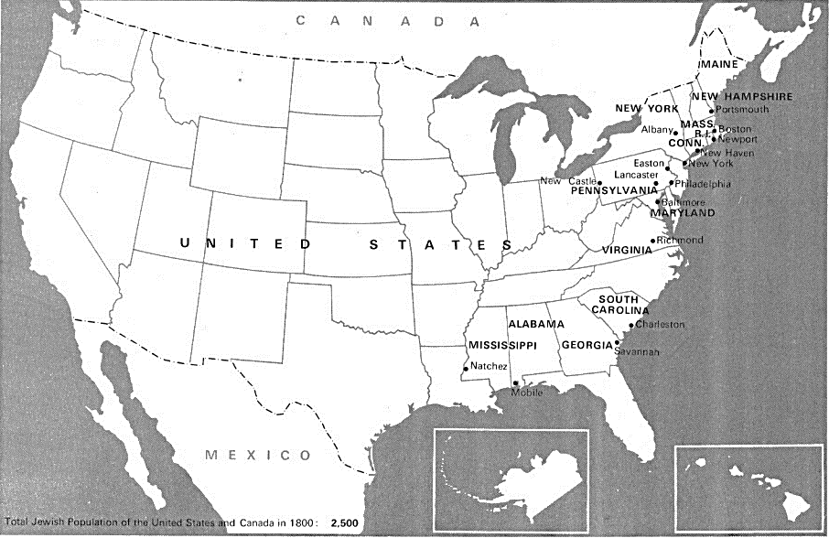
Change in American Jewish population 1800 to 1918

Map of main centers of Jewish population in the U.S. – 1800 according to borders of today
Image from Encylopaedia Judaica, (1971) Vol. 15.

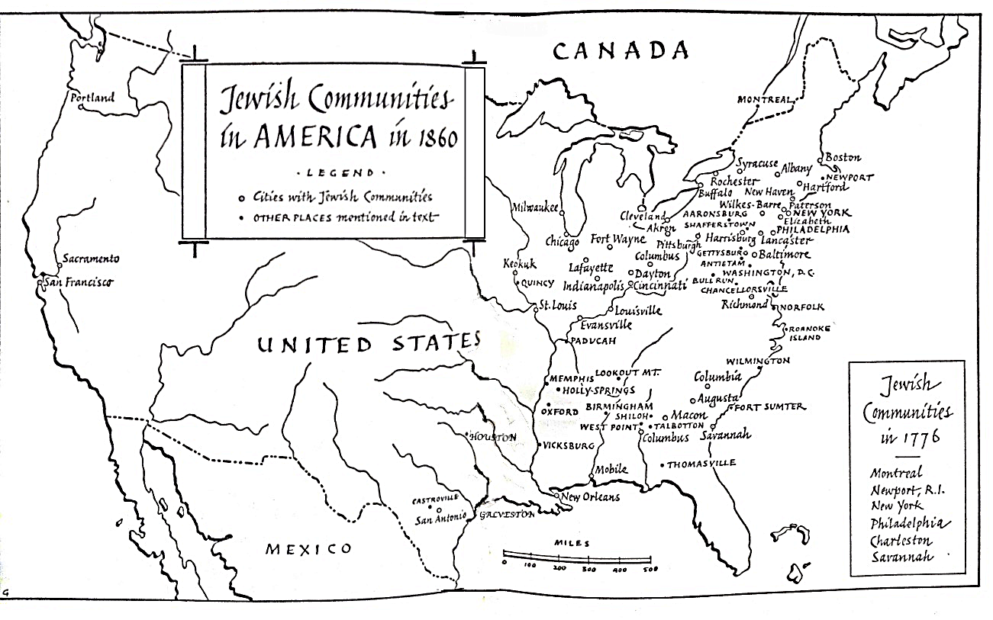

Map of Jewish Communities in America, 1860 (No state boundaries) from The Jews in America, Goldberg 1954

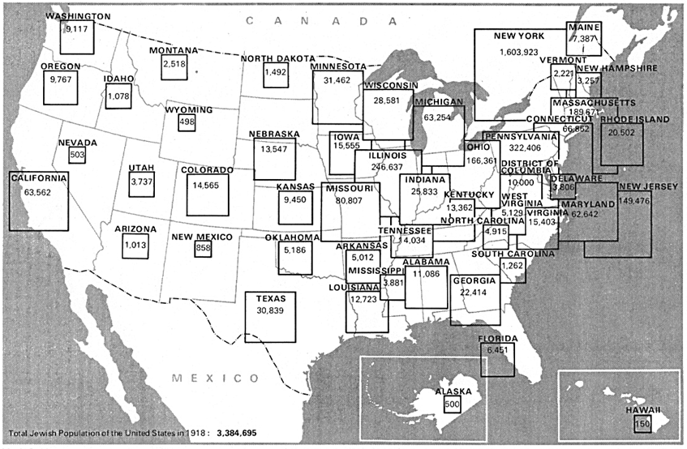

Map of the U.S. indicating Jewish population by state in 1918, according to borders of today
Image from Encylopaedia Judaica, (1971) Vol. 15

APPENDIX D
Moorish Revival Synagogues

America
Adas Israel, Washington, DC
1908: Adas Israel completed a new, larger building at 6th and I Streets, NW. Designed by Baltimore architect Louis Levi, the sanctuary sat 1,600 and featured the Moorish architecture popular at the time. Originally Orthodox, the congregation affiliated with the Conservative movement in 1928.

Adath Israel, Louisville, KY, 1868

Adath Israel, Owensboro, KY 1877
The Moorish Revival facade of the modest building features a gothic-arched door flanked by a pair of gothic-arched windows punctuated by four pilasters. These are surmounted with molded capitals and fanciful embellishments and the whole is topped by a whimsical row of four, small, onion domed turrets.

Adath Jeshurun, New York, NY, 1903

Adath Jeshurun Synagogue, Philadelphia, PA, 1888
Designed by architect J. Franklin Stuckert, the building’s Moorish-revival architecture is typical of early synagogues in Philadelphia. Circles dominate the exterior: Large circular brick and brownstone arch encircles 6 round windows than encircle a keyhole window (horseshoe arched window frames). Initially, two bulbous onion domes sat atop the flanking towers. The southern dome was removed sometime after 1931, during its second ownership. The keyhole windows are used extensively on the façade and are placed on the building in 4 tiers on two sides of the towers, alternating number of windows – 2 on top of three on top of one on top of three.

Adath Yeshurun, Houston, TX 1908

Agudas Achim, San Antonio, TX, 2nd synagogue, built in 1923

Agudath Jacob, Waco, TX, Late 19th early 20th – destroyed after 1913 in storm

Ahavath Joseph, Paterson, NJ, 1889

Ahavath Sholom, Buffalo, NY, 1903 designed by A.E. Minks & Sons

Anshe Chesed/Beth El then Rodeph Sholom, David and John E. Jardine, Lexington Avenue at 63rd Street 1873

Anshe Lubavitz, Buffalo, NY, c. 1890s

Beth El, New York, NY, 1891

Beth El, Corsicana, TX
The synagogue was built by a Reform Jewish congregation in 1898-1900. It is a wood frame building, with clapboard siding, keyhole windows in the front doors, and a pair of octagonal towers topped by onion domes.

Beth Israel Synagogue, Atlantic City, NJ, founded c.1839, built 1881-82

Beth Israel, Boise, ID, 1896 (merged with Ahavath Israel to become Ahavath Beth Israel)

Architectural style is Rundbogenstil and Moorish Revival, General contractor was Judkins & Co.

Beth Israel, Buffalo, NY, c. 1890s

Beth Israel, Clarksdale, MS, 1929
Designed by local architect Robert J. Moor in 1929, the Beth Israel Synagogue (now vacant) is an example of the Moorish style that was popular for synagogues in Mississippi.

Beth Israel 2nd Building, Los Angeles, CA April 13, 1902

Beth Israel, Macon, GA 1890

Beth Israel, Norwalk, CT, 1906
The Moorish Revival style building is the only known synagogue building in Connecticut displaying Moorish onion domes, and an unusual example of an urban wood-frame synagogue. Beth Israel's Orthodox congregation is now known as Beth Israel of Norwalk/Westport and worships in a new building at 40 King Street in Norwalk. The building's design is influenced by that of the 1872 Central Synagogue in New York City, which also has onion domes. While the onion domes are an unusual detail, the architecture is otherwise within usual standards for synagogues in Connecticut. Beth Israel is further the only frame-construction, rather than wood-frame, synagogue in Connecticut of its era.

Beth Israel, Palestine, TX, 1901

Beth Israel, Portland, OR – 2nd building, 1887
Designed by Portland architect Warren H. Williams, the building, is of Moorish Revival design but may be described as a combination of eclectic revival styles. The building has two towers topped by bulbous domes consistent with many Moorish synagogues of the time, which are 165 feet tall. It was located at S.W. 12th and Main streets in downtown Portland. The main interior space measured 82 by 56 feet (and featured an arched ceiling 52 feet high.

Beth Israel, San Diego – 2nd building, 1925.
Throughout the interior and exterior there is evidence of Moorish Revival style, from the three arched doors at the entrance, the onion-shaped arches and the metal grille work, to the domed cupola, which rests above a series of four tiered octagonal drums. Designed by William H. Wheeler.

Beth Israel, San Francisco, CA 1905 – near completion when it was destroyed by the Great Earthquake

Beth Israel, West Hartford, CT
Congregation Beth Israel built the first building to be constructed in Connecticut for use as a synagogue on Charter Oak Avenue. Jewish congregations began to form in Connecticut in 1843 when the General Assembly took action to permit public worship by Jews for the first time. In the 1870s, Beth Israel became the first congregation in the state to have the size and financial strength to build. It would also be the first congregation in the area to transition away from its established Orthodox roots to join the Reform movement when it became affiliated with the Union of American Hebrew Congregations in 1878. Designed by renowned architect George Keller, this building (depicted above, with interior to the right) was dedicated in 1876.

Beth Israel, York, PA, 1907
This synagogue is a Moorish Revival brick building topped with large, copper Onion domes.

Beth Jacob Anshe Shalom, South Third Street, Williamsburg, Brooklyn, 1906
Congregation hired George Pelham to make a replica of Brunner’s 1894 Shaaray Tefila – West End Synagogue.

Beth Tefilloh, Brunswick, Georgia, 1890

B’nai Abraham, Philadelphia, PA

B’nai Brith, Los Angeles, CA

In 1895 the synagogue built their second structure. They started as a small community in1862. Los Angeles was long over-shadowed by San Francisco. Building designed by A.M. Edelman with flanking towers topped with copper onion domes.
B’nai Brith Jacob, Savannah, GA, 1909
The architect was Hyman Witcover, design on based loosely on the New York’s Central Synagogue.

B’nai Israel, Baltimore, MD
It is noted for its Moorish Revival architecture. The elaborate ark is carved wood, highlighted by a pair of tall minarets.
The congregation was founded in 1873, by a group who separated from the Baltimore Hebrew Congregation because their policies became too liberal. The present building was erected in 1876. It was later sold in 1895 to the B'nai Israel ("Sons of Israel") a congregation which was chartered as a Russian Congregation. B'nai Israel is now one of two synagogues in the collection of the Jewish Museum of Maryland. Its large central window, stained glass, and interior sanctuary are heavily influenced by Eastern Mediterranean and Byzantine architecture. The sanctuary’s original ceiling frescoes were inspired by those in European churches and remain intact, as does the ark in the central sanctuary.

B’nai Israel, Butte, MT, 1903

B'nai Jeshurun, Newark, NJ, 1868

B’nai Jeshurun – (Barnert Temple), Paterson, NJ, 1894
This was a towered Moorish building used until 1964 – interior featured stain glass windows and organ.

B’nai Sholom, Brookhaven, MS, 1896
The white clapboard building is notable for its Moorish Revival Horseshoe arch windows and for a truncated tower that "references the porthole of an Islamic minaret" with a slender Horseshoe arch window.

B’nai Sholom, Quincy, IL
It was built in 1870 in the Moorish Revival style. The original, 80 foot high, twin minaret-style towers were damaged by a tornado in 1947 and not replaced.

Bush Street Temple (Ohabai Shalome), San Francisco, CA, 1895
The building was built in 1895 in a Moorish Revival-Venetian style designed by Moses J. Lyon. The arches across the front are copied form the Doge's Palace. It was extensively renovated in 2003, at which time it was joined to a new adjacent structure. The building is constructed almost entirely of redwood. Originally, much of the interior was painted in Trompe l'oeil to resemble marble. In its original configuration it featured a pair of elaborate towers, since lost.

Charter Oak Temple (Congregation Beth Israel), Hartford, CT, 1876
High Victorian eclectic including Moorish elements including three distinct motifs of flower designs, the most recent from about 1910, and the earliest echoing a Moorish style of vines and lotus blossoms that was used by many middle and late 19th-century synagogue designers to celebrate the Middle Eastern roots of Judaism. Congregation made up mostly of German immigrants. The building, designed by the Hartford architect George Keller.

Chizuk Amuno, Baltimore, MD, 1876
Designed by architect Henry Burge, this synagogue was actually commissioned by Russian Jews in reaction to the reforms of the Lloyd Street Synagogue. Although membership was Eastern European, the synagogue was located in a German Jewish neighborhood. The interior is relatively unadorned with the focal point being an ornate Oriental Ark that dominates the apse on the eastern wall.

Central Synagogue, New York, NY, 1872
The Central Synagogue (Congregation Ahavath Chesed) is built in the Moorish Revival style and closely copies Budapest's Dohány Street Synagogue. It has been in continuous use longer than any other in the city. The building was designed by Henry Fernbach.
Congregation Albert, Albuquerque, NM, 1897
In April 1900 Congregation Albert's first building was dedicated on West Gold Avenue (at the northeast corner of its intersection with 7th Street), with an onion-shaped oriental dome, pitched roof, and twin staircases leading to a second-story entrance
Congregation Beth Israel, Meridian, MS, 1879
The congregation's first permanent house of worship was a Middle Eastern-style building constructed in 1879.

Congregation Rodeph Shalom, Philadelphia, PA, 1928

Congregation Talmud Torah, 67 E Street, SW, Washington, DC, 1907
Byzantine-Moorish design.

Eldridge Street Synagogue, New York, NY, 1887
The Architects for this synagogue were Peter and Francis William Herter, who chose the Architectural style Moorish Revival. This was one of the first synagogues built by Eastern European Jews in America. It is rare that they chose to use Moorish revival because this style was overwhelmingly used by German, Reform congregations. It was noted at the time it was erected for its 70 foot high vaulted ceiling, stained-glass rose window, elaborate brass fixtures and hand stenciled walls. After years of disintegration, the building underwent a 24 year long renovation, and now serves as a synagogue and a museum.

Eutaw Place, Baltimore, MD, 1892
Eutaw Place Temple is a large, eclectically-styled former synagogue on Eutaw Place in the Bolton Hill neighborhood of Baltimore, Maryland. This synagogue was the second building constructed for the German Jewish immigrant congregation of Oheb Shalom 1892. It borrows design elements from the Great Synagogue of Florence. The architect was Joseph Evans Sperry of Baltimore.

Gemiluth Chessed (Acts of Loving Kindness,) Port Gibson, MS 1892
This Moorish Revival synagogue is the oldest surviving synagogue in the state and the only building of this architectural style. It was built by a community of Jewish immigrants from German states and Alsace-Lorraine.
Hebrew Benevolent Congregation (now The Temple), Atlanta, GA, 1875

Isaac M. Wise Temple, Cincinnati, OH
The Isaac M. Wise Temple (formerly the Plum Street Temple) is the historic synagogue erected for Rabbi Isaac Mayer Wise and his congregation in Cincinnati, Ohio. Wise was the founder of American Reform Judaism. The temple building was designed by prominent Cincinnati architect James Keys Wilson. Its design was inspired by
the Alhambra at Granada. Temple was dedicated on Friday, August 24, 1866.

Keneseth Israel, Louisville, KY, 1901
The earliest building was a former church. In 1901, the congregation, then B'nai Israel, dedicated a new building on the site of the former church building at 432 E. Jefferson Street. The building has twin towers with pyramid-form roofs and was strongly stripped in red-and-white in the Moorish Revival style then fashionable for synagogues. For most of its history, Keneseth Israel was an Orthodox synagogue affiliated with the Union of Orthodox Jewish Congregations of America. In 1994, its members voted to affiliate with the United Synagogue of Conservative Judaism.

Kol Israel Anshe Poland, New York, NY, Schneider and Herter, 1892

Moses Montefiore Congregation, Bloomington, IL, 1889
In 1889 the congregation dedicated a Moorish Revival synagogue building at the southeast corner of Monroe and Prairie Streets.

Ohab Zedek, New York, NY, 1926
Building was noted for its Moorish Revival architecture. Designed by architect Charles B. Myers, the interior features magnificent Mudéjar style plasterwork. (Earlier Moorish building on Henry Street, no information on it).

Ohabai Sholom, Nashville, Tennessee
In 1874 dedicated the striking, Moorish Revival Vine Street Temple. In 1873 the congregation was one of the founding members of the Union of American Hebrew Congregations, now the Union for Reform Judaism.

Ohabei Shalom, Brookline, Massachusetts, 1925
The congregation’s present building, is a combination of Byzantine Revival and Moorish Revival styles. The sanctuary seats 1,800. The original plans for the building called for a tall minaret, although the building was constructed without this detail. The sanctuary was modeled on Hagia Sophia

Park East Synagogue, New York, NY, 1890
Congregation Zichron Ephraim was established by Rabbi Bernard Drachman and Jonas Weil to promote Orthodox Judaism as an alternative to Reform Judaism popular on the Upper East Side. The architects were Schneider and Herter who designed numerous tenements on New York's Lower East Side as well as Hell's Kitchen neighborhoods. The building is similar to other synagogues built at the time which were in the Moorish Revival style that also featured a prominent Rose Window. One of the most remarkable characteristics is the asymmetrical twin towers with the eastern tower being taller (most other synagogues of the period featured twin towers of similar height). The towers are also adorned differently. Each of the towers originally were also topped by a bulbous dome which have since been removed: It is one of fewer than a hundred surviving nineteenth-century American synagogues. Architectural style is combination of Byzantine Revival, Moorish Revival, and Romanesque Revival.

Prince Street Synagogue/Oheb Shalom, Newark, NJ, 1884, 1884
The Oheb Shalom, a congregation of Bohemian Jews, built this Moorish Revival building in 1884. The synagogue features windows with Horseshoe arches, an entrance arch with red and white Voussoirs, and twin towers topped by modest domes.

Rodeph Shalom, Philadelphia, PA, 1927
The congregation was founded in 1795, and is the oldest Ashkenazic synagogue in the Western Hemisphere. It is noted historically for its leadership of the Reform movement among American Hebrew congregations, for its spiritual influence upon international Jewry, and for its unique 1927 Moorish Revival building on North Broad Street.

Shaare Emeth Congregation, 1878, St. Louis, MO, 1878

Shaaray Tefila, Henry Fernbach, 127 West 44th Street 1868 – 1869

Shaaray Tefila, West End Synagogue, Arnold Brunner, 160 W. 82nd Street, 1894

Shaarey Tefiloh, Perth Amboy, NJ, no record of dedication date

Shaare Zedek, Michael Bernstein, 25 W. 118th Street 1900

Sinai Temple (2nd Building, New Hampshire Ave), Los Angeles, 1925

Sixth & I Historic Synagogue, Washington, DC, 1908
The building was designed by Louis Levy and incorporates stylistic elements from Moorish Revival, Byzantine Revival, and Romanesque architectures.

Talmud Torah, Washington, DC, 1887, 1906
Architect Isaac Hamilton Rapp designed it in a Moorish Revival style, with stained-glass windows and an onion dome.

Temple Beth-El, San Antonio, Texas, 1927
Originally founded in 1874, it is the oldest synagogue in South Texas.

Temple Emanu-El on Pearl Street in Denver, CO, is a building that was built in 1898–1899 and expanded in 1924

Temple Emanu-El, Birmingham, Alabama, 1889
Opening of railroad into central AL led to formation of new town of Birmingham in 1871. Synagogue built by 85 members at 5th Ave and 17th St. N. Jews were involved in Iron Technology and became very wealthy. As wealth grew and more immigrants arrived Jews split into various neighborhoods and built other synagogues. Knesseth Israel built by Russians at end of century. Emanu-el started as Orthodox but dedicated as Reform.

Temple Emanu-El, Dallas, TX, 1876
In 1874, forty members of the Hebrew Benevolent Association founded Congregation Emanu-El. At their first meeting, the members of the society voted find a site and build a synagogue. The members of Emanu-El acted quickly, constructing a synagogue in 1876 on land owned by the B’nai B’rith lodge. The Moorish revival synagogue project included classrooms and a meeting space for local Jewish lodges.

Temple Emanu-El, Denver, CO, 1898 - 1899 with a large addition in 1924
Temple Emanuel is reportedly the only Moorish- and Turkish-Revival style synagogue in Colorado. The architect was John J. Humphreys. The original facade includes the raised entrance and two Turkish-style towers. The synagogue was constructed using simple buff brick, but laid with a projecting horizontal stripe pattern at the front façade.

Temple Emanu-El, New York, NY, 1868
The fourth building - By 1868, the congregation had built a permanent structure on Fifth Avenue and 43rd Street, designed by Leopold Eidlitz and Henry Fernbach. At that time, Temple Emanu-El was the largest synagogue building in the United States.

Temple Emanu-El, Helena, MT, 1890
Construction of the temple began in 1890, and was completed in 1891. Architects Heinlein and Mathias used granite, porphyry and sandstone in the construction to create the building, which could hold as many as 500 people. It is built in Neo-Romanesque style with Moorish influence keyhole windows and stained glass. The original building also featured a 30-foot high ceiling in the sanctuary and keeping with Moorish Revival design, two large onion domes which capped the towers that flank the front entrance.

Temple Emanu-El, San Francisco, 1866
San Francisco’s Jews were predominantly from Germany and Central Europe. They formed Congregation Emanu-El in 1850. This community prospered through the second half of the century and eventually built a magnificent synagogue which was designed by the British architect, William Paxton. Twin towers, capped by bronze-plated bulbous domes, rose 176 feet into the sky, flanking the entry. The building accommodated 1,200 people, which made it the third largest in America. The building withstood the severe earthquakes of 1868 and 1906, but the interior was destroyed by the fire, in the wake of the 1906 quake. It was one of the first Moorish Revival synagogues in the United States.

Temple Emanu-El, Spokane, WA, 1892
In 1890, the Jewish community met to organize a Reform congregation, called Congregation Emanu-El. On September 14, 1892, they dedicated their synagogue, Temple Emanu-El, the first in the state by four days, since Seattle's Ohaveth Sholom opened within a week. The architect was Herman Preusse.

Temple House of Israel, Staunton, Virginia, 1925
In 1925 the congregation constructed its current building at 115 North Market Street a contributing property to the Gospel Hill historic district. The Moorish Revival structure was designed by Sam Collins of T.J. Collins and son, and includes Mercer tiles, and windows and a glass screen by Charles Connick of Boston.

Temple Israel, Children of Israel Synagogue, Memphis, TN, 1884

Temple Israel, Minneapolis, 1878
The congregation was founded in 1878 as an Orthodox congregation known as Shaarai Tov. In 1880, the congregation built its first building; a small, wooden synagogue in the popular Moorish Revival style at 5th Street and Marquette Avenue. In 1888, the congregation moved the building to the corner of 10th Street and 5th Avenue South. When the synagogue burned down in 1902, the congregants erected a new synagogue in stone on the site of the lost building. The congregation became Reform and in 1920 renamed itself Temple Israel.

Temple Israel, Paducah, KY, 1884
Paducah's elaborate, Moorish Revival Temple was built in 1893 on the corner of Broadway and 7th Street. The architect was Brinton B. Davis. Rabbi Morris Ungerleider is often credited with providing the inspiration for Moorish Revival architecture. The building featured a central tower and a pair of minarets, all three topped with large onion domes which were removed in the early 1930s. There was an oriel window on the front of the tower, and three tiers of horseshoe windows. The front entrance featured a tripartite, columned, horseshoe-arched doorway topped by a tripartite tier of horseshoe windows. This synagogue building was torn down in 1963.

Temple of Israel, Wilmington, NC, 1876
The Temple of Israel's architecture is a combination of Greek Revival and Moorish styles. The Moorish architecture is unique in the city of Wilmington, but was common during late 19th century for many American synagogues. The synagogue features horseshoe arches and twin towers topped with golden onion domes.

Temple Mount Sinai, El Paso, 1899

Temple Sinai, Chicago, IL, 1876
Synagogue was designed by Dankmar Adler and Edward Burling. The interior stenciled wall decoration is said to have been developed by Louis Sullivan.

Temple Sinai, New Orleans, LA, 1872
Temple Sinai was founded in 1870 by German and Alsatian Jews. By 1872, this building, its first, had been completed. It was located on Carondelet, just off of Tivoli Circle. It is the oldest Reform congregation in Louisiana and, also, the largest. It had two towers flanking the central entrance, similar in style to Emanu-El’s 43rd Street Building in New York City.

Temple Shalom, (Eoff Street Temple), Wheeling, West Virginia, 1892
This elaborate Moorish Revival synagogue was dedicated in April 1892. The building featured a dome, a keyhole door and elaborate keyhole windows. The Eoff Street Temple structure no longer stands.

Temple Sholom, Chicago, IL, 1921-28
The current building's design began as a 1921 assignment given to three students at the School of Architecture at the Armour Institute (now the Illinois Institute of Technology). By 1928, with the assistance of professional architects Charles Hodgson of Chicago and Charles A. Coolidge of Boston, the Byzantine Revival and Moorish Revival structure was completed.

Temple Sinai, Sumter, SC, 1912
Built in 1912 of brick in the Moorish Revival style. With the exception of one round window high over the entrance portico, the windows are uniformly five feet wide by twenty feet high and in their shape mimic the castellated domed Moorish towers that flank the entrance.

Temple Tifereth Israel (The Temple), Cleveland, OH, 1924
Charles R. Greco, architect – “Saracen Mooresque" (Mosque like architecture

The Temple, Atlanta, GA, 1875
Congregation established by German Jews in 1860. Second building, used between 1875 and 1902 was Moorish Revival.

Washington Hebrew, Washington, DC, 1897
Washington Hebrew built an impressive new structure on the site of its original synagogue near 8th and I Streets, NW. Constructed of rough-hewn bricks, the building has two towers flanking the entry, upon which rests domed cupolas. Designed by Louis F. Stutz and Frank W. Pease.

Young Israel of Flatbush, Brooklyn, NY, 1925-29
Moorish-inspired style building faced in polychromatic patterned brick. It features horseshoe arches, minarets, and polychromatic tiles.

Zichron Ephraim – Park East Synagogue, New York, NY, 1889-1890
Ernest Schneider and Henry Herter were the architects of this elaborate Moorish creation with two towers of differing heights and a decorative façade.

Zion Temple, Chicago, IL, 1885
In the early 1880s Adler & Sullivan designed Chicago's Zion Temple dedicated on September 5, 1885. This original plans drew inspiration from the Mole Antonelliana in Turin, Italy and combined the monumental nature of that structure with the two tower archetype familiar in the United States. However, the final plan eliminated the towers, leaving the building with a squat appearance with a highly stylized, front window that only added to the heavy feeling of the synagogue. Demolished in 1950.

Unknown Names
Synagogue in Houston, Texas dated 1908

Argentina

Sephardic Temple, Barracas district, Buenos Aires, Argentina

Austria

Leopoldstädter Tempel , Vienna, Austria, 1858
It was built in 1858 in a Moorish Revival style by the architect Ludwig Förster. The tripartite facade of the Leopoldstädter with its tall central section flanked by lower wings on each side became the model for numerous Moorish Revival synagogues, including the Zagreb Synagogue, the Spanish Synagogue in Prague, the Tempel Synagogue in Kraków and Templul Coral in Bucharest.

Austro-Hungary

Bratislava Synagogue, Bratislava (now Slovakia) 1895, architect Dezso Milch

Czernowitz Synagogue, Czernowitz, Austria-Hungary today Chernivtsi, Ukraine, 1873, closed in 1940
It was a domed, Moorish Revival synagogue built in 1873. The original building was designed by architect Julian Zachariewicz.

Hlohovec Synagogue, Hlohovec, (now Slovakia)

Tranava Synagogue, Tranava (now Slovakia), 1897

Uzhgorod Synagogue, Uzhgorod, Carpathian Ruthenia region (now the Ukraine), 1904 The building was designed by the architects Gyula Papp and Ferencs Szabolcs in a flamboyant Romantic style, boldly intermingling Byzantine and Moorish elements.

Vrbove Synagogue, Vrbove (now Slovakia) 1883

Belgium

Liege Synagogue, Liege, Belgium, 1899
The architecture of this building was Joseph Remont. His design combines elements of Islamic styles, with those of Roman and Romanesque Lombard influence. The main facade of the synagogue is representative of neoclassical architecture during the second half of the 19th century. It is mainly characterized by a white stone alternating bands of red and freestone and it has two towers topped with ovoid domes. The interior of the building features extensive space for worship.

Shomre Hadass Synagogue, (Hollandse or Dutch Synagogue), Antwerp, Belgium, 1893
Synagogue was designed by Joseph Hertogs and Ernest Stordiau and was opened in 1893. It was modeled loosely on earlier domed and turreted Moorish style synagogues. The building is so named because it was commissioned by descendants of Jews who came to Antwerp from the Netherlands in the early 19th century. It was the first large synagogue in Antwerp.

Bosnia

Sarajevo Synagogue, Bosnia, 1902
An Ashkenazi synagogue, seen in the photo to the right, was built in 1902 in an elaborate Moorish Revival style. Designed by Karel Pařík, its highly decorated neo-Moorish style was a popular choice for synagogues in the Austro-Hungarian Empire. The synagogue has enormous arches with richly-painted decorations. The high, ornate ceiling was highlighted by a ten-pointed star.

Bulgaria

The Sofia Synagogue (Bulgaria) 1909
This is the largest synagogue in Southeastern Europe, one of two functioning in Bulgaria (with the one in Plovdiv) and the third-largest in Europe. Constructed for the needs of the Bulgarian capital which is mainly a Sephardic Jewish community. The design is after a project by the Austrian architect Friedrich Grünanger, and it resembles the old Moorish Leopoldstädter Tempel in Vienna. The synagogue officially opened on 9 September 1909 in the presence of Tsar Ferdinand I of Bulgaria. The architectural style is essentially Moorish Revival, with elements of the Vienna Secession and, with elements of Venetian architecture in the facade.

Canada

Adath Jeshurun, Ottowa, Ontario, Canada 1904

Anshe Sholom, Hamilton, Ontario, Canada, 1882

Congregation Shaar Hashomayim, Montreal, Canada, 1885-86
Synagogue was built on McGill College Avenue and was the second building of the congregation. It was used until 1922, when they moved again.

Holy Blossom Temple, Toronto, Canada, 1900
Second building for congregation designed in Moorish-Byzantine style with flanking towers and onion domes.

Croatia

Slavonski Brod Synagogue, Croatia, 1896, Destroyed in 1941
Slavonski Brod Synagogue was built under Jakob Kohn, the president of the Jewish Community of Slavonski Brod, in the 1896 by Hönigsberg & Deutsch architecture studio. At the time Jewish Community counted over 110 members. The synagogue was burned by Nazis in 1941, and remains were bombed by allied forces during the bombing of in 1944.

Vukovar Synagogue, Croatia, 1889
Architect Ludwig Schöne built the Great Vukovar Synagogue for over 200 members of the Vukovar Jewish community.

Zagreb Synagogue, Zabreb, Croatia, 1867, demolished 1941
This was the main place of worship for the Jewish community of Zagreb in modern-day Croatia, from its construction in 1867 in the Kingdom of Croatia-Slavonia within the Austrian Empire, until its demolition by the fascist authorities in 1941 in the Axis-aligned Independent State of Croatia.
The Moorish Revival synagogue was located on modern-day Praška Street and has been the only purpose-built Jewish house of worship in the history of the city. It was one of the city's most prominent public buildings, as well as one of the most esteemed examples of synagogue architecture in the region.

Czech Republic

Caslav Synagogue, Caslav, Czech Republic 1899
Third synagogue designed by Wilhelm Stiassny (He also designed the Jubilee Synagogue in Prague and Malacky in Slovakia).

Great Synagogue of Plzeň, Pilsen, Czech Republic, 1893
Emmanuel Klotz put forward a new design that retained the original ground plan of the older synagogue and created the distinctive look that combined the Romantic and neo-Renaissance styles, which were then covered with Oriental decorations and a giant Star of David. At the time the Jewish community in Plzeň numbered some 2,000. The mixture of styles is a curiousity; from the onion domes of a Russian orthodox church, to the Arabic style ceiling, to the distinctly Indian looking Aron Kodesh.

Jubilee Synagogue, Prague, Czech Republic, 1906
It is also known as the Jerusalem Synagogue because of its location on Jerusalem Street. It was built in 1906, designed by Wilhelm Stiassny and named in honor of the silver Jubilee of Emperor Franz Joseph I of Austria. The synagogue is designed in Moorish Revival form with Art Nouveau decoration, especially in the interior. Since Czechoslovakia became independent in 1918, it has been called the Jerusalem Synagogue as the name Jubilee Synagogue referred to the anniversary of the rule of Franz Joseph I in the defeated Austro-Hungarian Monarchy. The facade and form of the synagogue are a hybridized blend of Moorish Revival and art nouveau, with Horseshoe arches on the facade and on the interior columns supporting the women's galleries in a three-bay building. The Mudéjar red-and-white coursing of the stone facade is particularly striking. Inside, the Moorish elements are overlaid with brilliantly painted Art nouveau patterning.

Litomysl Synagogue, Litomysl, Czech Republic, 1909-1910, demolished 1968
This was a Neo-Romanesque-Moorish synagogue designed by Cenek Vanek. The building featured a nave and two towers with onion domes.

Opava Synagogue, Czech Republic, 1895

Olomouc Synagogue, Olomouc, Czech Republic, 1897
Designed by Jakob Gartner, the edifice was one of the biggest and finest synagogues in Czechoslovakia. On the night of March 15-16, 1939, the synagogue was attacked and burned to ashes.

Spanish Synagogue, Prague, Czech Republic, 1868
A Moorish Revival synagogue built in Prague in 1868 to the design of Vojtěch Ignátz Ullmann. The facade copies the form of the Leopoldstädter Tempel, built in Vienna, Austria, in 1853, a tripartite facade with a tall central section flanked by lower wings on each side. As in Vienna, the central section is topped by a pair of domed turrets. The synagogue is most remarkable for the elaborate style of the interior, every surface is covered by elaborate Islamic-style polychrome and gilded patterns, some painted and some carved or molded.
Despite its name, the synagogue was never used by a Spanish or Sephardic congregation: it was in fact an early Reform temple. There are two theories to account for the synagogue's name. The Moorish architectural style may have been found reminiscent of the Golden age of Jewish culture in Spain.

England

Bournemouth Hebrew Congregation, Bournemouth, England, 1911
The squat tower with its square dome and interlocking window arcade give the entrance a different look. The Horseshoe arched windows to the left are also part of the original facade.

Bradford Reform Synagogue, Bradford, England, 1884
Bradford Reform Synagogue (Bradford, England) cornerstone laid 1880. Moorish Victorian architecture, oldest reform synagogue outside of London.

Brondesbury Synagogue, Brondesbury, England, 1904-05, designed by Frederick Mark

New West End Synagogue, London, England, 1877-79, designed by W. and G. Ardsley with N.S. Joseph
Designed in Gothic-Moorish style.
Princes Road Synagogue, Liverpool, England, 1874
Located in Toxteth, Liverpool in England, this synagogue was built by the Liverpool Old Hebrew Congregation. It was designed by William James Audsley and George Ashdown Audsley and consecrated on September 2, 1874. It is considered one of the finest example of the Moorish Revival style of synagogue architecture in Great Britain.

Reading Synagogue, Reading, England, 1900
Designed by William G. Lewton.

Southend and Westcliff Synagogue, Westcliff-on-Sea, England, 1911-12 by Parks and Evans

Spanish and Portuguese Synagogue on Cheetham Hill Road in Manchester, England (now Manchester Jewish Museum) Manchester, England (SEPHARDIC)
The synagogue was completed in 1874 but the building became useless with the migration of the Jewish population away from the Cheetham area. The synagogue was built in the Moorish Revival style by the noted Manchester architect Edward Salomons, who was of German Ashkenazic descent. The two tiers of horseshoe windows on the facade are emblematic of the style, and the recessed doorway and arcade of five windows on the floor above the entrance are particularly decorative. Inside, a horseshoe arches and polychrome columns support the galleries. The Synagogue is currently a Jewish Museum whose permanent collection documents the history of Manchester Jewry, while special exhibitions often focus on the cultural diversity of present day Cheetham.

West London Synagogue, England, 1870
Its current building in Upper Berkeley Street dates from 1870, making it the oldest standing Reform synagogue, and one of the oldest synagogues, in the United Kingdom. It is of Neo-Byzantine/Moorish design.

France

La Ferte-sous-Jouarre Synagogue, France, 1891
Built in 1890, inaugurated in 1891. Plans are by Edmond Fauvet, a city architect, and built by Mr. Picard, a Fertois entrepreneur who realized this synagogue’s architecture was clearly inspired by the Orient. The work was funded by the Alsatian Jews established in the region. Inside is an oblong room surrounded by grandstands, but the building no longer is used as a synagogue. It is currently used as a gallery.

Synagogue of Besançon, Besancon, France, 1869
This synagogue was built in 1869 after an Imperial Decree dated 22 May 1867 authorized the community to acquire land on the Quai Napoléon. The community then entrusted the local architect Pierre Marnotte with the commission to design a building according to Moroccan style.

Synagogue of Chalons-sur Marne, France, 1874 - 1875
Chalons synagogue was built between 1874 and 1875 using the plans of local architect Alexis Vagny and opened in September 1875. It is all white stone with Moorish style detailing including horseshoe arched entrance set in an alfez and multi-lobed arches over the second floor windows.

Synagogue of Epernay, Epernay, France, 1889-1890
The synagogue was built in 1889-1890 by architect Henry Clouet. This synagogue is a fusion of Neo-Byzantine with Moorish elements specifically seen in the design of the windows which feature horseshoe arches, multi-lobed arches and ajinez windows (twin windows separated by slim mullion).

Synagogue of Reims, Reims, France, 1879
Ernest Brunette was the architect, decoration by Brand-Fogel, a local artist. The synagogue was built in 1879 in Moorish spirit. The building has an eclectic style, which is a result of a movement initiated in 1852 with the construction of the synagogue in the rue Notre Dame de Nazareth in Paris in a Roman-Byzantine style. The synagogue in Reims more particularly illustrates the taste for Orientalism than Paris, and is similar in feeling to the synagogues in Verdun and Chalons.

Synagogue of Verdun, Verdun, France, 1873 to 1875
Designed by architect Henri Mazilier, on the site of a former convent. His style is characterized by the polychrome materials (limestone and brick), the use of horseshoe arches and fretted barricades. There are no side openings, but glazed sections in the roof allow some light into the building. These sections are supported by columns.

Galicia

Myslenice Synagogue, Galica (now Poland), 1910

Germany

Aachen Synagogue, Aachen, Germany, 1862, destroyed November 9-10, 1938

Bochum Synagogue, Bochum, Germany, 1863, destroyed November 9- 10, 1938

Bochum Synagogue, Bochum, Germany, 1863, destroyed November 9-10, 1938

Bruchsal Synagogue, Bruchsal, Germany, 1881, destroyed November 9-10, 1938

Darmstadt Synagogue, Darmstadt, Germany destroyed November 9-10, 1938

Delme Synagogue, Delme, Germany, 1881, partially destroyed during WWII, rebuilt with smaller dome and without small cupolas in 1946.

Dresden Synagogue (Semper Synagogue), Dresden, Germany, 1838-40, Destroyed November 9-10, 1938
Synagogue was built in 1838-40 for the Jewish community of Dresden by Gottfried Semper. It was an early example of the Moorish Revival style of synagogue architecture. While the exterior was Romanesque, its interior featured the richly ornamented style that was to become the hallmark of Moorish Revival architecture. The elaborate Arabic-style interior had a two-tiered balcony supported by columns copied from the Alhambra. The arches and balcony fronts were richly worked with intricate polychrome foliate and lattice designs in the Moorish style.

Frankfurt Hauptsynagogue, Germany, 1855-60, destroyed November 9-10, 1938
This synagogue was the spiritual center of Reform Judaism in Frankfurt until it was destroyed during the Kristallnacht under the Nazis. It was designed by Johann Georg Kayser with Moorish and Byzantine elements. It was within the Jewish neighborhood of Börnestraße.

Glockengasse Synagogue, Cologne, Germany, 1861, destroyed November 10, 1938
The Glockengasse Synagogue was Cologne and it was built according to the plans of the architect of the Cologne Cathedral, Ernst Friedrich Zwirner.

Great Synagogue of Efurt, Efurt Germany, 1884, destroyed November 9-10, 1938
This was a Moorish Revival synagogue designed by Siegfried Kusnitzky. This was constructed of red brick, held 500 people, and was decorated with hand stenciled walls.

Great Synagogue of Nuremberg, Nuremberg, Germany, 1874, demolished August 1938
The Great Synagogue was built according the plans of noted architect Adolf Wolff. Wolff built the synagogue on Hans-Sachs-Platz, according to an almost square plan. The design was of a Moorish style, and featured a dome so high it was visible from afar. There were two smaller domes on the front corners of the roof that framed the larger dome. A porch built in sandstone led to a balustrade, which led to the main entrance. Above the entry was a rosette set within a large horseshoe arch above five keyhole windows. The interior featured a colonnade with oriental capitals, which supported the women’s gallery. The entire synagogue was ornamented with polychrome decorations, which contrasted with the stark white and gold ark. The rose window was filled with stained-glass.

Great Synagogue of Wiesbaden, Wiesbaden, Germany, 1869, destroyed November 9-10, 1938

Heilbronn Synagogue, Heilbronn, Germany, 1873, destroyed November 9-10, 1938
Synagogue was designed by architect Adolf Wolff. The synagogue was built in the Moorish style with horseshoe arches and the decorative stalactites of Mudejar architecture. On the roof, above the transept was a cylindrical drum with twelve windows which brought light into the synagogue. Atop the drum sat the central dome covered in copper finished in a green patina. Four small domes were located on each corner of the roof. The abundance of domes was reminiscent of the architecture of Persian or of the Taj Mahal.

Kaiserslautern Synagogue, Kaiserslautern, Germany 1886, destroyed on November 9-10, 1938
This synagogue, of Moorish-Byzantine style, was designed by Ludwig Levy from Karlsruhe. They design used a Greek key floor plan placing a bulbous dome upon a large drum. The façade features a large horseshoe arch which encloses a rosette and a tripartite portal. The building featured many small windows that were both decorative and served to light the interior.

Leipzig synagogue, Leipzig, Germany, 1855, destroyed November 9-10, 1938
The ornate Moorish Revival Leipzig synagogue in Leipzig, Saxony, Germany, was built by German Jewish architect Otto Simonson who had studied under Gottfried Semper. The synagogue was commissioned by the small Leipzig Jewish community and by Jewish merchants from throughout Europe who gathered for the annual Leipzig Trade Fair. The interior featured horseshoe arches, an Aron Kodesh in the style of a mihrab, and a pulpit in the style of a mimbar. Because so many businessmen gathered in Leipzig for the fairs, the synagogue is thought to have influenced the decision to build Moorish revival synagogues in other cities.

Munich synagogue, Munich, Germany, 1832, destroyed November 10, 1938
Designed by Friedrich von Gärtner, 1832 was one of the earliest Moorish revival synagogue.

Neue Synagoge (Oranienburgerstraße Synagogue), Berlin, 1859-1866, Survived Kristallnacht
Built 1859–1866 as the main synagogue of the Berlin Jewish community, on Oranienburger Straße. Because of its splendid eastern Moorish style and resemblance to the Alhambra, it is an important architectural monument of the second half of the 19th century in Berlin.
The building was designed by Eduard Knoblauch. Following Knoblauch's death in 1865, Friedrich August Stüler took responsibility for the majority of its construction as well as for its interior arrangement and design.
From 1988 to 1993, the structurally intact parts of the building close to the street, including the façade, the dome, and some rooms behind were restored as the "Centrum Judaicum", (a museum and archive), the main sanctuary was not restored. In May 1995, a small synagogue congregation was reestablished using the former women's wardrobe room.

New Synagogue, Gleiwitz, Germany (today Gliwice, Poland), 1859-1861, destroyed November 9-10, 1938
It was designed by Salomon Lubowski and Louis Troplowitz.

Stuttgart Synagogue, Stuttgart, Germany, 1859 to 1861, destroyed November 9-10, 1938
Synagogue was built in the Moorish style and was elaborately decorated on the interior.

Synagogue of Pforzhiem, Phforzheim, Germany, 1892, destroyed on November 9-10, 1938
This synagogue was built in the Gothic-Moorish style, and served as a model for the synagogue in Wuppertal-Barmen. The synagogue was built according to the plans Ludwig Levy of Karlsruhe. The synagogue in Pforzheim was typical of the synagogue late neo-Islamic style, with its dome and walls of red sandstone brick with strips of green bricks alternately to form colored stripes. The eastern wall had an apse that held the Ark. There was a large door on the western side in the shape of a horseshoe and a crenellated cornice according to Moorish style. Because of orientation on the lot, Levy chose the South façade as the front and it featured a huge window with three doorways, with bricks of two colors drawing a horseshoe.
The Star of David atop the dome and the Act tables stylized with the beginning of the Ten Commandments in letters Hebrew, above the entrance to the Southwest corner tower building to identify outside a synagogue.

Georgia

Batumi Synagogue, Batumi, Adjara, Georgia, 1904
This synagogue was built by Semyon Vulkovich.

Hungary

Debrecen Synagogue, Debrecen, Hungary, 1895-97, destroyed by fire 1948 The synagogue was designed by Jacob Gartner (see Olomouc).

Dohány Street Synagogue, Budapest, Hungary, 1854-1859
It is the largest synagogue in Europe and one of the largest in the world. The synagogue seats 3,000 people and is a center of Neolog Judaism a Hungarian variation more closely aligned with Conservative Judaism, which developed at the same time Reform was evolving in Germany. The synagogue was built between 1854 and 1859 in the Moorish Revival style. Designed by Viennese architect, Ludwig Förster. He believed that no distinctively Jewish architecture could be identified, and thus chose architectural forms that have been used by oriental ethnic groups that are related to the Israelite people, and including the Arabs. Islamic motifs decorate the synagogue inspired by those found in North Africa and medieval Spain (the Alhambra). The interior design is partly by Frigyes Feszl.

Malacky synagogue, Malacky, Hungary (now Slovakia), 1886, rebuilt 1900
Synagogue is located north of Bratislava and was designed by Bratislava born architect Wilhelm Stiassny, a leading architect in Central Europe. Congregation was Neolog.

Moorish Synagogue of Esztergom, Esztergom, Hungary, 1888
The Moorish synagogue in Esztergom is the oldest synagogue in Hungary. It was constructed by the biggest specialist in architecture of synagogues, Lipot Baumhorn. Baumhorn built this early neo-Moorish synagogue and won a first prize for its construction. It is now a science center.

Prešov Synagogue, Prešov, Hungary (now Slovakia), 1898

Rumbach Street Synagogue, Budapest, Hungary, 1872
The synagogue in Rumbach Street was built in 1872 to the design of the Viennese architect Otto Wagner. It served the Status Quo Ante community. The Moorish Revival synagogue is an octagonal shaped synagogue that had beautiful, intricately patterned and painted decoration of Islamic style on the interior surfaces. It was built not as an exact replica of, but as an homage to the style of the octagonal, domed Dome of the Rock Muslim shrine in Jerusalem.

Synagogue of Gyor, Gyor, Hungary, 1870
Designed by Karoli Benko
.
Synagogue Kecskemet, Kecskemet, Hungary, 1858

Synagogue of Szekesfeherevar, Szekesfeherevar, Hungary, 1862, destroyed

Synagogue of Szekszard, Szekszard, Hungary, 1890, now an art museum

Szombathely Synagogue, Szombathely, Hungary, 1880
This was a grandiose Moorish-style synagogue, built in 1880 that was designed by Ludwig Schone. It has long been used as a concert hall. The synagogue was ornamented with two large, dome-topped towers and a lavishly decorated exterior.

Újpest Synagogue, Budapest, Hungary, 1866

Vrbov Synagogue, Vrbov, Hungary (now Slovakia), 1883

Zidovska Synagoga, Brezno, Hungary (now Slovakia)

Italy

Great Synagogue of Florence – Tempio Maggiore, Florence, Italy, 1882
The overall plan of the synagogue is cruciform. The central dome raised on pendentives is reminiscent of the Hagia Sophia and many mosques inspired by it. The corner towers are topped with horseshoe-arched towers themselves topped with onion domes in the Moorish Revival style. Three horseshoe arches form the main entrance, above which rise tiers of ajimez windows, with their paired horseshoe arches sharing a single column. The natural copper roof was oxidized to green so that it would stand out in the Florentine skyline. Inside the building "every square inch is covered with colored designs," in Moorish patterns. The interior mosaics and frescoes are by Giovanni Panti. Giacomo del Medico designed the great arch.
The 1892 Eutaw Place Temple of Temple Oheb Shalom, (Baltimore, Maryland) is of similar scale and character, using a number of design elements from the Great Synagogue.

Great Synagogue of Turin – Tempio Grande, Italy, 1884

Vercelli Synagogue, Vercelli, Italy, 1878.
Synagogue was designed by Marco Treves, an architect born in Vercelli who also designed the Great Synagogue of Florence. The Moorish Revival synagogue features red-and-white masonry courses and a flat, tripartite facade with a raised central portion, which resembles a number of other European and American synagogues with designs inspired by Vienna's Leopoldstädter Tempel, by architect Ludwig Förster.

Latvia

Choral Synagogue in Liepāja, Latvia (Libau), 1868, destroyed in 1941

Jelgava Synagogue, (Jelgava, Latvia was called Mitau when associated with Germany), 1860, destroyed July, 1941

Lithuania

Choral Synagogue, Vilnius, Lithuania, 1903
The Choral Synagogue of Vilnius was built in 1903. The synagogue is built in a Romanesque-Moorish style.
Architect was Dovydas Rosenhauzas.

Great Choral Synagogue (Minsk, Lithuania/Russia) 1898

Luxembourg

Great Synagogue of Luxembourg, Luxembourg City, Luxembourg 1894, destroyed 1943

Netherlands

Great Synagogue of Deventer, Deventer, Netherlands, 1892
This temple was built in 1892 by J.A. Mulock Houwer. It is a Neo-Renaissance building with Moorish influences, including minaret-like turrets, with crescents on either side. On the summit, just above the stone tablets with the Ten Commandments, was a large copper Star of David. The oriental style is a reference to the life in Toledo, where, before 1492, peaceful and prosperous coexistence of Judaism with Islam and Christianity prevailed. The combination of crescents and a Star of David explicitly refers to the peaceful co-existence with Islam in Toledo.

Groningen Synagogue, Groningen, Netherlands, 1906

Poland

Bielsko Synagogue was a synagogue in Bielsko, Poland. It was built in 1879-1881, The synagogue was designed by Karol Korn. It was completely destroyed by Nazis on 13 September 1939.

Bytom Synagogue (aka Beuthen Synagogue), Bytom, Poland 1869, Destroyed on November 9-10, 1938
This synagogue was built in Beuthen, located in the Prussian Province of Silesia (present-day Bytom, Poland).

Great Synagogue, Lodz, Poland, 1881, Synagogue was designed by Adolf Wolff.

New Synagogue, Ostrów Wielkopolski, Poland, 1860
It was built in Moorish Revival style, using the design of Moritz Landé, who also supervised its construction. The synagogue was completed in 1860. Building the synagogue would not have been possible without support from outside the Jewish community. Special merits went to Józef Aleksander Nasierowski, heir of the village of Wysocko..

Rosenberg Synagogue, Olesno, Poland, 1889, destroyed on November 10, 1938

Stanislau/Stanislawow Tempel, Stanislau, Poland (now Ivano-Frankirsk, Ukraine), 1860-1880
The Reformed Synagogue was constructed by the architect Maximilain Schlos and features a restrained oriental style. The structure was plainly plastered, with no exposed brickwork, and finished with a masonry lattice that imitated a jail*. The most exotic elements of the synagogue were the four tall turrets crowned with onion domes and Stars of David. (*perforated stone or latticed screen, usually with an ornamental pattern constructed through the use of calligraphy and geometry).

Stara (Old) Synagogue, Lodz, Poland, 1897 – 1900, destroyed November 15-16, 1939
This synagogue was an elaborate Moorish Revival synagogue designed by Adolf Zeligson, a well-known Łódź architect. It was noted to be tall and beautiful with 1500 seats, including two women’s galleries.

Romania

Cetate Synagogue, Timisoara, Romania, 1863-65
It was built between 1863 and 1865 in Moorish style. It has a rectangular plan with a dome and arches, with a vestibule and two towers on the west side. The facade features two towers that flank the center archway, creating a massive entry. This frontage is comprised of alternating courses of brick with glazed ceramics. Seated upon the two towers are onion domes and there is a round stained-glass window above the archway on the façade.

Citadel Synagogue, Timisoara, Romania, 1864
The architect was Carl Shumann, The building was constructed of ochre and brown bricks with blue ceramic ornamentation. The building was 3 stories tall with two towers topped with blue domes. The architectural style was eclectic with a horseshoe arch flanked by Corinthian columns and an 8-pointed star in the rosette rather than a 6-pointed star.

Cluj-Napoca Neolog Synagogue, Romania, (formerly Kolozsvari Synagoga in Hungary), 1886-1887
Originally built for the Neolog community, it is located on Horea Street, it was built based on the plans of Izidor Hegner, an engineer, between 1886 and 1887. Seriously affected after attacks by the Iron Guard on September 13, 1927, it was soon rebuilt by the Romanian government.

Fabric New Synagogue, Timisoara, Romania, 1899
The Fabric New Synagogue in Timișoara, is a Neologue synagogue in the Fabric quarter of the Romanian city of Timișoara, in the region of Banat. It was built when Timișoara (Temesvar) was a part of Transylvania and integrated in the Austro-Hungarian Empire. The style is Neo-Moorish; it remains one of the most impressive buildings in the city. The building was dedicated on September 3, 1899. Its construction was made possible by the contributions of donors, recruited by the head of the community, Alex Kohn. The building was designed by the well-known Hungarian architect Lipot Baumhorn (or Leopold Baumhorn), based in Budapest.

Great Choral Temple (Templul Coral), Bucharest, Romania, 1857-1867
It is a copy of Vienna's Leopoldstadt-Tempelgasse Great Synagogue, which was raised in 1855-1858. It was designed by Enderle and Freiwald and built between 1857 and 1867. The synagogue was devastated by the far-right Legionaries, but was then restored after World War II, in 1945.

Great Synagogue Constanta, Constanta, Romania, 1910-1914

Iosefin Synagogue, Timisoara, Romania, 1910
The synagogue located in Iosefin, a neighborhood of Timișoara, Romania. This, it is the newest of the city's three synagogues, and the last still functioning.

Satu Mare Synagogue or Decebal Street Synagogue, Satu Mare, Romania, 1857

Synagogue in Targu Mureş, Romania, 1899-1900
The Synagogue of Tîrgu-Mureş, also known as the “Large Temple", was built between 1899 and 1900. The design of the synagogue was drawn up by Jewish architect Gartner Jacob of Vienna and the construction works were coordinated by Sóos Pál. The main entrance is sheltered by a portico with three semi-circular arches supported by columns. Above it lies the large, floral rosette.

Tailors Synagogue (Holy Union of Tailors Synagogue), Bucharest, Romania, 1850
Built in 1850 by the Jewish Tailors’ Guild of Bucharest. The structure is sustained by steel columns and the facade is decorated with alternative layers of bricks and white plaster. The whole composition gathers Moorish, Romanesque and Byzantine elements. Synagogue now houses the Jewish History Museum.

Yeshua Tova Synagogue, Bucharest, Romania, 1840
Yeshua Tova Synagogue was built in 1840 in Moorish style and is now the oldest synagogue in Bucharest.

Russia

Choral Synagogue, Smolensk, Russia (photographic evidence existing in 1899)

Choral Synagogue, Samara, Russia, 1908
The Samara Synagogue was built by architect Kleinerman Selman. During the Soviet rule, all Jews were expelled from the city and the synagogue was closed.

Galitska Synagogue, Kiev, Russia, (Now the Ukraine), 1909
The Aesopian synagogue was built in 1909 in a Moorish Revival style. An Aesopian synagogue is one that was built with its true purpose disguised. This term is used in relation to the former Russian Empire where there were severe restrictions against the building of Jewish places of worship. To get around the rules, architects would build a "mansion" or some other building that would end up being used as a synagogue.

Grand Choral Synagogue, St. Petersburg, Russia, 1880-1893
The group of architects responsible for this, the first synagogue in St. Petersburg, chose the Moorish style for its design, after being inspired by Berlin's Oranienburger Straße New Synagogue with its eclectic mix of Moorish and Byzantine motifs. The finished synagogue displayed an eclectic blend of neo-Byzantine and Moorish revival styles with Arabesque motifs. The architects who designed the Grand Choral Synagogue were I.I. Shaposhnikov, L. Bakhman, and V.A. Shreter, with the participation of V. V. Stasov and N. L. Benois who was the curator of the project with the approval of the Tsar and the Russian government.

Great Choral Synagogue of Elizavetgrad, Russia (now Kirovograd, Ukraine), 1850-1853, and rebuilt in 1895

Great Choral Synagogue, Kiev, Russia (now the Ukraine), 1895
The Aesopian synagogue was built in 1895. It was designed in Neo-Moorish style by Nikolay Gordenin. Gabriel Yakob Rozenberg, a merchant, financed the building. The building was reconstructed in 1915 by Valerian Rykov
.
Karaite Kenesa, Kiev, Russia (now the Ukraine), 1898
The synagogue, designed by Vladislav Gorodetsky with decorations by Emilio Sala, was built from 1898 to 1902 in the Moorish style.

Serbia

Synagogue of Nagybecskerek, currently Zrenjanin, Serbia, 1896, destroyed 1941
Designed by Lipot Baumhorn

South Africa

Gardens Shul (Cape Town Hebrew Congregation), Cape Town, South Africa, 1841
Located in the Cape Town Botanical Garden.

Muizenberg synagogue, Cape Town, South Africa, 1920s
Paul Kruger Synagogue, Pretoria, South Africa, built between 1890 and 1895. Architect John Ibler. No longer structurally sound.

Port Elizabeth Orthodox Hebrew Congregation, Port Elizabeth, Cape Town, South Africa, 1912
The architect was Orlando Middelton, an exponent of the Art Nouveau style, which he incorporated into the facade of the Byzantine-design synagogue, with its turrets and keyhole windows. Its unique architectural features later ensured its protected status as a national monument.

Switzerland

Grand Synagogue, Geneva, Switzerland, 1858-1859
The Grand Synagogue was designed by Swiss architect Jean-Henri Bachofen, in using Byzantine-Moorish architectural styles. The design was meant to symbolize the Jews' eastern origins in Israel as well as the Ashkenazi community's former glory in Muslim Spain. The synagogue's exterior is comprised of walls painted gray of the lower level and striped brick and white on the upper level, in imitation of polychrome coursing. The roof is highlighted with a large dome placed over an octagonal base. The front façade features Moorish-style horseshoe arches and a Hebrew inscription over the double doors. The east wall has a Byzantine-style apse. The interior is decorated in a predominately Moorish style, with an elaborate Ark that rises up two stories and is surrounded by white arches at the east end. The architect was Jean-Henri Bachofen.

Great Synagogue Basel, Switzerland, 1868

Great Synagogue La Chaux-de-Fonds, Switzerland, 1896

Great Synagogue St. Gallen, Switzerland, 1868

Lowenstrasse Synagoge, Zürich, 1884
This is the oldest and largest synagogue in the Swiss municipality of Zürich. Designed in Moorish style, the Synagogue of Zürich also houses the prayer and school house of Israelitische Cultusgemeinde Zürich (ICZ) which was founded in 1862.

Sweden

The Great Synagogue of Stockholm, Sweden, 1867–1870 The architect was Fredrik Wilhelm Scholander.

Malmö Synagogue, Sweden, 1903
The only synagogue in Malmö, Sweden. It was built in 1903 and designed by the architect John Smedberg. Smedberg, working within the age of Art Nouveau incorporated elements from that style with Moorish Revival design, rather than falling back to the neo-Byzantine of Romanesque revival. The services of worship are Orthodox.

Yugoslavia

Derventa Synagogue, Dervental, Yugoslavia, (now Serbia-Herzogovina), 1911

Lower Osijek synagogue, Oseijek, Yugoslavia, (now Bosnia-Herzogovina), 1903
The building combined neo-Romanesque with neo-Moorish elements, featuring two side towers with separate entrances and staircases which once led to the women's galleries. Its Torah ark crowned by Tablets of the Law, remains in place, as well as the Stars of David in the round windows of the women's gallery. The main façade had Tablets of the Law over the entrance.

Zenica Synagogue, Zenica, Yugoslavia, now Bosnia-

Herzegovina, 1906

Illustrations
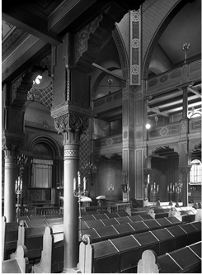
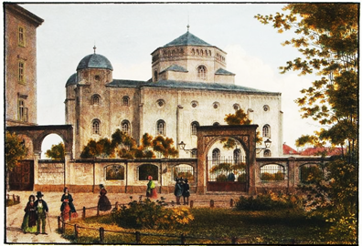
Figure 2. Dresden Synagogue, Interior View, photo from 1898, unknown photographer, in the public domain
Figure 1. Dresden Synagogue c. 1860, built 1839 – 1840, destroyed November 10, 1938, colored steel engraving c. 1860-1870 by Louis Thumling after a photograph by Herman Krone, edited by Gustave Georg Lange in Darmstadt, in the public domain

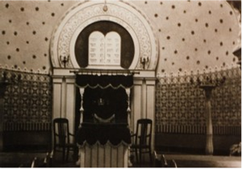
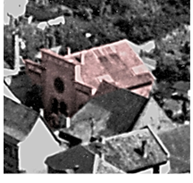

Figure 4. Interview, Ark and Torah Niche, photo c. 1930s. Society of German-Israeli Friends of Ingelheim.
Figure 3. The Synagogue of Ingleheim, 1841, picture c. 1930, destroyed on November 10, 1938. Society of German-Israeli Friends of Ingelheim

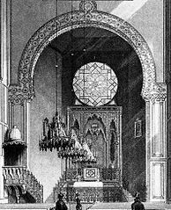
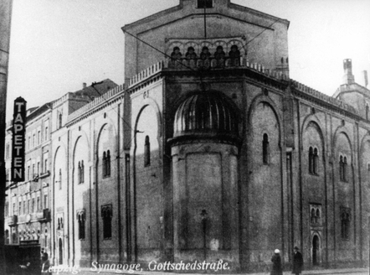

Figure 5. Leipzig, Germany, Prewar, The Gottschedstrasse Synagogue, 1855, Otto Simonson, destroyed November 10, 1938. Yad Vashem Photo Archive
Figure 6. Interior Detail of Gottschedstrasse Synagogue, facing East – ark under the window, engraving by Alfred Krause from a drawing by Adolf Eltzner, public domain
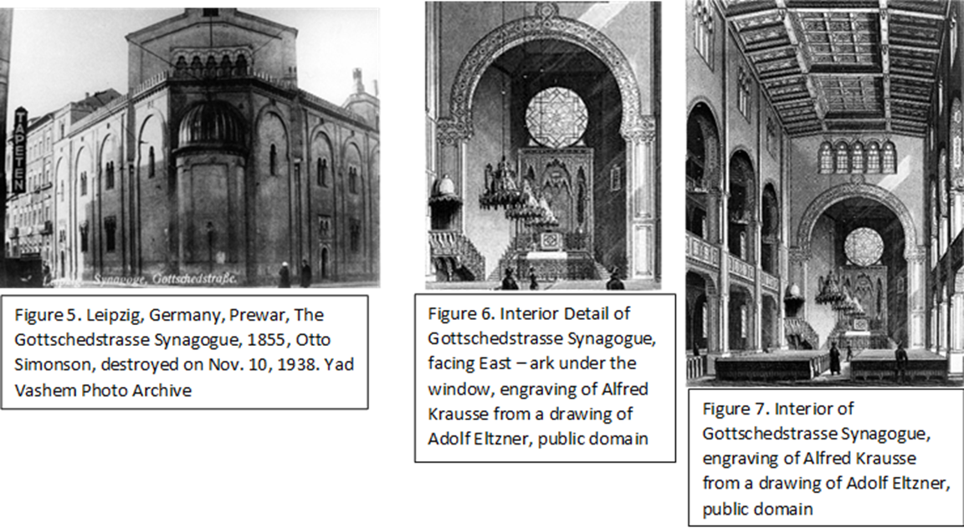

Figure 7. Interior of Gottschedstrasse Synagogue, engraving by Alfred Krause from a drawing by Adolf Eltzner, public domain
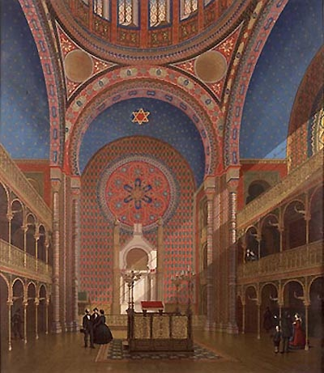
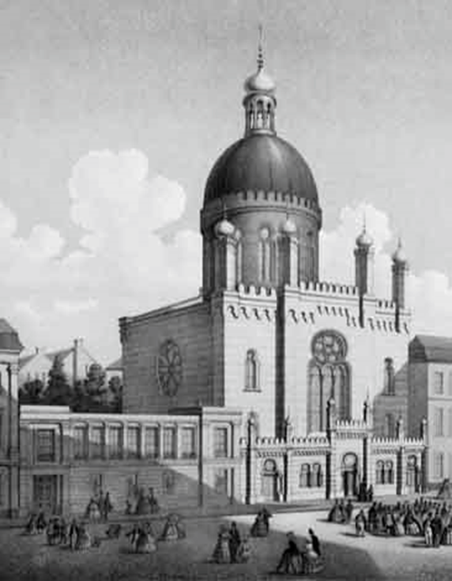
Figure 9. Interior view of the Cologne Synagogue in the Glockengasse, chromolithography by J. Hoegg after an aquarelle by Carl Emanuel Conrad, ca. 1861, public domain
Figure 8. Cologne Synagogue in the Glockengasse, chromolithography by J. Hoegg after an aquarelle by Anton Meder and Carl Emanuel Conrad circa 1861, public domain

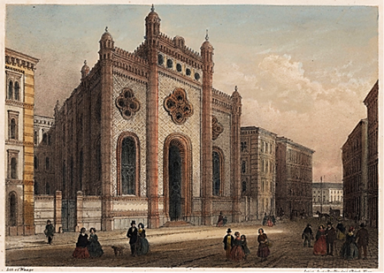
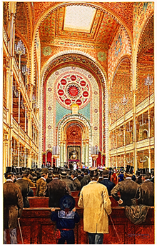
Figure 11. Interior View of the Leopoldstadt Temple, by Emil Ranzenhofer, d. Nineteenth Century, public domain
Figure 10. Color print of the Tempelgasse Synagogue (Great Leopoldstadt Temple), Vienna. Print by Karl Waage. Ludwig von Forster designed the synagogue in the Islamic Revival Style between 1853 and 1858. Part of the William A. Rosenthall Judaica Collection – Prints and Photographs

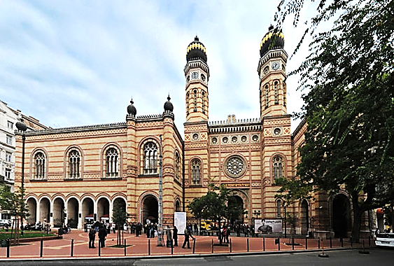

Figure 12. Dohany Utca Tempel, Budapest built 1859, Ludwig von Forster, www.synagogues360.org

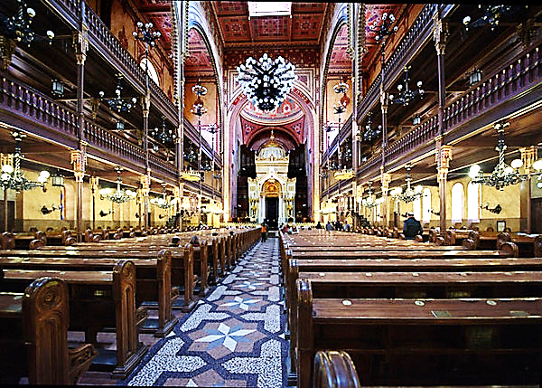
Figure 13. Dohany Utca Tempel, Interior View, www.synagogues360.org

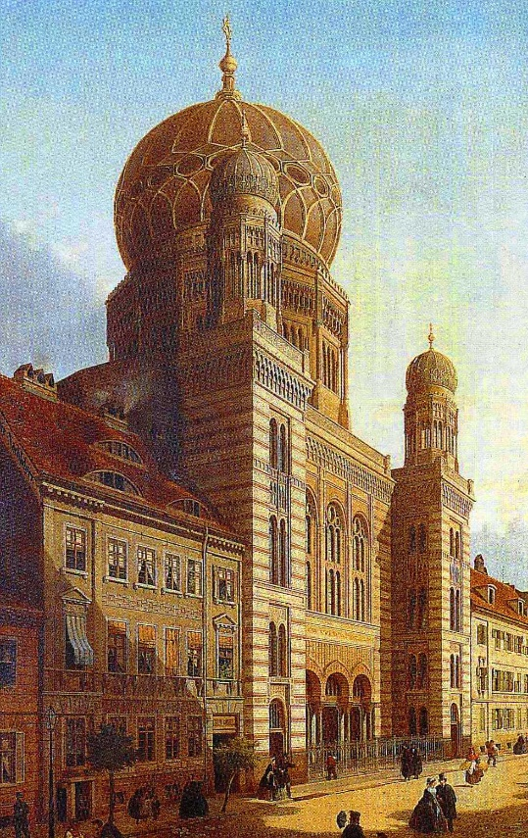

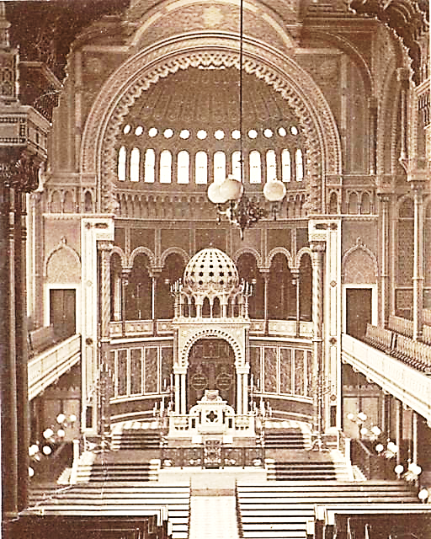

Figure 14. Inauguration of Neue Synagogue on Oranienburger Strasse, Eduard Knoblauch and Friedrich Stuler, Berlin, 1866, picture by Emil Pierre Joseph de Cauwer, c. 1866, public domain
Figure 15. Neue Synagogue, Interior View, c. 1890, public domain

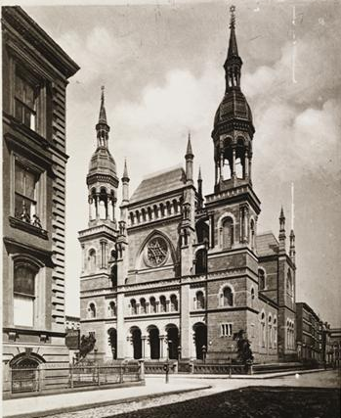

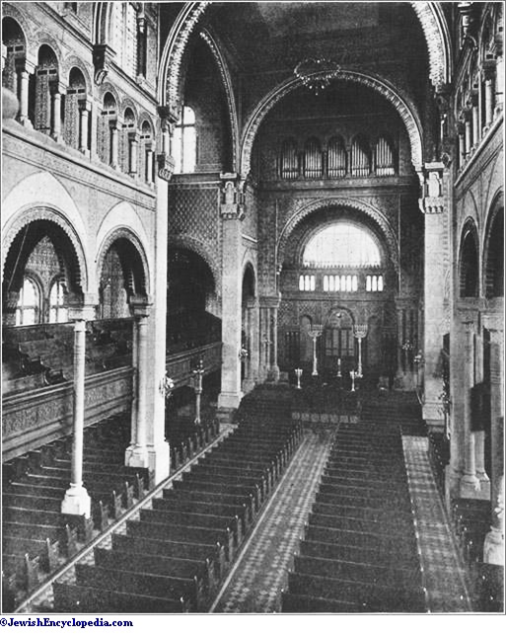
Figure 16. Exterior View, Temple Emmanuel, 5th Ave and 43rd Street, NYC 1901, Leopold Eidletz and Henry Fernback, from the collection of the museum of the city of New York

Figure 17. Temple Emanu-El, Interior View
http://www.jewishencyclopedia.com/articles/11501-new.york

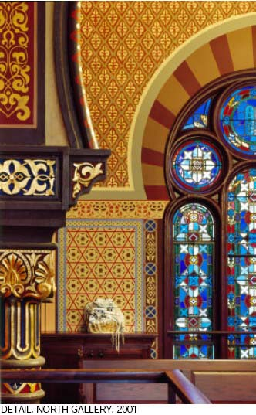
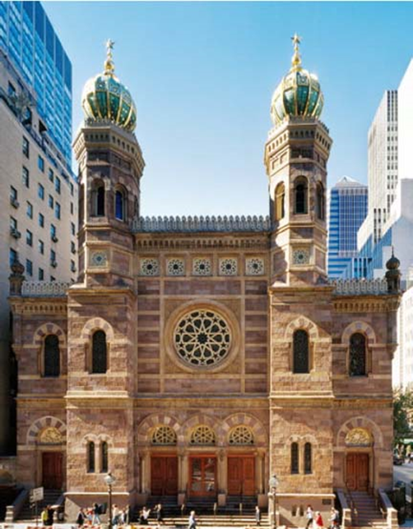

Figure 18 - 21. Central Synagogue, Congregation Achawath Chesed, 652 Lexington Avenue, NYC, Henry Fernbach, 1872
18. Front Façade 19. Detail of North Gallery, sciame.com
http://nyc-architecture.com/UES/UES004.htmer centralsynagogue_04_469x327.jpg
20. Interior View, www.nycago.org 21. Detail of Tower, www.panoramio.com

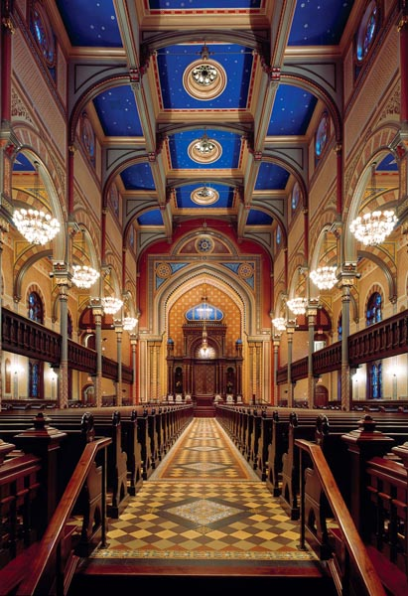
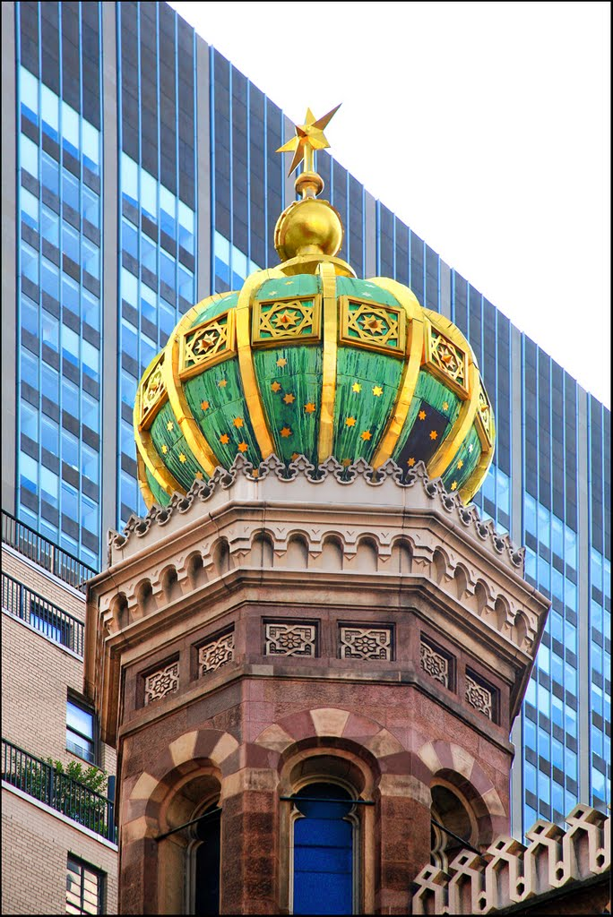

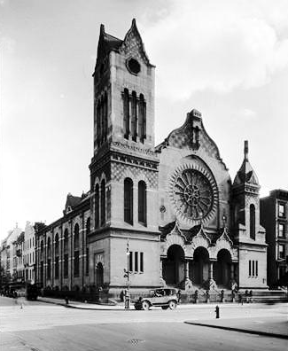
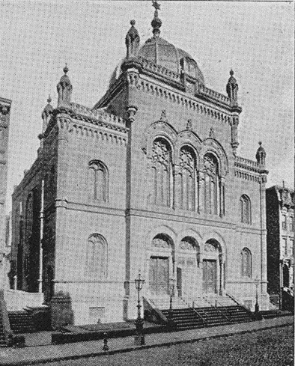

Figure 22. Shaaray Tefila, 127 W. 44th Street, NYC, Henry Fernbach, Henry Fernbach, 1869. Photo: Moses King, King's Handbook to New York (1892), public domain (in use 1869 – 1894)

Figure 23. Anshe Chesed/Beth El, then Rodeph Sholom, Lexington Avenue at 63rd Street, NYC, David and John E. Jardine, 1873. Photo by Samuel H. Gottscho from the collection of the Museum of the City of New York

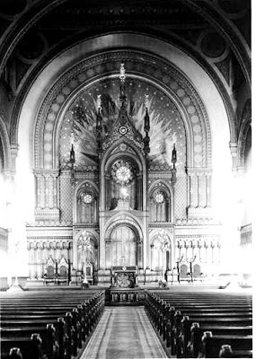

Figure 24. Anshe Chesed/Beth El, Interior View, Photo by Samuel H. Gottscho from the collection of the Museum of the City of New York

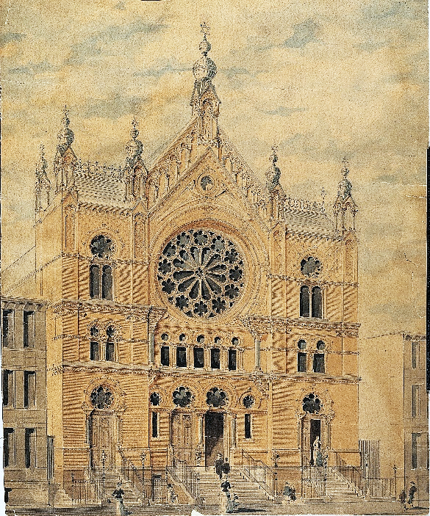
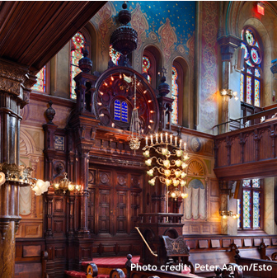
Figure 26. Eldridge Street Synagogue, Interior View of Ark, Eldridge street.org

Figure 25. Khal Adas Jeshurun (Eldridge Street Synagogue), 12 Eldridge Street, NYC, Peter and Francis William Herter, 1887. 1886 drawing of the facade. Collection of the Museum of the City of New York.

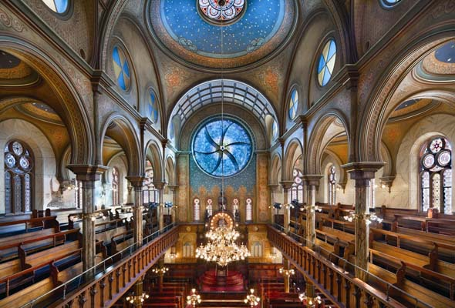

Figure 27. Eldridge Street Synagogue, Interior View, (Photo: Peter Aaron/OTTO)
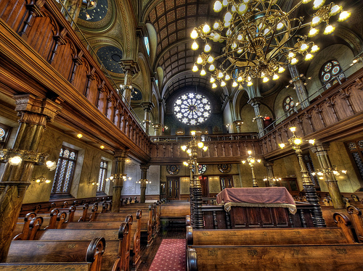
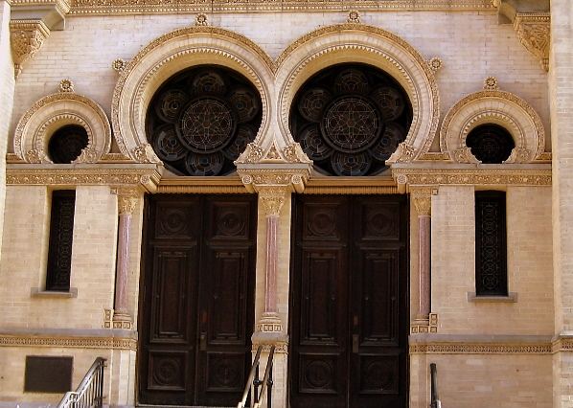
Figure 28. Eldridge Street Synagogue, Interior View, nyhistorywalks.wordpress.com

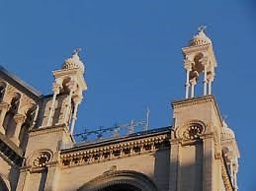
Figure 29. (Lft) Figure 29. Detail of Roof Line w/ Minarets, forgotten-ny.com
Figure 30. (above) Detail of Moorish Doors on Entrance. Raystours.nyc

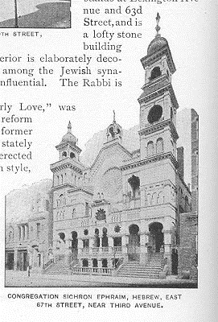

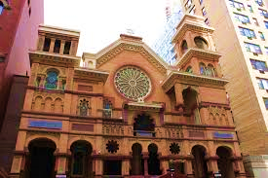

Figure 31. & 32. Park East Synagogue, 163 E. 67th Street, NYC, Schneider & Herter, 1890. Note distinctive baldachin structure over gable. That baldachin and those over towers have been removed. From Kings Handbook of New York (1893) Picture on left from Flicker by Emilio Guerra

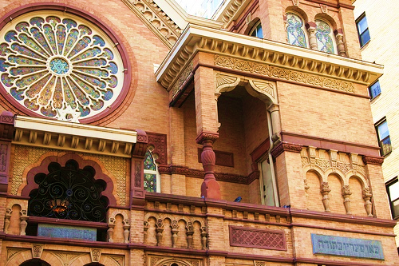

Figure 33. Park East Synagogue, Detail of Exterior, http://daytoninmanhattan.blogspot.com/2011/01/park-east-synagogue-zichron-ephraim-163.html

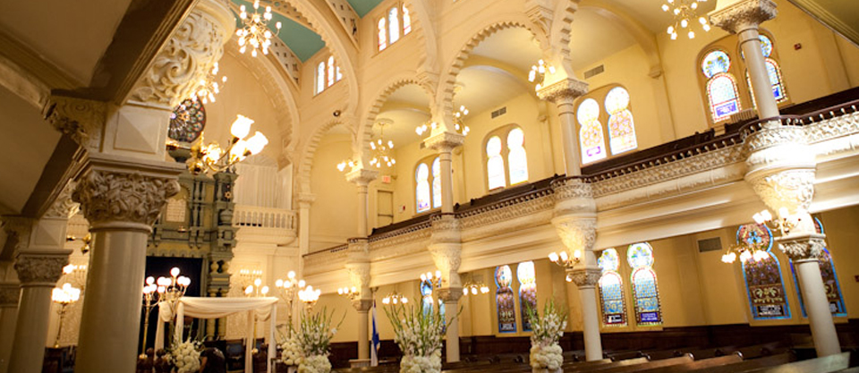
Figure 34. Interior View, note multi-lobed arches and horseshoe arched windows. parkeastsynagogue.org

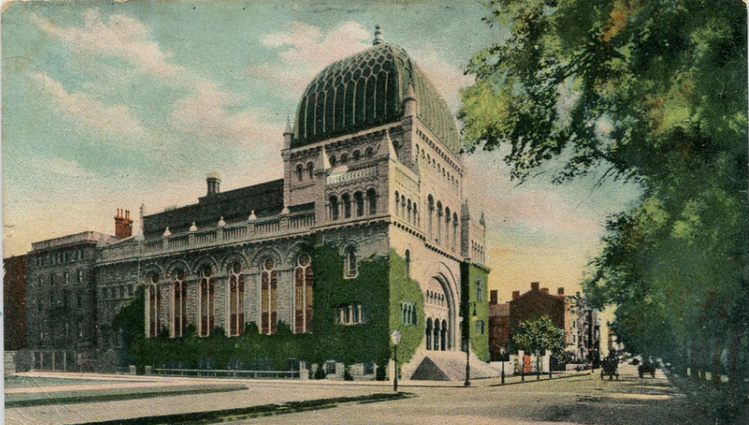

Figure 35. Temple Beth El, 945 Fifth Avenue at 76th St., NYC, Arnold Brunner and Thomas Tryon, 1891, Exterior View on Postcard c. 1906, unknown photographer, in the public. Card sold by Delcampe.net d(http://www.delcampe.net/http://www.delcampe.net/http://www.delcampe.net/

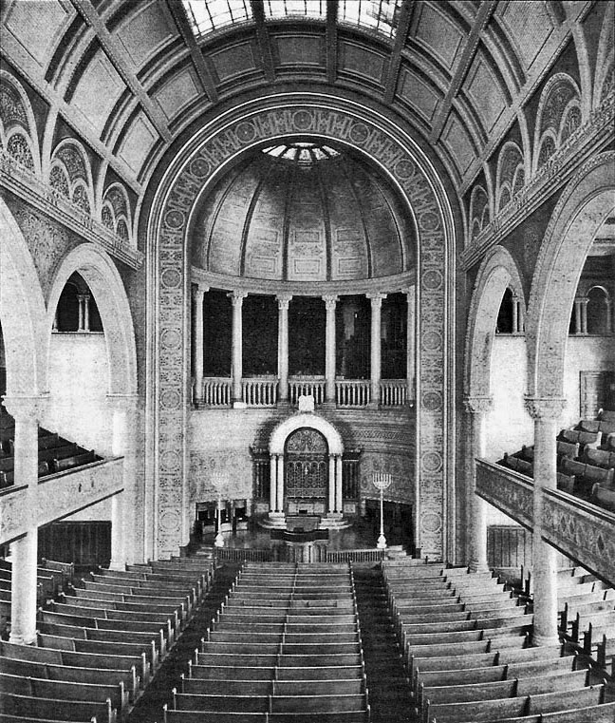

Figure 36. Temple Beth El, interior view on Odell Organ Co. Brochure, 1896. Unknown Photographer. http://www.nycago.org/Organs/NYC/html/BethEl.html
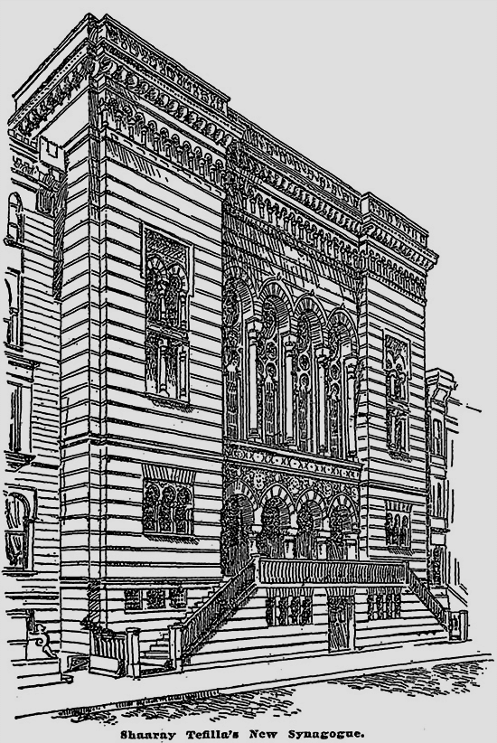

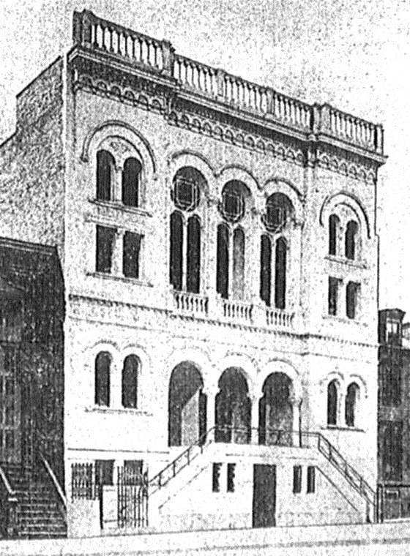

Figure 38. Beth Jacob Anshe Shalom, South Third Street, Williamsburg, Brooklyn, George F. Pelham, 1906. Picture from Brooklyn Daily Eagle, September 1906
Figure 37. Shaaray Tefila, West End Synagogue, 160 W. 82nd St., NYC, Arnold Brunner, 1894, unknown artist, (in use 1894 – 1959) http://www.nycago.org/Organs/NYC/html/ShaarayTefila.html http://www.nycago.org/Organs/NYC/html/ShaarayTefila.html

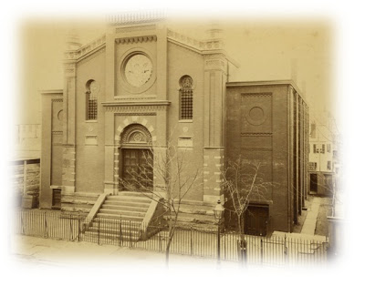

Figure 39. Oheb Shalom, Prince Street, Newark, NJ, 1884
http://newarkpreservation.blogspot.com/2011/04/37th-annual-awards- ceremony.html

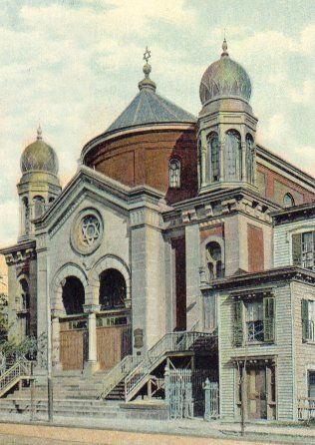

Figure 40. B’nai Jeshurun, Newark, NJ, 1905
Newark Preservation Society

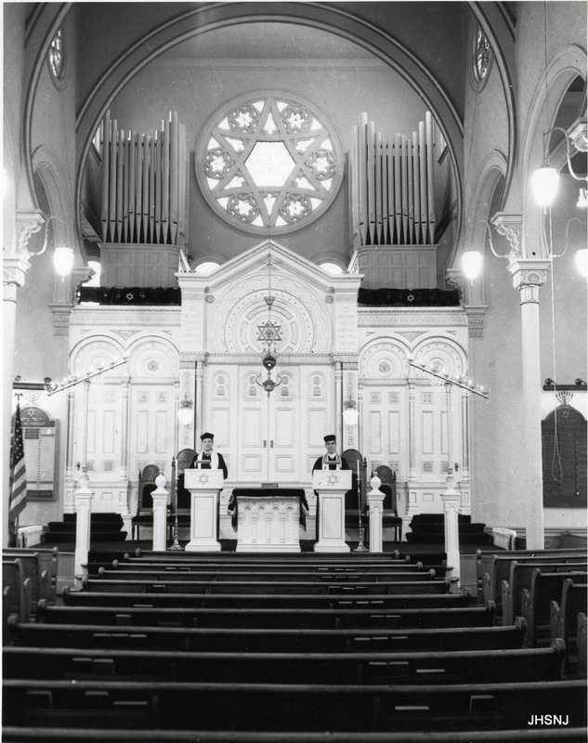
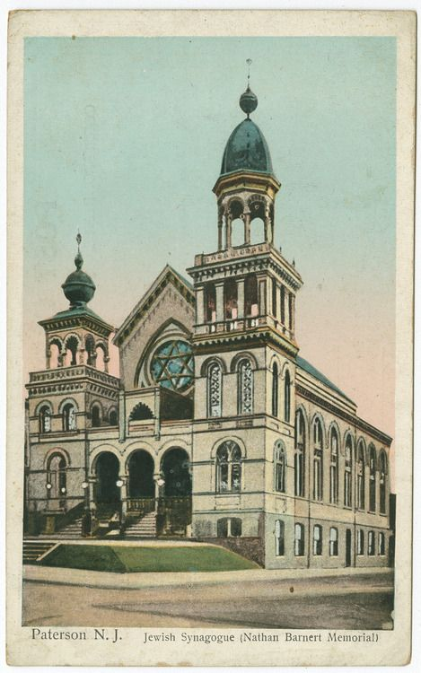
Figure 41. B’nai Jeshurun (Barnert Synagogue), Paterson, NJ, 1894 (public domain)
Figure 42. Interior View, B’nai Jeshurun, Jewish Historical Society of North Jersey

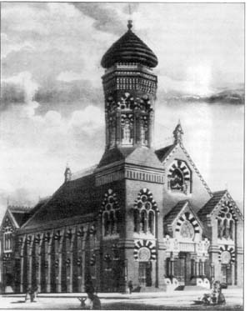

Figure 43. Rodeph Sholom, Philadelphia, PA, 1870, Frazer, Furness and Hewitt
Figure 40. Exterior Figure 41. Interior View, Ark
Isaac M. Wise Templ (Plum Street), Cincinnati, Ohio, 1866, James Keyes Wilson
(Pictures courtesy of Hillary Teichman)

Figure 42. Interior Detail, windows, domes, arches and walls

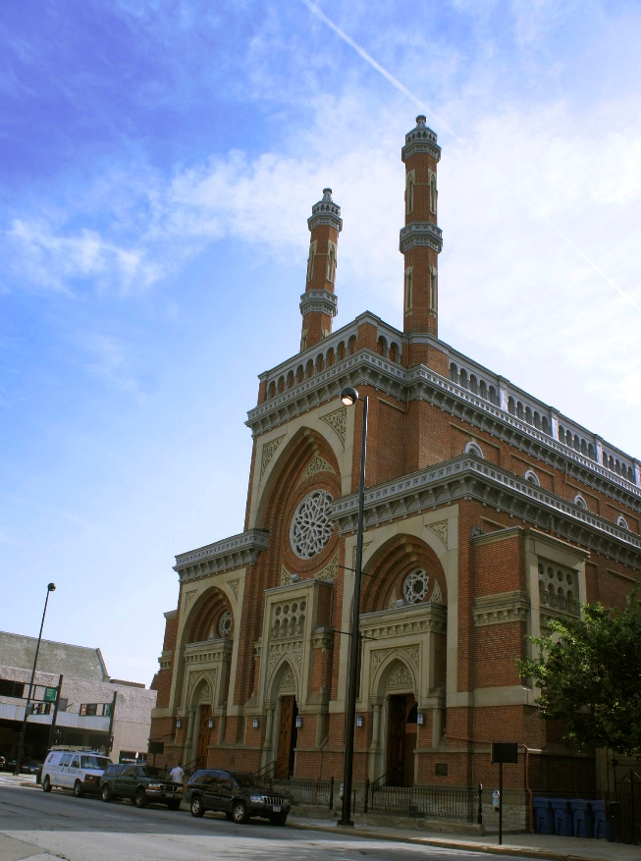
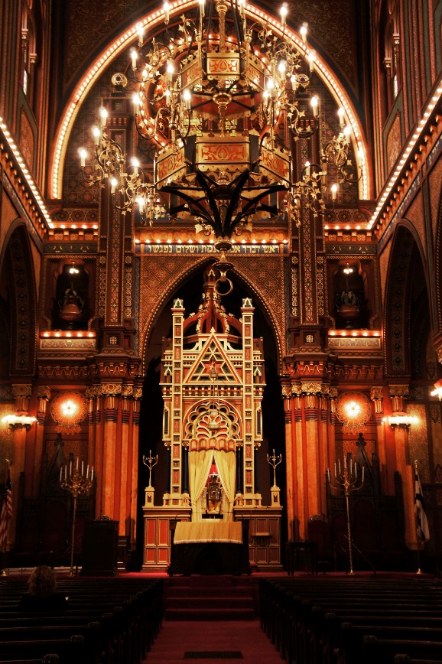
Figure 44. View of Façade Figure 45. View of Ark
Isaac Mr. Wise Temple (Plum Street Synagogue), Cincinnati, Ohio, 1866, James Keyes Wilson
Figure 46. Detail of Domes, Walls, Windows and Arches
Photographs courtesy of Hillary Teichman

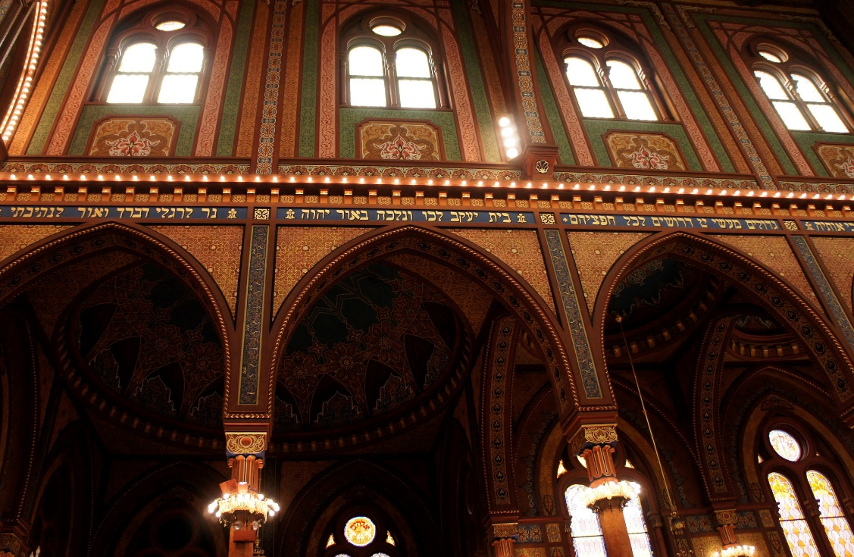

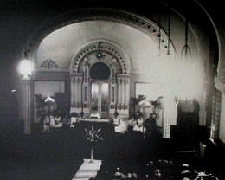
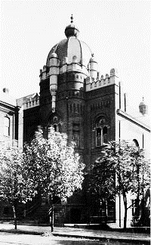
Figure 47. Exterior View and 48. Interior View
Eoff Street Temple (Leshem Shomayim), Wheeling, West Virginia, 1892

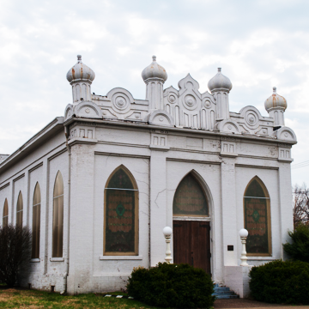
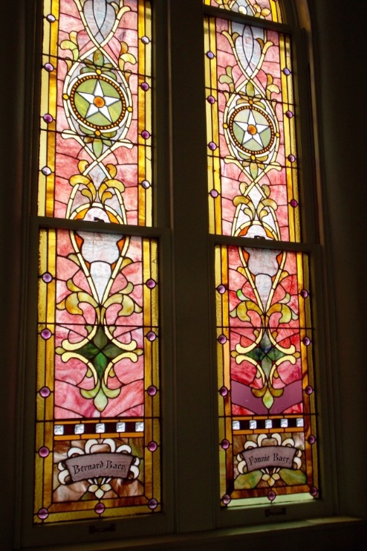
Figure 49. Façade of Building Figure 50. Detail of Window Adas Israel, Owensboro, Kentucky, 1878 Photographs: Institute of Southern Jewish Life

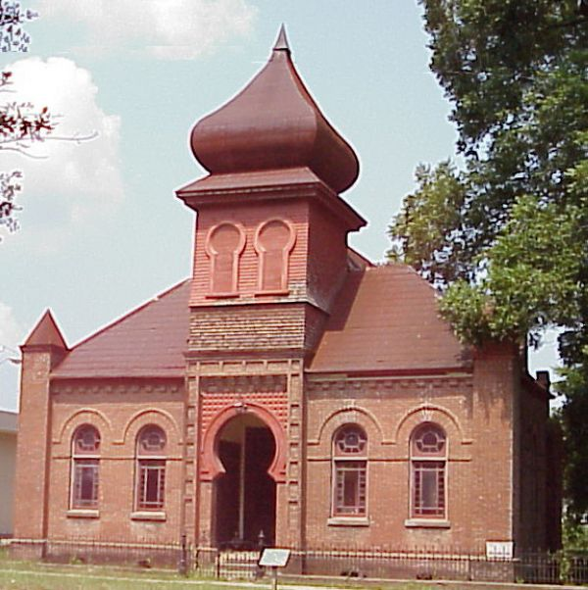
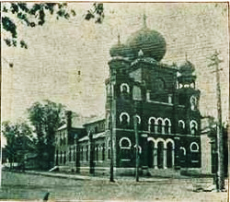
Figure 51. Temple Israel, Paducah, Kentucky, 1884, Brinton B. Davis Photograph from Institute of Southern Jewish Life

Figure 52. Gemilith Chessed, Port Gibson, Mississippi, 1892, Bartlett and Budemeyer, Photograph by scenictrace.com

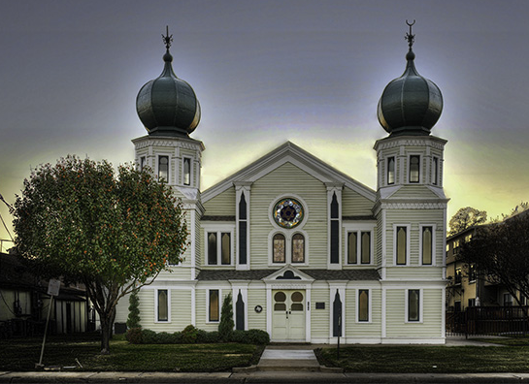

Figure 53. Beth El, Corsicana, Texas, 1898-1900
Photograph by synagogues360.blogspot.com

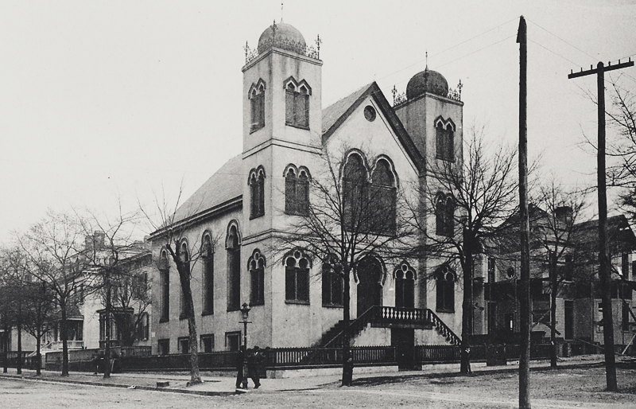

Figure 54. Temple of Israel, Wilmington, North Carolina, 1876, Samuel Sloan, Photograph c. 1895, Courtesy of New Hanover Public Library

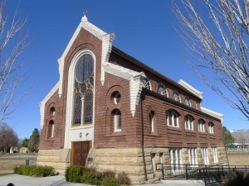

Figure 55. Beth Israel, Boise, Idaho, 1896, Exterior Photograph by Jewish Museum of the American West

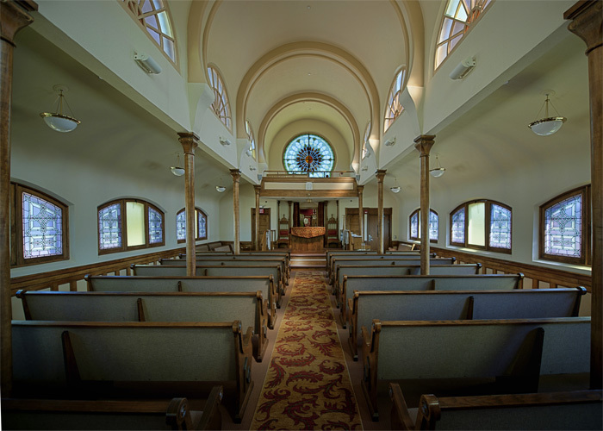

Figure 56. Beth Israel, Boise, Idaho, Interior www.synagogues360.org

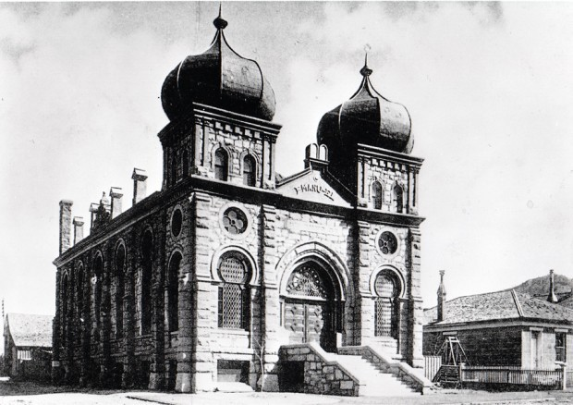

Figure 57. Temple Emanu-El, Helena, Montana, 1891, Heinlein &Mathias, Photo courtesy of Montana Historical Society Research Center — Photograph Archives

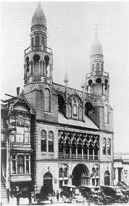
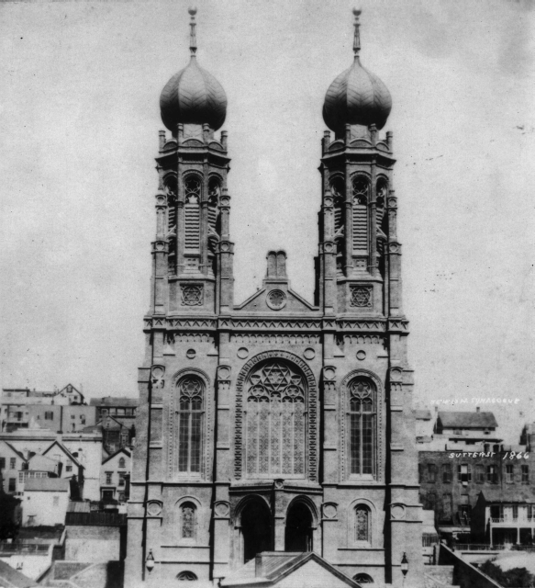
Figure 58. Temple Emanu-El (Sutter Street Synagogue), 1854, William Patton, Photograph from the Jewish Museum of the American West
Figure 59. Ohabai Shalome, (Bush Street Synagogue), 1895, Moses J. Lyon
(Collection of San Francisco Public Library)

