DESIGN, CRAFT, AND AMERICAN IDENTITY: RUSSEL WRIGHT’S “AMERICAN-WAY” PROJECT, 1940-2

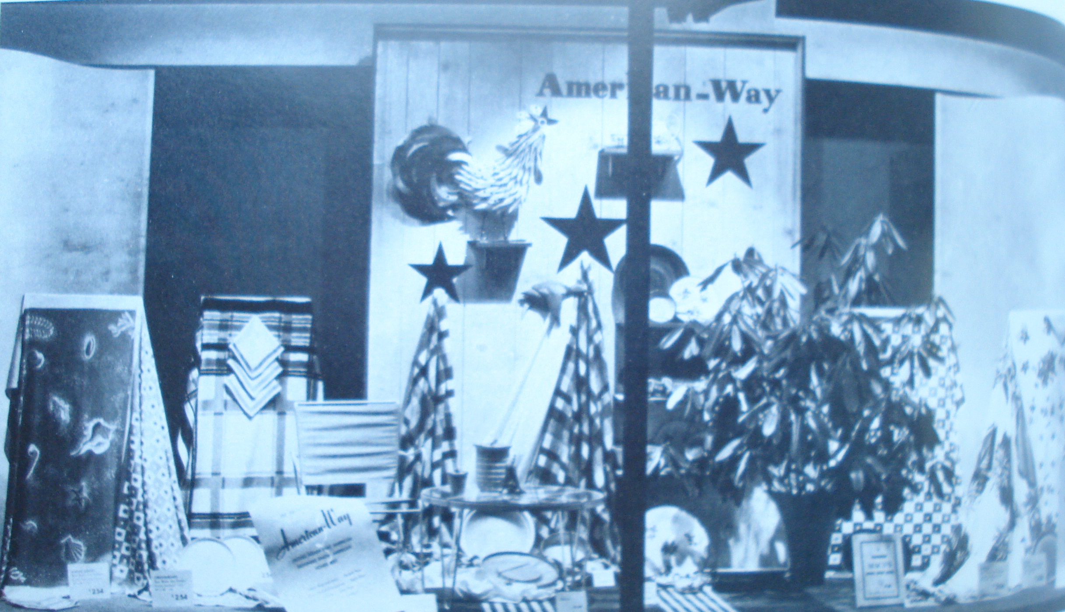

SUBMITTED IN PARTIAL FULFILLMENT OF THE
REQUIREMENTS FOR THE DEGREE
MASTER OF ARTS IN THE
HISTORY OF THE DECORATIVE ARTS AND DESIGN

MA PROGRAM IN THE HISTORY OF THE DECORATIVE ARTS AND DESIGN
COOPER-HEWITT, NATIONAL DESIGN MUSEUM, SMITHSONIAN INSTITUTION
AND PARSONS THE NEW SCHOOL FOR DESIGN

Presented by Dianne O. Pierce
2010

©2010

Dianne Oakes Pierce

All Rights Reserved

